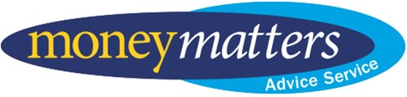

Money Matters Advice Service
Annual Report
2023-2024
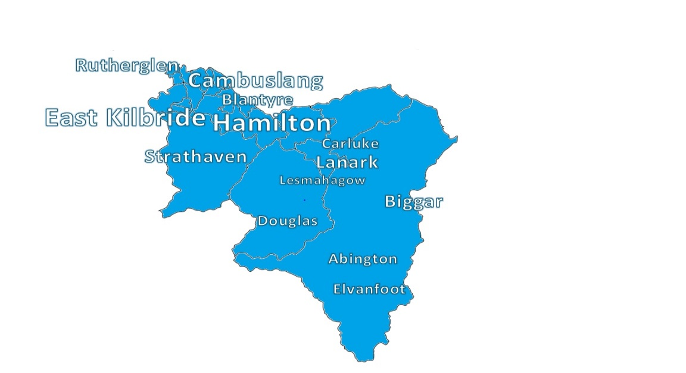

If you need this information in another language or format, please contact us to discuss how we can best meet your needs. Phone 0303 123 1015 or email equalities@southlanarkshire.gov.uk

Contents

Chapter 1 Foreword
Chapter 2 What does MMAS do?
Chapter 3 Community Wellbeing Team
Chapter 4 Money Advice
Chapter 5 Welfare Rights
Chapter 6 Projects
Chapter 7 Client satisfaction survey
Chapter 8 Who are our service users?
Chapter 9 SIMD area
Chapter 10 Clients by electoral ward
Chapter 11 Case studies

Foreword

Money Matters Advice Service (MMAS) is the money and welfare rights service of South Lanarkshire Council and has been serving the residents of the South Lanarkshire since 1997.
Over the years, it has been at the forefront of tackling poverty across South Lanarkshire, by maximising the income of clients and assisting with problem debt. This has particularly been the case in the last few years with the Covid 19 and Cost-of-Living crisis.
“I am very pleased that there is such an opportunity to receive help. Everyone works positively and professionally. Thank you once again”
Client
In recent years, the service has also played a larger role in the provision of emergency support for clients. This reflects the changing advice landscape that the service is operating in and demonstrates how the service has changed and developed to face the challenges the community it serves is facing.
Looking ahead, the service anticipates the after-effects of Covid 19, and the Cost-of-Living crisis will remain with us for some time, and the demands placed on the service are expected to continue to be higher than those that existed pre-Covid 19.

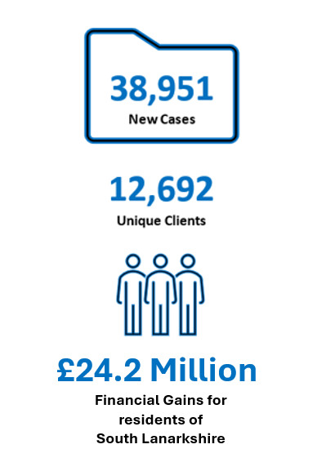

What does MMAS do?

The primary objective of Money Matters Advice Service is to support the residents of South Lanarkshire and the employees of South Lanarkshire Council in tackling poverty.
The Service also plays a vital role in supporting other services across South Lanarkshire Council and helps to ensure the council meets many of its statutory obligations.
The role of MMAS is to support and empower the residents of South Lanarkshire by providing them with a high-quality advice and representation service, that maximises their income and provides them with positive solutions and strategies for dealing with problem debts.
This generally means ensuring people can access advice and assistance in relation to matters concerning their welfare, but also assisting Housing Services to meet legal pre-action requirements by offering advice and assistance to clients when their tenancy is at risk of being terminated because of rent arrears.
Money Matters also offers other tenants and homeowners’ advice when their landlords or mortgage lenders notify the council, that the tenant, or homeowner is at risk of homelessness because of rent or mortgage arrears. This can include MMAS providing representation for these clients at Court.
In addition to this, MMAS provides residents with a gateway to all Scotland’s formal debt solutions, such as the Debt Arrangement Scheme

and bankruptcy, where clients must apply through an approved Money Advice Service.
It also provides representation for clients at all social security appeal tribunals, and at Upper Tier Tribunals.
MMAS also work collaboratively with various other South Lanarkshire Council’s services, including Debt Recovery to assist clients in maximising their income, but also finding sustainable solutions to their debt problems.
The Service also provides vital support to Social Work in ensuring their clients’ income are maximised and if they have problems debts, that these are dealt with. MMAS also works with Children and Families to ensure Kinship Carers are supported by South Lanarkshire Council and are receiving everything that they are entitled to.
MMAS works also in partnership with Employability Services and has a dedicated employability adviser who supports their service users.
Money Matters also participates in various partnerships across South Lanarkshire in relation to various issues, including Carers Support, Child Poverty, Veterans and Trauma Informed Practices.
The service also has a crucial role to play in challenging child poverty and has a dedicated Telephone Advice Line Service that supports families with young children who are under the age of 5.
The role of the Money Matter Advice Service is constantly evolving and changing to meet the needs of South Lanarkshire residents, but also importantly to meet the needs of South Lanarkshire Council to ensure it meets its statutory obligations to residents.
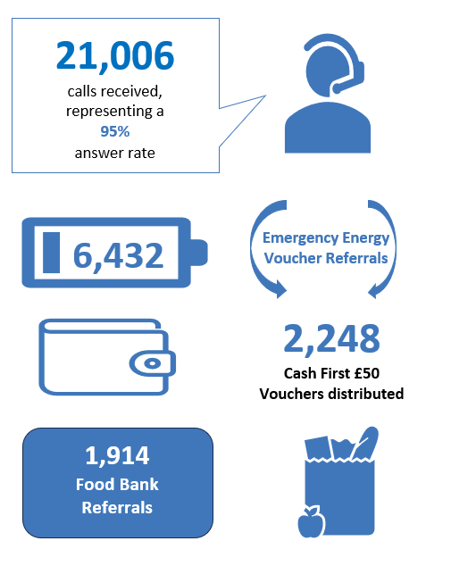

Community Wellbeing Team
In the autumn of 2023, the Money Matters’ Community Wellbeing Team took on the role of operating a triage system for the service and dealing with any requests for emergency support from clients experiencing food and fuel shortages.
“The introduction of the Community Wellbeing Team has established a streamlined triage system, facilitating immediate benefit checks, emergency support and seamless referrals to the most appropriate team for advice and assistance”
Independent Service Review
It now receives all telephone calls into the service, identifies the issues clients are presenting with and ensures they are referred onto the appropriate team for assistance.
97.62% of all clients who received a referral to the Money Advice and Welfare Rights Teams received a call back from an adviser within 5 working days, surpassing the service target of 95%.
The Community Wellbeing Team also process all digital referrals received through the council’s website. They have a 97% success rate for same day processing of all food and fuel bank referrals and a 97% success rate for same day processing of payments for the Cash First project, which it is operating in partnership with Hamilton, East Kilbride, and Clydesdale Citizen Advice Bureaux.

Money Advice

The Money Matters’s Money Advice Team are South Lanarkshire Councils specialist debt advice team and can, as approved money advisers, provide residents with specialist debt advice and access to formal debt solutions such as sequestration (bankruptcy) and the Debt Arrangement Scheme, as well, as providing advice and representation in relation to debts that are being pursued though the Sheriff Court.
Very helpful staff who go over and beyond to help as much as they can, especially when you don’t know where to turn or what to do.
Client

The type of debts that Money Matters helps clients with includes consumer credit debts, utility debts, rent and mortgage arrears and Council Tax arrears amongst others.
In addition to this the Money Advice Team also assists clients where they need advice on developing sustainable repayment plans with individual creditors and where necessary disputing their liability for consumer credit debts.
The service can also assist clients in requesting debt write offs where this is appropriate and developing sustainable household budgets.

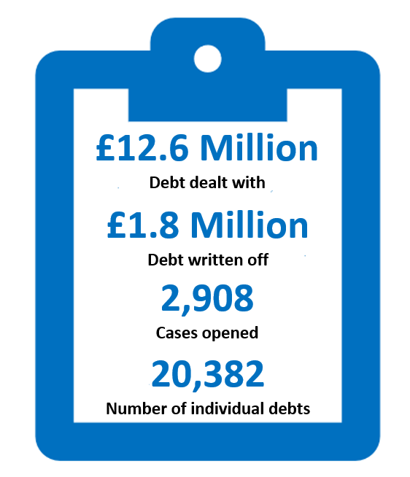

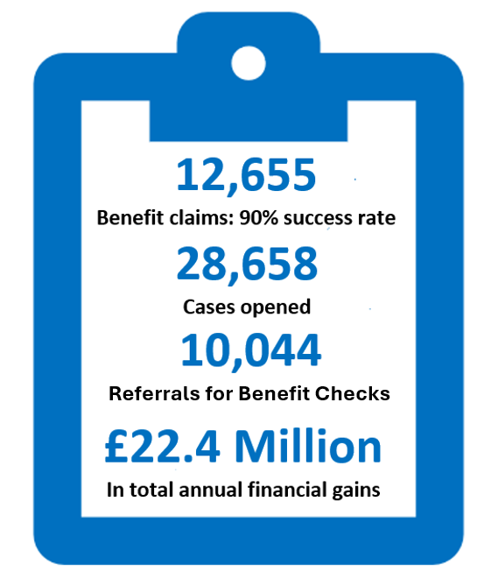

Welfare Rights

The Welfare Right Service in Money Matters provides advice and assistance to clients on how they can maximise their income in relation to all UK, Scottish and local authority benefits.
All clients who contact the service receive a benefit check, if they have not had one in the previous six months and are helped to identify any entitlements they have. They are then assisted in submitting claims for those benefits, with all necessary follow up work provided.
I went to a drop in hub to access the service. I was told that someone would call me early in the week, more than likely Monday. That happened. A lady spoke with me took my details and said that she would speak with her supervisor and get back to me and that happened. Very good information and advice. Five stars.
Client

The service also helps clients to challenge any decisions where they are unsuccessful, and will also help them request Mandatory Reconsiderations, Redeterminations and ultimately appeal their case to the Social Security Tribunal or Upper Chamber for Social Security, where necessary.

Projects

The Money Matters Advice Service operates several projects with Partner agencies, who help fund bespoke services to different client groups.
MacMillan Cancer Support
MacMillan Cancer Support partly funds the provision of a specialist Welfare Rights Officer to support clients and their families where someone has a cancer diagnosis.
NHS Scotland – Financial Wellbeing project
The Financial Wellbeing Project works closely with Community Link Workers, who are based in GP Surgeries, to provide specialist welfare benefit support to clients.
NHS Scotland – Cost of Living project
The Cost-of-Living Project was launched in 2023 with NHS Lanarkshire and involves a Money Matters Welfare Rights Adviser who works closely with NHS staff and teams across South Lanarkshire and is based in Hairmyres Hospital.
South Lanarkshire Council – Employability project
The Employability Project is funded by South Lanarkshire Council Employability Service and works closely with employability services across South Lanarkshire to support clients to re-enter the workplace.
South Lanarkshire Council - Telephone advice line
The Money Matters Telephone Advice Line is a specialist service funded by South Lanarkshire Council that provides specialist support to prospective families or families with children under the age of five.



Client satisfaction survey

Money Matters Advice Service surveyed existing clients on their experience of using the service.
The service received an average rating of 4.58 out of 5 from those clients who responded to the Survey.
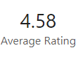
74% of respondents accessed the service by telephone, 17% by online form, 7% through Hubs and 2% by email.
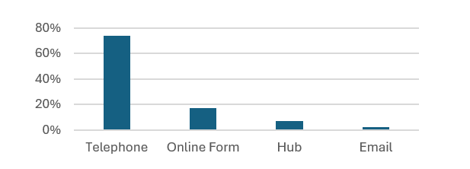

97% of clients surveyed found accessing the service either Very Easy, Easy or Okay. Only 3% found it Difficult or Very Difficult.
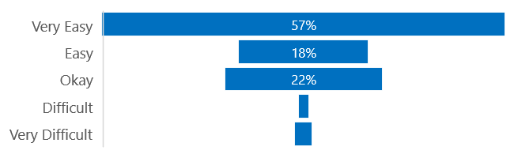

86% responded that the service was able to provide them with the help that they required.
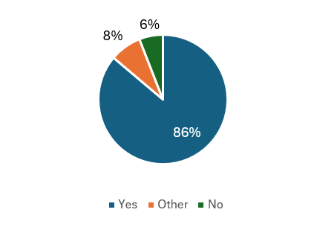

94% of those who responded said they would use the service again or recommend it to a friend or family member.
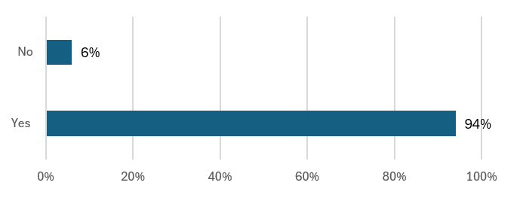

Who are our service users?
Gender
56% of all clients were female, whilst 41% were male.
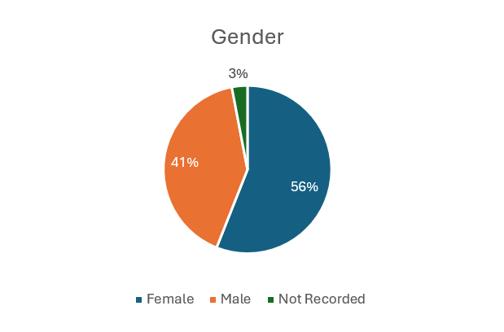
Household composition
66% lived in a household without children, whilst 21% were in a household where there were children.
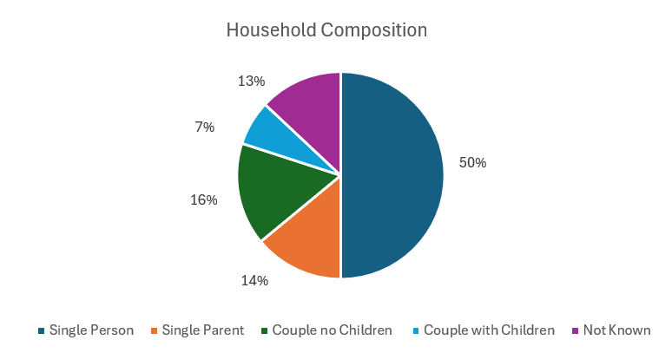

Client income
88% of all clients had a household income level of less than £15,000 whilst only 4% had an income level of more than £25,000.
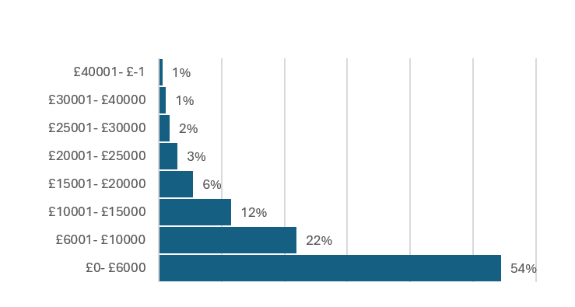

Client age
58% of clients are between the ages of 25 and 59 years old.

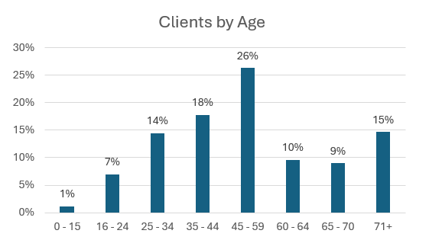

Health
73% of all clients reported having health issues.
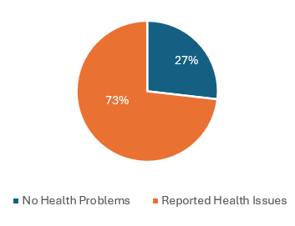
Health issue
30% of all clients reported having a mental health problem, whilst 59% of clients reported having physical health problems.
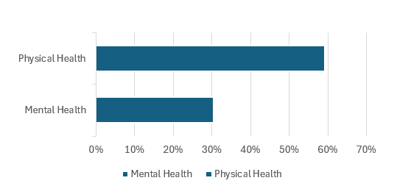

Carers
13% of all clients reported being carers.
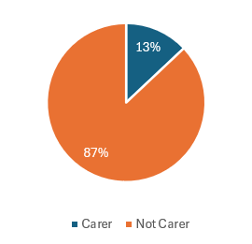
Priority service register
22% of all clients are registered with their energy providers as vulnerable.
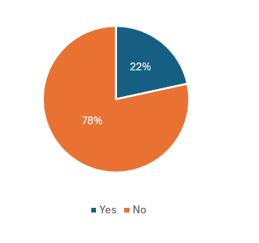

SIMD area

The Scottish Index of Multiple Deprivation (SIMD) is a relative measure of deprivation across 6,976 small areas (called data zones). If an area is identified as ‘deprived’, this can relate to people having a low income, but it can also mean fewer resources or opportunities.
SIMD looks at the extent to which an area is deprived across seven domains: income, employment, education, health, access to services, crime, and housing.
Money Matters can show, using client post codes, how its clients are distributed over these data zones, with the most deprived areas being a “1” and the least deprived areas being a “10”.
This shows that 23% of Money Matters clients live in data zones that are in the top ten per cent of the most deprive areas and 17% live in data zones that fall within the next ten per cent of the most deprived areas.
Overall, 79% of Money Matters clients live in data zones that are classified as being in the lower half of all SIMD data zones.
This demonstrates that Money Matters Advice Service is successfully reaching clients that are in the most deprived areas of South Lanarkshire.

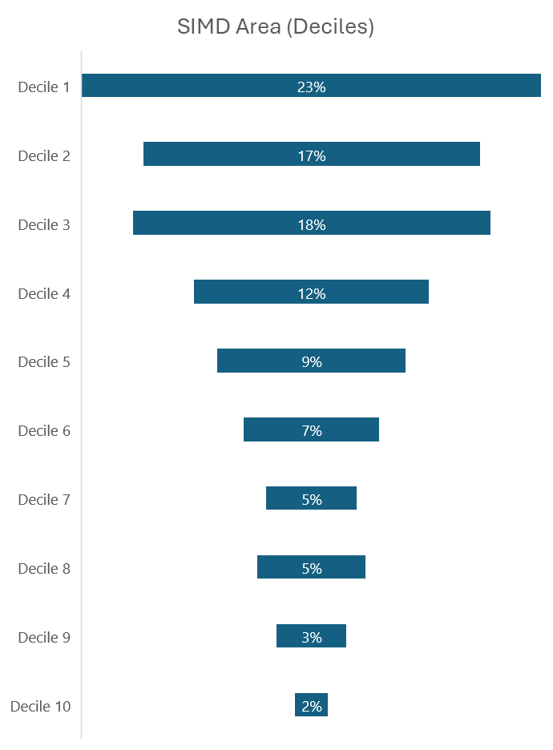

Clients by electoral ward

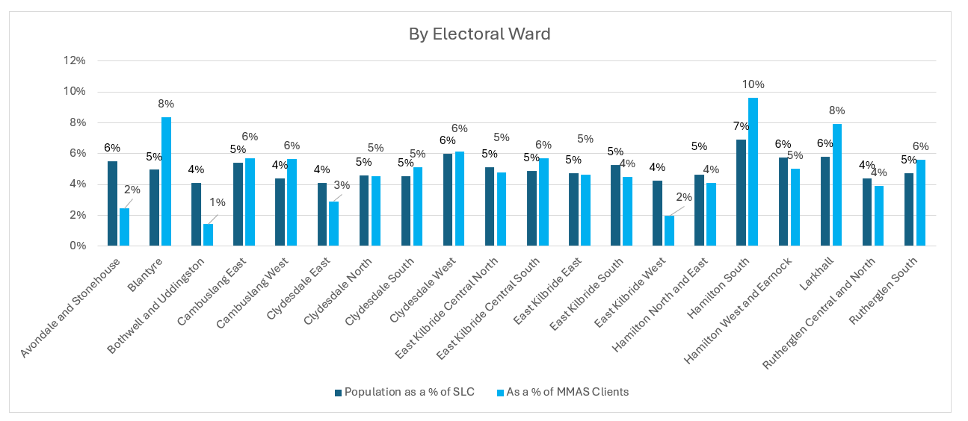

This graph shows where Money Matters clients live by electoral ward and contrasts this with what percent each ward makes up of the South Lanarkshire population.
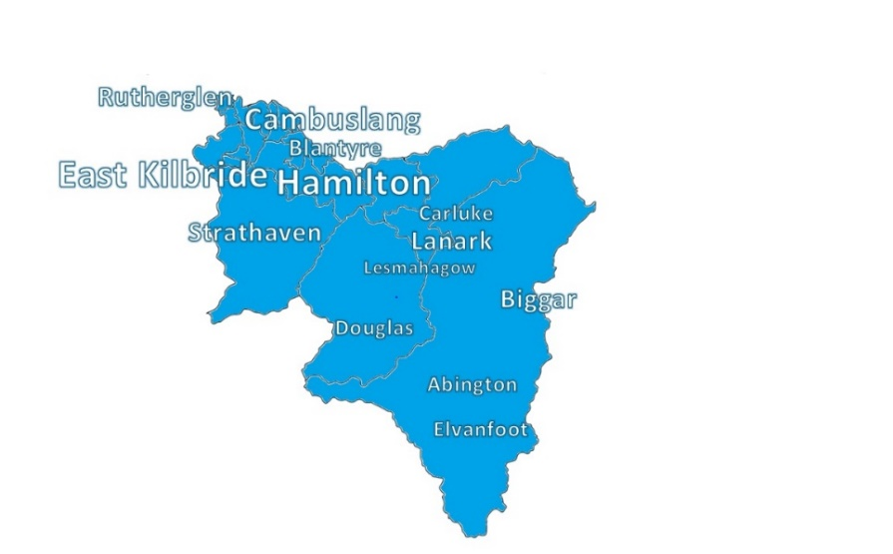
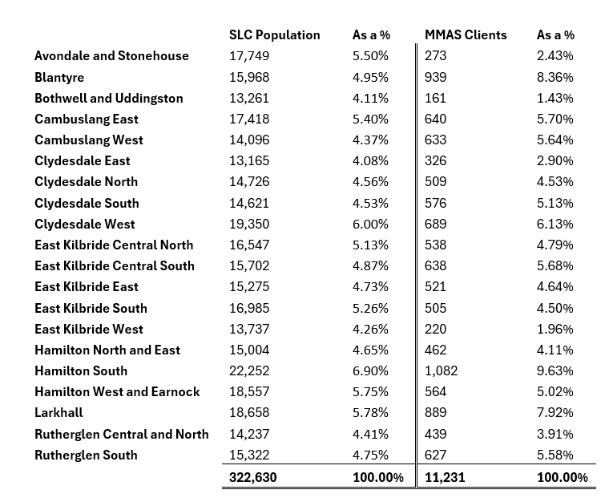

Note:
The total number of clients by SLC Electoral Ward does not equal the total number of clients supported by Money Matters Advice Service in 2023-24, as some Money Matters clients will not live in South Lanarkshire electoral wards, such as kinship carers and South Lanarkshire Council employees, but they can still access Money Matters Services.
Data Source:
National Registers of Scotland. June 2021.

Case studies

Case study one – Community Wellbeing Team
Money Matters Advice Service was contacted by the client as she had seen a reduction in her income at work and this had left her with insufficient funds to pay for her essentials, including her gas and electricity and food. She lived in her home with her two children who were 6 and 8.
The Community Wellbeing Team carried out a Financial Wellbeing Health check to see if the client was entitled to any other benefits. She was already in receipt of Universal Credit and getting help with her rent and Council Tax and she had a single person discount for Council Tax.
However, she was not claiming the Scottish Child Payment which she was entitled to. She also had a few small debts she was struggling to pay. Client was advised how to apply for Scottish Child Payment and the client was provided with a referral to the Fuel Bank Foundation and provided a £50 Cash First voucher. Also advised about Scottish Welfare Fund and we could provide referrals to food bank if she required further help. Client also referred to Money Advice for help with debts.
Case study two – Community Wellbeing Team
Client was a pensioner and lived on his own. He contacted the service to request a benefit check and explained he did not have enough money to turn on his gas and electricity and was keeping warm with a blanket. He also explained he did not have enough money for food until his pension credit was paid again.
The client was referred to Welfare Rights for a full benefit check and was issued a £50 Cash First voucher to help him buy food and referred to the Fuel Bank Foundation for an energy top up voucher.



Case study three – Welfare Rights
Client resided with his wife and 2 children, aged 10 and 2 years old in an owner occupier mortgaged property, and was struggling with day to day with cost-of-living costs due to low family income.
A benefit check was completed, and was assisted to claim - Best Start Foods, Best Start Grant - Early Learning Payment, Carer’s Allowance, Council Tax Reduction, Child Disability Payment for his 2-year-old disabled son, Scottish Child Payment, Child Benefit and Universal Credit. Client also received help from Financial Wellbeing Support Fund.
The total client financial gain for the family was £ 43,171.43.

Case study four – Welfare Rights
Client was single and lived alone. Client contacted the service for assistance after suffering a stroke as he was struggling financially.
Client had been living off his savings before his stroke. The stroke prevented him from starting employment. Client had no income when he contacted the service, client was unable to pay for priority bills such as rent, Council Tax, gas and electricity.
A full benefit check was completed, and the client was assisted to apply for Universal Credit, Council Tax Reduction and Adult Disability Payment.
After client’s contact with the service, he has received a total yearly financial gain of £15,535.85.

Case study five – Money Advice
Client was a single parent working part time. She had struggled during the Covid 19 Crisis, falling behind with her rent, Council Tax, utilities, and some non-priority debts. She tried to enter an arrangement with her creditors, but due to the level of arrears each creditor wanted more than she could afford to pay, so she stopped paying.
Due to level of her rent arrears, she was advised her case would be calling at court and could possibly lead to an eviction. This frightened the client as she had 2 young children.
The Money Adviser spoke to the client and discussed potential options with her. Due to her low income and debt level, it wasn’t feasible she could repay her debts within a reasonable period, so bankruptcy was discussed. The Money Adviser helped her apply for a Minimum Asset Bankruptcy. Due to her low income, she was not asked to contribute to the bankruptcy. Once it was awarded, she set up direct debits for her ongoing bills. The court action was stopped, and her tenancy was saved.
Case study six – Money Advice
The client had started missing payments to his debts due to cost of living crisis. He was also struggling to maintain payments to his mortgage and Council Tax. The client felt there was no way to get his debt under control and this was causing him a lot of stress and affecting his work and family life.
The adviser explained that there was an option called the Debt Arrangement Scheme that would allow the client to repay back his debt with a monthly payment. It would also stop interest and charges and would protect him from his creditors taking recovery action. The Money Adviser set up the Debt Arrangement Scheme and he is now repaying his debt at an affordable amount each month; he will be debt free in 6 years and 3 months.

