10. Transport
SEA objective that relate to transport
Promote sustainable travel modes and reduce traffic emissions.

Sustainable Development Goals
The Goals relevant to this chapter are:
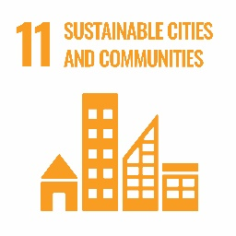
Introduction
South Lanarkshire has a diverse range of settlements located within the urban areas to the north or spread through the rural areas in the south and west. The distribution and population of these settlements determine the level and type of transport used which has a distinctive influence on the built and natural environment, human health and the impacts associated with vehicle emissions (including local air quality and climate change). The demand for transport has continually increased with individual vehicle ownership growing. This has resulted in the transport sector being one of the key concerns for atmospheric emissions.

A summary of the indicators used in assessing the state of South Lanarkshire is presented, highlighting the current status of each indicator and the directional trend.

G | Good | F | Fair |  |  | Improving
 |  |  |  |  |  | No change
P | Poor |  |  |  |  | Deteriorating
 |  |  |  |  | Note: The most recent data available was used in assessing the environmental indicators

Indicator | Current status | Trend direction | Explanation
Road network condition | F |  | The condition of the road network remains similar to previous years, although it remains better than the Scottish average. Emerging statistics for 2023/2024 indicate a deteriorating picture across all categories of road.
Traffic growth | G |  | Road traffic growth is returning to pre-pandemic levels following the relaxation of Covid19 restrictions.
Congestion | G |  | The number of residents who did not experience congestion in the area has remained consistent over recent years.
Road safety | G |  | The council is making a positive contribution towards the Scottish Government’s 2030 casualty reduction targets. The number of child fatalities as a result of road traffic collisions has remained at zero for the past four years.
Public transport | F |  | The number of park and ride facilities increased to help facilitate an uptake in public transport. However, due to Covid19 restrictions, the number of train and bus passengers significantly reduced. A large number of residents are using concessionary bus passes, particularly secondary school pupils.
Active travel | P |  | Although the number of people walking and cycling remains low these remain higher than pre-pandemic levels. Active travel amongst school pupils remains constant and the uptake of cycling continues to improve due to initiatives in schools such as Bikeability.

Baseline situation
South Lanarkshire is located at the heart of west central Scotland and its settlements have very diverse characteristics due to the physical environment. The north of South Lanarkshire is distinctly urban with surrounding greenbelt and is home to the majority of the population with an abundance of services that are well connected to the road and rail infrastructure. To the immediate south are the commuter settlements typified by the large numbers of daily commuters working in larger towns and Glasgow. However, the impact of this is that these centres have declined significantly to levels where many no longer offer an essential range of services and dependence on private vehicle ownership is high.

Across the middle of South Lanarkshire some settlements have lost their traditional industries of mining or agriculture and to the south are rural centres where there is a higher than average number of retired people. Employment within these areas is largely reliant on the service sector, including tourism. In general, the environmental quality of the area is high but public transport provision is relatively limited.

10.1 Local transport issues
The influence on transport issues is highly dependent on the area in which the individual lives and works because transport infrastructure differs considerably across South Lanarkshire. During the recent consultation on the council’s forthcoming Local Transport Strategy for 2024 – 2034, a number of issues were identified which will be considered and taken account of in the final Strategy, including:

- The condition of roads and footways need to be improved.
- Improve road safety.
- A need for new and improved walking, wheeling and cycling routes.
- Infrequent rural bus services.
- Improvements to public transport.
- The need to encourage children to walk or cycle to school.
- Congestion, particularly in town centres.
- The need for lower residential speed limits.
- The need to encourage low carbon vehicles.

The council is currently preparing a new Local Transport Strategy which will outline the future direction of its approach to the development and upkeep of the transport infrastructure within South Lanarkshire.

10.2 Road network condition
South Lanarkshire Council is responsible for a road network that is 2,295 km (1,426 miles) in length and comprises of 290 km of A class roads, 250 km of B class roads, 407 km of C class roads and 1,348 km of unclassified roads. This excludes the motorway and trunk road network which is the responsibility of Transport Scotland.

Information on the condition of local authority roads is collected in the annual Scottish Road Maintenance Condition Survey organised by the Society of Chief Officers of Transportation in Scotland (SCOTS). The Survey is taken on all A class roads in one direction, with the other direction being surveyed the following year. Fifty per cent of B and C class roads in South Lanarkshire are surveyed, meaning that all the B and C class network is surveyed over a four year period. Only 10% of the unclassified road network is completed each year. The survey produces a Road Condition Index and identifies, for each 10 metre section of road, the percentages within three categories. These are red (requires maintenance), amber (should be considered for maintenance, or green (serviceable). The Road Condition Index is published annually as a national performance indicator. The results for South Lanarkshire and the Scottish average are set out in Table 10.1.

Table 10.1: Carriageway condition - % of network that should be considered for maintenance treatment
Year | South  Lanarkshire | Scotland average | Year | South Lanarkshire | Scotland average
2022/2023 | 30.8 | 33.6 | 2012/2013 | 36.8 | 36.2
2021/2022 | 29.7 | 34.2 | 2011/2012 | 37.5 | 36.4
2020/2021 | 30.6 | 35.5 | 2010/2011 | 38.0 | 37.9
2019/2020 | 30.3 | 35.8 | 2009/2010 | 37.5 | 36.1
2018/2019 | 31.2 | 36.3 | 2008/2009 | 37.5 | 34.2
2017/2018 | 31.8 | 36.7 | 2007/2008 | 39 | 37
2016/2017 | 33.1 | 36.4 | 2006/2007 | 51 | 47
2015/2016 | 33.5 | 36.7 | 2005/2006 | 49 | 42
2014/2015 | 33.8 | 37.0 | 2004/2005 | 48 | 42
2013/2014 | 35.9 | 36.7 | 2003/2004 | 53 | 45
Figures have been rounded
Source: South Lanarkshire Scotland; SCOTS

The roads across South Lanarkshire have undergone an extensive maintenance programme over the last decade which has resulted in a drop in the percentage of network requiring maintenance. However, some regression has been noted in recent years with the most significant regression during the latest survey year of 2022/2023. Emerging data for 2023/2024 also indicates further regression.

SCOTS notes that when examining road condition results for individual local authorities it is important to recognise that local road networks vary in character, carry different volumes of traffic and serve widely disparate communities. In SCOTS view, authorities should not be judged on the absolute values given in their survey but on their performance to improve the conditions of their road networks.

10.3 Traffic growth
It is important to recognise that local road traffic contributes to national and global carbon emissions. This in turn is a contributory factor to global climate change. Traffic also leads to the build-up of levels of other harmful particulates which are responsible for air pollution. Transport, in particular private car use, puts pressure on our natural resources (land, air quality and especially energy, mainly fossil fuels) and makes a significant contribution to our global environmental impact.

In order to manage levels of private car use and operate a safe and efficient road network it is vital to have a traffic monitoring programme which provides information in relation to the volume and type of traffic using the various routes. The council has assessed the traffic growth rates and volumes over the last 20 years and in particular the change in the rate of traffic growth. South Lanarkshire can be split into two distinct geographical areas, notably urban to the north and west and rural to the south and east.

In 2019, traffic growth decreased in 10% of the council’s strategic monitoring sites and increased in 90% of sites. This compares to a 72% reduction and a 28% increase in traffic growth in 2018. In 2020, 100% of strategic monitoring sites had a reduction in traffic growth which coincides with the period before and immediately following Covid19 restrictions in mid-March. All journeys decreased following announcements advising against all unnecessary travel. In 2021, 82% of the strategic monitoring sites experienced an increase and 18% experienced a decrease. In 2022, 65% experienced an increase and 35% a decrease. The significant increase seen at the strategic monitoring sites in 2021 and 2022 reflect the relaxation of restrictions following the Covid19 pandemic as life and working practices returned to normal.

The council’s traffic monitoring programme to date has also demonstrated the measurable effects of major alterations in terms of the road network as well as that of developments in South Lanarkshire. Events which have had a significant effect on traffic flows can be clearly observed, including the opening of the M74 completion, the completion of the M74/A725 Raith Interchange Improvement and the Cathkin Relief Road. The effects that the Covid19 pandemic and the associated travel restrictions and relaxations have had on traffic growth can also be clearly seen, however, it is anticipated that as traffic growth continues to level out following the pandemic, similar patterns will be observed in future monitoring exercises on corridors subject to public transport improvements.

Analysis of the general trends from the data gathered so far has also been comprehensive enough to provide an indication of predicted future traffic levels if current circumstances continue. The council is keen to alleviate the adverse impacts of traffic and traffic growth, including the harmful effects on the environment, which is the underlying principle of the Road Traffic Reduction Act 1997. However, there are a number of external factors that make it unrealistic for the council to achieve a reduction in the level of traffic using its roads.

These include:
- The reducing cost of motoring in real terms.
- The increasing cost of public transport.
- The deregulation of bus services (taking them outwith the council’s control).
- Rail legislation is also outwith the direct control of the council.
- Availability of funding for transport improvements.
- The decline of traditional urban shopping and employment centres leading to people travelling further for the same services.
- Increased disparity between those who cannot afford to own a car and the more affluent people who increasingly depend on private car use and own multiple cars.
- No local control over fuel duty or road tax.
- The lack of national policy instruments to introduce road user charging on the trunk road network.

Although these factors make it difficult to reduce traffic levels there are other measures available to the council and its partners that could cumulatively slow down the rate of traffic growth. These are:

- Travel plans for all major generators of traffic, particularly the private car.
- School travel plans.
- Travel awareness and safety campaigns.
- Traveline, Transport Direct and other coordinated marketing initiatives.
- Improvements to the walking and cycling infrastructure.
- Introducing significant park and ride provision at rail stations.

10.4 Congestion
South Lanarkshire residents identified congestion, particularly in town centres and at certain pinch points as areas of concern. A baseline using combined data from 2005 – 2008 for congestion in South Lanarkshire has been established using data provided by the Scottish Household Survey. The number of South Lanarkshire residents who did not experience congestion in this period was 86%. For the period 2012 - 2013 this increased to 92.5% and reduced to 85.4% and 78.2% in 2013 – 2014 and 2014 – 2015, respectively. This coincided with the improvement works to the M74/A725 Raith Interchange which had a significant impact on journey times. In 2015 – 2017, this increased to 80.8% and increased again to 85% in 2017 – 2019. In 2019 – 2021, this remained at 85%. Nationally, during the period 2019 – 2021, 88.9% of residents did not experience congestion.

10.5 Road safety
As a local Roads Authority, the council has a duty to manage and maintain safe local public roads, footways, street lighting, street furniture and the power to improve infrastructure as necessary. This is achieved through road safety engineering and education, accident investigation and prevention as well as ongoing road maintenance.

For road safety measures to be effective, cooperation is needed across the various disciplines, the four ‘Es’ of road safety: education; engineering, enforcement and encouragement. At the heart of road safety planning, it is essential that casualty reduction strategies are identified and actions developed to implement these strategies. Travel awareness, the promotion of safe travel and road safety engineering measures that target specific areas where accidents occur all contribute to the target for reducing accident casualties in South Lanarkshire. Examples of road safety engineering measures carried out by the council include route action plans on our main, rural routes, provision of mandatory 20 mph speed limits around many of the council’s schools and the treatment of accident cluster sites.

Road safety education initiatives include Go Safe: Ziggy’s Road Safety mission, Park Smart, Bikeability, Roadside Child Pedestrian Training, Walk to School Week, and the promotion of national resources produced by Road Safety Scotland through the ‘Curriculum for Excellence’ which includes the innovative peer learning Junior Road Safety Officer Initiative. Schools are also encouraged and supported to develop a School Travel Plan to encourage more sustainable modes of travel, such as walking and cycling with the aim of reducing congestion outside schools, increasing safety, improving health and environmental awareness and ultimately, setting active travel patterns for life. All of the above assist in reducing road casualties in South Lanarkshire.

The Scottish Government has set casualty reduction targets to 2030. Based on the average number of casualties from 2014 to 2018, these targets are a 50% reduction in road deaths and a 50% reduction in serious injuries, with the equivalent targets for children being 60% for deaths and 60% for serious injuries. Progress towards these targets is shown in Figure 10.1 to Figure 10.4.

Figure 10.1: All fatal casualties in South Lanarkshire, 2016 – 2022
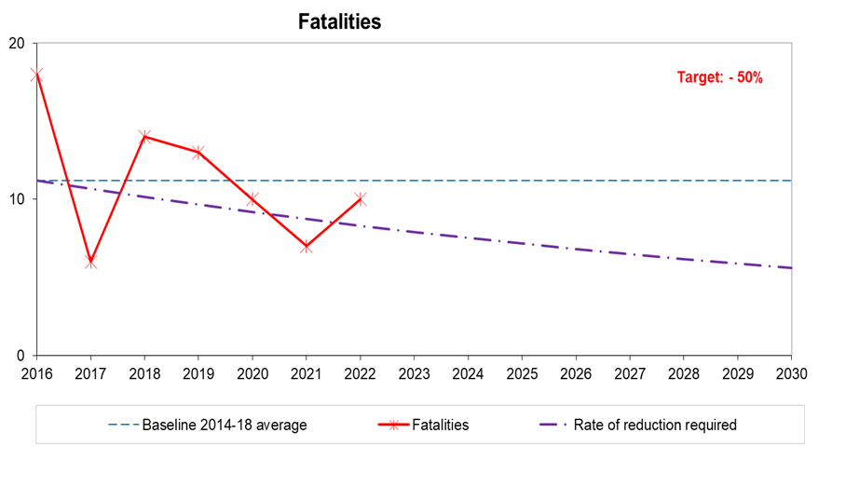
Source: South Lanarkshire Council
Figure 10.2: All serious casualties in South Lanarkshire, 2016 – 2022
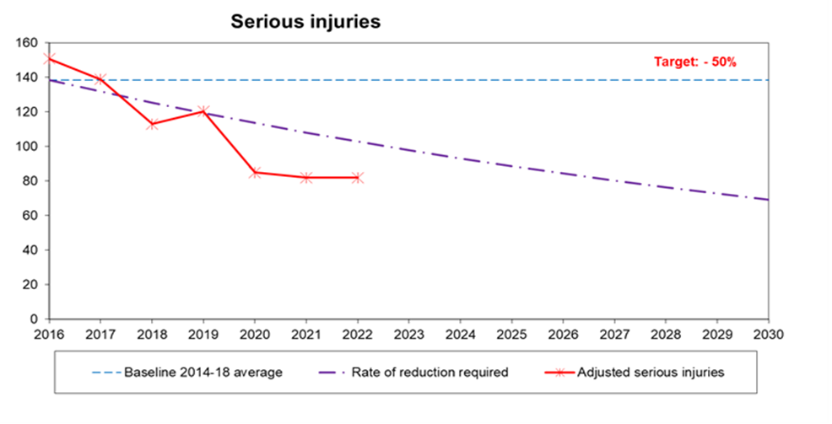
Source: South Lanarkshire Council
Figure 10.3: Child under 16 fatal casualties in South Lanarkshire, 2016 – 2022
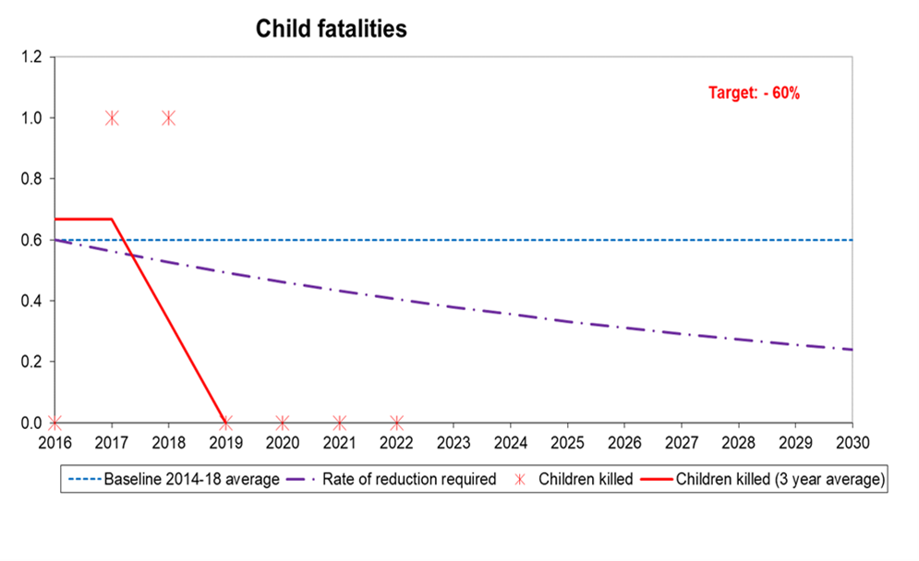
Source: South Lanarkshire Council

Figure 10.4: Child under 16 serious casualties in South Lanarkshire, 2016 – 2022
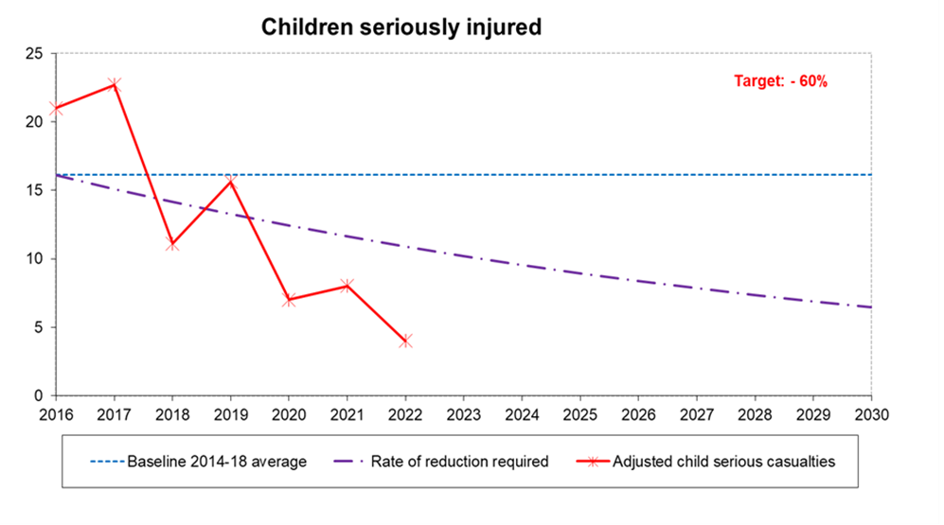
Source: South Lanarkshire Council

The graphs show the progress in lowering casualties across all severities and categories when compared to the 2014 to 2018 average baselines. The council is making progress towards the 2030 targets. However, these targets are challenging and our future policies must, therefore, continue to strive to reduce casualty numbers.
The Scottish Government has published Scotland’s Road Safety Framework to 2030 and an ambitious long term goal where no-one is seriously injured or killed on our roads by 2050. In addition to the four headline targets above, the Framework has placed focus on reducing killed or seriously injured casualties within the following modes of travel and age groups: pedestrians, cyclists, motorcyclists, road users aged 70 years and over and road uses aged between 17 to 25 years. These will be considered within the council’s accident investigation processes.

10.6 Public transport
Buses are the most important form of public transport in South Lanarkshire in terms of the number of passengers who use them. They are crucial to increase social inclusion through transportation. They are vitally important for people, especially those with no access to a car at the time they make the journey to get to the jobs and services they need. Unfortunately, the increase in car use has not only led to reduced numbers of bus passengers but the resultant congestion has also made bus journeys longer and less predictable.

Services are at their most frequent and buses of the best quality on the corridors into Glasgow. They are less frequent and convenient on links between the towns in South Lanarkshire and also for trips around the residential areas of larger towns such as East Kilbride. In rural areas there are often only infrequent bus services on the main routes.

Buses are not provided by the council. Instead, most services are operated by private companies who receive no direct subsidy from the Government and so have to make a profit. The companies decide when and where buses run and the fares. Where a bus is not provided by a private company and a service is seen as socially necessary, one could be secured through subsidy from Strathclyde Partnership for Transport (SPT) but they only have limited funds to do this. They have to decide how to fund such services all over Strathclyde which means that they cannot fund all the bus services that people in South Lanarkshire require.
The National Concessionary Travel Scheme for older and disabled people was rolled out across Scotland in April 2006. The scheme enables individuals aged 60 years and over, or those with an eligible disability, to travel free on buses across Scotland using a valid National Entitlement Card. In 2022, 91,844 passes have been issued in South Lanarkshire.

On 31 January 2022, the new Young Persons’ Free Bus Travel Scheme was launched which provides free bus travel for everyone living in Scotland aged between 5 and 21 years. Since its launch, 32,094 passes have been issued in South Lanarkshire.

In South Lanarkshire, the rail network is based on two main lines; Glasgow to London (the West Coast Main Line) and Glasgow to Edinburgh via Carstairs. There are also local lines from Glasgow to East Kilbride and Motherwell, Lanark and Larkhall via Hamilton, as well as the Cathcart Circle. In total there is 120 km of track and, apart from nine kilometres to East Kilbride, the entire track is electrified. South Lanarkshire has 19 railway stations, 17 of which have associated park and ride facilities and 5 offer bus and rail inter-links and many more have bus stops nearby. In 2021, an additional 257 spaces were introduced at the newly constructed Cambuslang Park and Ride and in 2022 a further 31 spaces were introduced as Phase 1 of the Lanark Park and Ride. As of June 2023, there are a total of 2,997 park and ride spaces, an increase of 400% on April 1994, when there were 599 spaces.

The bus patronage figures published in the Scottish Transport Statistics indicate a fall of 34.6% in the ten years between 2008/09 and 2019/20, 13% in the five years between 2014/15 and 2019/20 and 5% in the one year between 2018/19 and 2019/20.

Between 2019/20 and 2020/21 there was a 62% fall in bus patronage. This includes the period following the Government’s announcement of measures to limit the impact and transmission of Covid19 in mid-March 2020. Bus passenger journeys decreased following advice against all unnecessary travel. In 2021/22, bus patronage increased by 71% as the country recovered from the Covid19 pandemic.

It should be noted that this data covers the South West and Strathclyde area which also includes Dumfries and Galloway. Robust data at a South Lanarkshire area level is unavailable.

There is evidence that substantially more South Lanarkshire residents are travelling by train. The Office of Rail Regulation compiles a list of the number of passengers using railway stations in South Lanarkshire (Table 10.2).

Table 10.2: Rail patronage for all South Lanarkshire Stations (entries/exits)
Station | 2021/ 2022 | 2020/ 2021 | 2019/ 2020 | 2018/ 2019 | 2017/  2018 | 2016/  2017 | 2015/  2016
Blantyre | 234,322 | 64,912 | 515,938 | 511,822 | 551,508 | 567,570 | 610,730
Burnside | 132,112 | 30,194 | 263,304 | 272,764 | 282,282 | 276,012 | 270,746
Cambuslang | 443,054 | 165,944 | 769,008 | 758,836 | 850,510 | 806,638 | 774,352
Carluke | 154,426 | 35,624 | 399,962 | 405,328 | 420,170 | 428,140 | 396,046
Carstairs | 6,986 | 4,138 | 60,948 | 62,376 | 84,166 | 95,864 | 84,796
Chatelherault | 45,960 | 13,102 | 114,042 | 108,456 | 111,076 | 105,464 | 85,898
Croftfoot | 145,018 | 56,688 | 269,538 | 258,692 | 256,420 | 299,346 | 219,538
East Kilbride | 445,832 | 134,146 | 991,900 | 1,055,414 | 1,031,100 | 1,020,364 | 1,136,980
Hairmyres | 309,320 | 97,650 | 655,570 | 673,386 | 647,622 | 640,866 | 719,260
Hamilton Central | 378,966 | 103,426 | 757,450 | 756,528 | 811,104 | 847,474 | 825,176
Hamilton West | 344,710 | 91,530 | 775,536 | 774,500 | 866,144 | 921,250 | 935,000
Kirkhill | 38,876 | 5,950 | 71,430 | 78,116 | 69,104 | 72,854 | 76,068
Lanark | 143,656 | 30,996 | 279,864 | 292,294 | 303,834 | 328,034 | 306,236
Larkhall | 151,558 | 32,382 | 354,144 | 354,604 | 385,942 | 434,494 | 420,366
Merryton | 39,622 | 7,590 | 127,852 | 121,356 | 107,220 | 123,066 | 113,546
Newton | 305,856 | 88,638 | 719,034 | 678,490 | 669,530 | 653,312 | 584,522
Rutherglen | 489,766 | 213,110 | 1,015,208 | 1,027,812 | 1,072,296 | 1,098,300 | 1,110,088
Thorntonhall | 11,130 | 3,098 | 24,034 | 22,026 | 21,310 | 16,748 | 19,094
Uddingston | 408,504 | 138,094 | 863,522 | 898,176 | 888,052 | 876,000 | 826,694
Total | 4,229,674 | 1,317,212 | 9,028,284 | 9,110,976 | 9,429,390 | 9,541,795 | 9,515,136
Source: Office of Rail Regulation

Table 10.2: Rail patronage for all South Lanarkshire Stations (entries/exits) (continued)
Station | 2014/  2015 | 2013/  2014 | 2012/ 2013 | 2011/  2012 | 2008/  2009 | 2005/  2006 | 2002/ 2003
Blantyre | 623,058 | 602,544 | 560,532 | 527,094 | 460,462 | 340,118 | 207,174
Burnside | 275,500 | 270,748 | 318,628 | 337,054 | 309,398 | 273,199 | 249,715
Cambuslang | 750,022 | 716,608 | 777,400 | 757,576 | 660,234 | 557,494 | 419,258
Carluke | 392,812 | 369,582 | 345,766 | 328,270 | 291,128 | 253,635 | 189,146
Carstairs | 43,388 | 33,398 | 20,610 | 13,548 | 13,860 | 14,589 | 9,407
Chatelherault | 74,934 | 66,948 | 62,526 | 59,538 | 40,958 | 3,763 | 0
Croftfoot | 207,322 | 194,964 | 196,202 | 188,794 | 161,094 | 139,821 | 116,041
East Kilbride | 1,153,648 | 1,079,531 | 988,832 | 985,456 | 879,678 | 730,105 | 579920
Hairmyres | 727,414 | 692,092 | 569,386 | 542,390 | 478,732 | 334,077 | 218,263
Hamilton Central | 847,790 | 815,322 | 892,228 | 873,178 | 815,296 | 671,803 | 482,025
Hamilton West | 946,210 | 904,785 | 885,286 | 845,188 | 739,282 | 593,672 | 375,474
Kirkhill | 74,922 | 76,282 | 88,316 | 91,828 | 92,426 | 93,651 | 81,056
Lanark | 328,890 | 304,640 | 337,896 | 350,014 | 342,050 | 278,915 | 218,994
Larkhall | 420,130 | 406,074 | 342,704 | 327,070 | 334,308 | 0 | 0
Merryton | 116,234 | 111,384 | 113,088 | 106,308 | 99,506 | 19,998 | 0
Newton | 569,006 | 505,286 | 523,554 | 515,760 | 425,634 | 336,806 | 179,094
Rutherglen | 1,073,392 | 1,030,290 | 977,418 | 894,434 | 711,480 | 526,337 | 308,164
Thorntonhall | 18,314 | 18,394 | 21,624 | 19,348 | 19,654 | 14,961 | 13,444
Uddingston | 819,576 | 769,654 | 784,600 | 7695,18 | 723,332 | 580,677 | 446,373
Total | 9,463,102 | 8,968,526 | 8,806,596 | 8,532,366 | 7,598,512 | 5,763,621 | 4,093,548
Source: Office of Rail Regulation

Rail patronage in South Lanarkshire increased by more than 5.4 million journeys between 2002/2003 and 2016/2017, an increase of 133%. The notable increase to 2016/2017 indicates that the policies and investment, for example, park and ride by the council and its partners such as SPT, Scotrail and Network Rail are having a significant impact in encouraging more people to travel by train with the subsequent benefits for the environment. However, there was a slight decrease in 2017/2018, with this downward trend continuing in 2018/2019 and 2019/20.

Evidence of the impact of the Covid19 pandemic can be seen in 2020/21 with a decrease in rail patronage of 85% from 2019/20. 2021/22 has seen an increase of 221% as the country recovers from the pandemic and people return to their original working practices. However, the trend for working from home has continued into 2021/22 and is evident in the figures.

10.7 Active travel
Walking and cycling are the most sustainable forms of transport and can also be enjoyable leisure activities. It is also a crucial form of access to public transport. A high proportion of journeys in South Lanarkshire are made on foot. South Lanarkshire Council maintains an extensive path and footway network but there are limited opportunities for walking and cycling between communities, especially in the rural areas.

The council’s Outdoor Access Strategy supports the core paths network and aims to expand a path network throughout the area, focussing specifically on both recreational and functional use by walkers, cyclists and equestrians and those seeking to access water bodies.

In 2013, Cycling Scotland published their National Assessment of Local Authority Cycling Policy in which they promoted the establishment of Cycling Partnerships. The South Lanarkshire Cycling Partnership was formed in January 2014 to ensure that partners could maximise the benefits cycling can bring to the area’s residents. Alongside this, the council implemented its Cycling Strategy for South Lanarkshire 2015 – 2020 (extended to 2023) which accords with key aims within the Scottish Government’s Cycle Action Plan for Scotland and latterly the Cycling Delivery Plan for Scotland. The new forthcoming South Lanarkshire Transport Strategy will encompass the Cycling Strategy and set out aims to 2034.

Information on walking and cycling is collected biennially in South Lanarkshire for the Scottish Household Survey. The 2007/2008 baseline data is shown in Table 10.3, along with information from previous years.

Table 10.3: People who walk or cycle as main mode of transport (%)
Mode | 1999/ 2000 | 2003/  2004 | 2005/  2006 | 2007/ 2008 | 2009/ 2010 | 2011/ 2012
Walking | 16 | 12 | 10 | 19 | 13 | 23
Bicycle | 0 | 0 | 0 | 0 | 0 | 1
Mode | 2013/  2014 | 2015/  2016 | 2017/  2018 | 2019/  2020 | 2020/  2021 | 2021/ 2022
Walking | 19 | 14 | 17 | 17 | * | 20
Bicycle | 1 | 0 | 0.5 | 1 | * | 0
*Data not available
Source: Scottish Household Survey

There may appear to be a substantial increase in the percentage of people walking since 2007/ 2008. However, prior to 2007, only journeys over a quarter of a mile or five minutes on foot were recorded. Since 2007 all journey lengths are recorded. There has been a decline in walking since 2011/2012, however, a slight improvement was noted in 2017/2018. There has been a slight increase in the number of people cycling in 2019/20. In 2021, there was a decline in people cycling as their main mode of transport, however, there has been a 3% increase in people walking in the same year.

It should be noted that due to the Covid19 pandemic, all face-to-face interviewing for the Scottish Household Survey was suspended and replaced with telephone/video interviewing for both the 2020 and 2021 surveys. As a consequence, the results from 2020 and 2021 are not directly comparable to results from previous years.

Path use
User counters have been installed across several of the key path and cycle networks within South Lanarkshire. The data is collected using either pressure sensitive pads or induction loops installed within the path surface or beam splitter counters which record the number of pedestrians or cyclists passing. As the data recorded includes the time and date during which a count is made it allows the information to be analysed in a number of ways including hourly, daily, monthly or yearly. As well as the absolute number of users at a particular location it is useful to see seasonal variations and annual trends in the level of path usage.

Table 10.4 provides a summary of the level of use of sections of the path network at various locations across South Lanarkshire, including new counters added during 2020. Based on the data available it appears that access activity has generally remained steady over recent years. However, it is notable that there was a significant increase in usage in some popular locations like country parks, probably due to local people enjoying their local greenspace and open spaces during lockdown. Anecdotal evidence through observations also indicates that the level of cycle use for both recreational and function access, such as short trips to local shops also increased significantly over the lockdown period. Due to technical issues, data is unavailable for years 2019, 2021 and 2022.

Table 10.4: Summary of path network use
Path network | 2014 | 2015 | 2016 | 2017 | 2018 | 2020
Clyde Walkway - Rosebank | - | 16,500 | 10,000 | 9,000 | 6,000  (Jan – Nov) | 12,000  (August 20 – May 21)
Clyde Walkway - Crossford | 27,500 | 44,000 | 42,500 | 23,500 | 35,500 | 48,000  (August 20 – May 21)
Clyde Walkway – West Brownlee | 7,500 | 12,000 | 9,500 | 3,000  (Jan – Mar) | 11,000  (June – Dec) | -
Falls of Clyde - Reserve entrance, New Lanark | 84,000 | 99,500 | 111,500 | - | - | -
Falls of Clyde – Bonnington Linn | 9,000 | 10,000 | 8,500 | 5,500  (Jan – Oct) | - | -
Falls of Clyde –  Corra Linn | 25,500 | 27,000 | 27,000 | 38,000  (Jan – Oct) | - | -
The Kerse, Lesmahagow | 3,000  (July – Dec) | 18,500 | 66,000 | - | - | -
Chatelherault – Riccarton Path | 66,500 | 68,500 | 61,500 | 66,000 | - | 71,000  (June 20 – May 21)
Chatelherault – Old Avon Bridge (NCR 74) | 83,000 | 90,000 | 64,500 | 38,500  (Jan – July) | - | -
Chatelherault – Sunnyside Path | 17,000 | 31,000 | 26,500 | 30,000 | 39,000 | 42,000  (June 20 -June 21)
Morgan Glen –  Avon Road entrance | 14,000 | 97,000 | 16,000 | 12,500 | - | 21,000  (April 20 – May 21)
Morgan Glen –  Millheugh entrance | 23,000 | 13,000 | 16,000 | 11,500 | 25,000 | 33,000  (April 20 – May 21)
Braidwood | 6,500  (July – Dec) | 40,500 | 36,500 | 27,000 | 21,500 | 27,000  (August 20 – June 21)
Lower Nethan Reserve (Crossford) | - | - | 2,500  (June – Dec) | 4,500 | 5,000 | 5,000  (August 20 – June 21)
North Haugh (NCR 74) Strathclyde Park entrance | 91,000 | 46,500 | 77,500 | 81,000 | - | -
Redlees Park, Blantyre | 8,000 | 19,000 | 25,000 | 17,000 | 18,500 | 28,000  (Nov 20 – July 21)
Langlands Moss LNR,  East Kilbride | 25,500 | 27,000 | 23,500 | 12,500  (Jan – Aug) | 9,000  (Apr – Dec) | -
Ashgill Path, Ashgill | - | - | 4,000  (May – Dec) | 5,500 | 6,000 | 7,000  (June 20 – May 21)
Clatty Brae, Rosebank | - | - | 1,000 (May – Dec) | 1,000 | 1,000 | -
Goose Pond, South Haugh, Hamilton | - | - | 26,500  (Apr – Dec) | 32,000 | 37,000 | 26,000  (June 20 – June 21)
Law | - | - | 7,000  (May – Dec) | 12,000 | 14,000 | 11,000  (Aug 20 – June 21)
The Ditches, Nemphlar | - | - | 1,500  (June – Dec) | 3,000 | 3,000 | 3,000  (Aug 20 – June 21)
Calderglen Country Park* | 910,000 | 896,500 | 1,069,500 | 986,500 | 1,006,500 | -
Whitelee Windfarm | 51,500 | 47,000 | 42,000 | 104,000 | 99,500 | -
Cambuslang Park | 158,500 | 153,500 | 170,000 | 147,500 | 194,000 | 300,000 (June 20 – May 21)
Fernbrae Park – car park | - | - | - | - | - | 60,000 (July 20 – May 21)
Fernbrae Park – Burnside Road | - | - | - | - | - | 58,000 (July 20 – May 21)
Fernbrae Park – Glenlyon | - | - | - | - | - | 27,000 (July 20 – May 21)
Fernbrae Park – Viewpoint | - | - | - | - | - | 15,000 (July 20 – May 21)
Fernbrae Park – Cathkin Steps | - | - | - | - | - | 20,000 (July 20 – May 21)
Tinto Hill | - | - | - | - | - | 25,000  (Dec 20 – June 21)
Glen Esk, East Kilbride – new houses | - | - | - | - | - | 22,000  (Oct 20 – July 21)
Glen Esk 1, East Kilbride | - | - | - | - | - | 37,000  (Oct 20 – July 21)
Glen Esk 2,  East Kilbride | - | - | - | - | - | 64,000  (Oct 20 – July 21)
Galloway Road,  East Kilbride | - | - | - | - | - | 24,000  (Oct 20 – July 21)
Lothian Road,  East Kilbride | - | - | - | - | - | 42,000  (Oct 20 – July 21)
Notes: Figures rounded to the nearest 500. Data gaps due to equipment malfunctioning or counters being moved or becoming inactive. No data available for years 2019, 2021 and 2022. *Visitor numbers to the Park.
Cycling data counts
Both the council’s Local Transport and Cycling strategies include actions relating to the monitoring of cycle routes and lanes. From an initial five monitoring sites established in 2014, further sites have been developed with a total of 48 sites identified by 2020. Table 10.5 provides a summary of the usage of 24 of these sites, located across South Lanarkshire. No further data is available at the time of writing this report.

Table 10.5: Summary of cycling path location and usage
Location | 2014 | 2015 | 2016 | 2017 | 2018 | 2019 | 2020
Pankhurst Road, East Kilbride | 5,173 | 4,406 | 5,188 | 5,581 | 5,141 | 4,924 | 11,199
Ferry Road, Uddingston (west of school) | 8,590 | 8,385 | 8,203 | 8,030 | 8,433 | - | -
B7071, Bothwell Road, Hamilton | 8,095 | 7,395 | 8,568 | 10,082 | - | - | -
A72, Riccarton, Larkhall | 12,992 | 9,817 | 12,864 | 13,545 | - | - | -
A70, South of Hyndford Bridge, Lanark | 1,739 | 1,805 | 2,772 | 1,770 | 1,729 | 1,327 | 2,788
North British Road, Uddingston | - | - | 14,788 | 17,340 | 16,165 | 17,052 | 21,613
A749, North of Nerston, East Kilbride | - | - | 6,048 | 7,252 | 6,881 | 7,181 | 14,322
A724, Dalton, north west of Blantyre (north bound) | - | - | 11,273 | 10,475 | - | - | -
A724, Dalton, north west of Blantyre (south bound) | - | - | 18,912 | 9,595 | - | - | -
A724, Glasgow Road, Cambuslang (north bound) | - | - | 11,820 | 10,946 | 10,629 | 10,060 | 14,120
A724, Glasgow Road, Cambuslang (south bound) | - | - | 7,160 | 8,137 | - | - | -
A730, Glasgow Road, Rutherglen | - | - | 26,376 | 31,209 | 32,908 | 36,451 | 37,982
Burnbrae Street, Larkhall (via Fairholm Park) | - | - | 9,344 | 14,394 | 12,735 | 11,374 | 23,206
B7078, Kirkmuirhill to Lesmahagow | - | - | 13,595 | 13,799 | 12,029 | 12,328 | 23,206
Cathkin Relief Road | - | - | - | 4,940 | 5,729 | - | -
Calderwood Road, East Kilbride | - | - | - | 3,683 | 4,441 | 4,644
Main Street, High Blantyre | - | - | - | 6,998 | 6,566 | 6,669 | -
Clyde Walkway, near Blantyrefarm Road, Uddingston | - | - | - | 8,314 | 8,203 | - | -
A724, Glasgow Road, East of Blantyre | - | - | - | 13,099 | 11,114 | - | -
A724, Clydesford Road, Cambuslang, (south bound) | - | - | - | 10,242 | 10,027 | 9,798 | -
A724, Clydesford Road, Cambuslang, (north bound) | - | - | - | 11,948 | 11,937 | 12,037 | -
A730, Mill Street, Rutherglen, (south bound) | - | - | - | 2,646 | - | - | -
B7078, Auldton, South of Lesmahagow | - | - | - | 11,958 | - | - | -
B7078, Cairnhouse, South of Coalburn | - | - | - | 12,517 | - | 12,192 | -

Cycling activity
The various restrictions in place during Covid19 resulted in travel patterns and peoples’ leisure activities altering. Cycling, in particular, increased during the pandemic. Daily flow data from a selection of the council’s cycle monitoring sites operational during the pandemic period was collated for 2021 and compared to the cycle flows from 2019 and 2020 (Figure 10.5).

Figure 10.5: Cycling activity before and during Covid19 pandemic

Source: South Lanarkshire Council

Cycle trips increased significantly at these sites during the pandemic period, particularly over spring, summer and autumn. Even during November and December the number of cycling trips remained higher in 2020 than in 2019 at most sites. In 2021, the number of cycle trips remained higher than in 2019, however, there was a slight reduction when compared to 2020 at most locations. Daily fluctuations were generally associated with weather conditions, with the higher flows corelating to warmer and drier days and conversely lower flows where inclement weather was experienced.

As lockdown restrictions changed over time, travel trends also changed. It is evident from the annual data that more people were cycling in 2020 when compared to 2019 despite people having settled into alternative work patterns as well as periods when travel to educational establishments was also affected. This trend continued into the first half of 2021.

The assessment of daily flow characteristics indicates that the time of day people were cycling shifted when compared to pre and post restrictions. Commuting was the predominant feature at some sites, such as the A730 Cambuslang Road, and this had a predominant flow occurring over peak periods between 7 am and 9 am and 4 pm and 6 pm. However, the distribution of cycle trips remains very similar. The flows remain at similar levels while other sites show a more significant increase when compared to 2019.

Analysis also considered locations where leisure cycle pursuits are more prominent at sites such as at Hyndford Bridge, near Lanark. Cycle trip volume more than doubled in 2020 and 2021 when compared to 2019 and for this type of leisure use, the period through the day which people cycle is longer. Previously, predominant flows were generally in the morning, however, the number of people cycling outwith that period had also increased.

The data indicates that more cycle trips were taking place within South Lanarkshire and it is considered this may be associated with leisure or shopping activity, depending on location. While the long-term effects of the pandemic are unknown, cycling is clearly an attractive and emerging different mode of transport for some.

No further data is available at the time of writing this report.

Bikeability
Bikeability Scotland training is a free, in-school programme, supported by a network of qualified instructors who are often teachers, parents and members of the local community. Within South Lanarkshire, schools are currently delivering Level 1 and Level 2 training:

- Level 1: Usually delivered in primary 5. Riders learn how to prepare for a journey, check their bike and equipment are safe and develop control skills, good observations and decision making. They also learn the importance of sharing space responsibly with other people. Training is completed in a traffic free setting.

- Level 2: Usually delivered in Primary 6, following a successful demonstration of skills learned at level 1. It takes place on single lane roads with simple junctions and moderate traffic. Riders learn to make good and frequent observations, communicate their intentions clearly to other road users, decide on and use the most suitable riding position, understand priorities on a road and make decisions about when people wait and when people go.

Cycle training fits within the context of the Curriculum for Excellence by supporting specific Health and Wellbeing Experience and Outcomes. Significant Aspects of Learning in Physical Education can also be applied directly to the activity of cycling.

During the school year 2022/2023, 68 schools were committed to Level 1 training. This amounted to 1,754 pupils actively taking part in playground-based training. In the same year, 55 schools were committed to Level 2 training. A further 4 schools undertook Level 2 style training but within a playground setting to 49 pupils. Due to the location of some rural schools, there may be no suitable site to complete on-road training.

In the previous school year 2021/22, 59 schools were committed to Level 1 training providing playground-based training to 1,577 pupils. At the same time, 49 schools were committed to Level 2 and delivered on-road training to 1,365 pupils and a further 9 schools delivered playground-based Level 2 style training to 212 pupils.

Due to the impact of Covid19 restrictions, a larger number of pupils took part in training during 2021/22 who had missed out in previous years. The uptake of Level 2 training within South Lanarkshire schools is specifically encouraged and supported.

10.8 Travel patterns of schoolchildren
The council encourages active travel in schoolchildren as a means of creating a lifelong change in residents’ travel habits through the promotion of school travel plans. The council employs a travel plan co-ordinator to encourage schools to develop and implement school travel plans to encourage more children to walk and cycle to school and to reduce the number of pupils travelling by car.

Fifteen schools had developed travel plans by 2005 and by June 2023 this increased to 78 schools and a further 60 schools had travel plans in development. As part of a national travel study, mode share data was collected from over 22,100 children in September 2021 and over 27,200 children in September 2022, who attended school in South Lanarkshire (Tables 10.6; 10.7; 10.8).

Table 10.6: Primary school pupils’ journey to school
Year | Walk | Cycle | Scooter/ Skate | Park and Stride | Driven | Bus | Taxi | Other | Sample Size
2008 | 49.5% | 2.0% | 0.9% | 5.5% | 29.4% | 10.0% | 2.5% | 0.2% | 18,496
2009 | 45.5% | 1.3% | 0.5% | 9.0% | 31.7% | 9.4% | 2.2% | 0.2% | 17,358
2010 | 45.0% | 2.1% | 0.4% | 10.6% | 31.9% | 7.4% | 2.2% | 0.3% | 17,370
2011 | 45.7% | 1.9% | 0.7% | 10.7% | 29.6% | 9.3% | 2.0% | 0.2% | 20,000
2012 | 44.1% | 2.3% | 1.2% | 9.7% | 29.5% | 11.0% | 2.1% | 0.1% | 19,556
2013 | 43.1% | 3.3% | 3.8% | 9.0% | 26.2% | 12.0% | 2.4% | 0.1% | 20,894
2014 | 41.4% | 3.6% | 3.3% | 9.0% | 26.6% | 13.6% | 2.3% | 0.1% | 20,275
2015 | 40.9% | 4.3% | 3.6% | 9.4% | 29.2% | 9.7% | 2.8% | 0.1% | 20,292
2016 | 40.4% | 3.6% | 3.4% | 10.9% | 29.0% | 10.1% | 2.3% | 0.3% | 21,116
2017 | 40.1% | 3.8% | 4.1% | 11.3% | 30.5% | 8.1% | 2.1% | 0.1% | 18,838
2018 | 38.2% | 3.8% | 2.7% | 12.0% | 32.6% | 8.1% | 2.4% | 0.2% | 17,897
2019 | 36.2% | 4.5% | 3.0% | 11.0% | 35.7% | 7.3% | 2.2% | 0.1% | 18,887
2020 | 40.9% | 4.4% | 3.0% | 10.5% | 32.3% | 6.3% | * | * | 12,270
2021 | 40.6% | 4.3% | 3.4% | 10.9% | 32.1% | 6.5% | 2.1% | 0.1% | 14,489
2022 | 38.8% | 4.7% | 4.1% | 10.9% | 32.6% | 6.7% | 2.1% | 0.1% | 16,842
* Data not available
Source: South Lanarkshire Council; Sustrans

Table 10.7: Secondary school pupils’ journey to school
Year | Walk | Cycle | Scooter/ Skate | Park and Stride | Driven | Bus | Taxi | Other | Sample Size
2008 | 35.7% | 0.3% | 0.2% | 3.2% | 12.5% | 46.1% | 1.1% | 0.9% | 10,308
2009 | 41.2% | 0.3% | 0.2% | 8.5% | 14.4% | 33.2% | 1.2% | 1.0% | 10,758
2010 | 43.1% | 0.2% | 0.1% | 7.0% | 15.4% | 31.7% | 1.7% | 0.9% | 9,859
2011 | 42.1% | 0.2% | 0.1% | 6.6% | 17.2% | 30.9% | 1.7% | 1.2% | 11,827
2012 | 39.1% | 0.3% | 0.3% | 6.5% | 17.0% | 34.2% | 1.1% | 1.6% | 12,575
2013 | 42.2% | 0.3% | 0.2% | 6.5% | 14.5% | 33.5% | 1.5% | 1.2% | 12,684
2014 | 44.6% | 0.1% | 0.2% | 6.8% | 15.2% | 30.5% | 1.5% | 1.1% | 13,379
2015 | 42.4% | 0.3% | 0.2% | 6.5% | 17.1% | 30.5% | 1.9% | 1.1% | 12,371
2016 | 41.9% | 0.1% | 0.1% | 7.9% | 16.3% | 30.8% | 1.9% | 0.9% | 12,680
2017 | 41.5% | 0.1% | 0.2% | 7.8% | 17.5% | 30.4% | 1.7% | 0.8% | 12,004
2018 | 40.9% | 0.1% | 0.1% | 7.4% | 19.3% | 29.9% | 1.5% | 0.8% | 12,414
2019 | 39.9% | 0.2% | 0.2% | 7.4% | 17.4% | 31.3% | 2.5% | 1.1% | 12,968
2020 | 37.3% | 0.4% | 0.1% | 10.4% | 19.5% | 29.8% | 1.6% | 0.9% | 7,587
2021 | 40.5% | 0.4% | 0.2% | 12.6% | 17.0% | 26.3% | 1.6% | 1.2% | 7,596
2022 | 34.9% | 0.2% | 0.1% | 9.7% | 16.5% | 34.1% | 2.7% | 1.7% | 10,322
Source: South Lanarkshire Council; Sustrans

Table 10.8: All school pupils’ journey to school
Year | Walk | Cycle | Scooter/ Skate | Park and Stride | Driven | Bus | Taxi | Other | Sample Size
2008 | 43.7% | 1.4% | 0.7% | 4.7% | 24.3% | 22.9% | 2.0% | 0.5% | 29,398
2009 | 43.2% | 0.9% | 0.4% | 8.7% | 25.6% | 18.7% | 2.0% | 0.5% | 28,605
2010 | 43.2% | 1.4% | 0.2% | 9.2% | 26.6% | 16.5% | 2.3% | 0.5% | 27,968
2011 | 43.6% | 1.2% | 0.5% | 9.1% | 25.4% | 17.7% | 2.1% | 0.5% | 32,425
2012 | 41.0% | 1.5% | 0.8% | 8.3% | 25.3% | 20.4% | 2.1% | 0.7% | 33,081
2013 | 41.8% | 2.2% | 2.4% | 8.0% | 22.3% | 20.3% | 2.5% | 0.5% | 34,347
2014 | 41.7% | 2.2% | 2.0% | 8.1% | 22.7% | 20.5% | 2.2% | 0.5% | 34,467
2015 | 40.5% | 2.7% | 2.3% | 8.2% | 25.2% | 17.9% | 2.7% | 0.5% | 33,503
2016 | 40.0% | 2.2% | 2.1% | 9.6% | 24.8% | 18.1% | 2.4% | 0.7% | 34,646
2017 | 39.6% | 2.3% | 2.5% | 9.8% | 26.1% | 17.1% | 2.3% | 0.4% | 31,714
2018 | 38.4% | 2.3% | 1.6% | 9.9% | 27.7% | 17.4% | 2.4% | 0.4% | 31,118
2019 | 37.6% | 2.8% | 1.9% | 9.5% | 28.2% | 17.0% | 2.5% | 0.5% | 31,917
2020 | 39.4% | 2.8% | 1.9% | 10.5% | 27.4% | 15.7% | 2.0% | 0.4% | 19,891
2021 | 40.4% | 2.9% | 2.3% | 11.5% | 26.9% | 13.4% | 2.1% | 0.5% | 22,148
2022 | 37.3% | 3.0% | 2.6% | 10.4% | 26.4% | 17.0% | 2.6% | 0.7% | 27,235
Source: South Lanarkshire Council; Sustrans

The 2022 survey results demonstrate that walking to school is the most popular mode of transport, with both primary and secondary pupils, with 37.3% of all pupils choosing this method. Park and stride proved popular with primary pupils (10.9%). More primary pupils (8.8%) than secondary pupils (0.3%) travelled to school by cycle or scooter. However, 34.7% of primary pupils and 19.2% of secondary pupils were driven to school (including by taxi). The number of secondary pupils using the bus to commute to school has increased significantly (34.1%) in 2022 compared to previous years. This may be due to the high number of pupils using the Young Persons’ Free Bus Travel Scheme.

It should be noted that the statistics for 2019 - 2020 include the period before and immediately following the Government’s announcement of measures to limit the impact and transmission of Covid19 in mid-March 2020. This resulted in schools being closed which may be reflected in the 2020 data.
If you need this information in another language or format, please contact us to discuss how we can best meet your needs. Phone 0303 123 1015 or email equalities@southlanarkshire.gov.uk

