South Lanarkshire Council

Local Heat and Energy Efficiency Delivery Plan June 2024

Executive Summary

The aim of LHEES is to provide a plan for decarbonising heat in buildings and improving their energy efficiency to meet statutory national targets by 2045. The Delivery Plan sets out how the council will support implementation of the LHEES. It identifies areas to target for low-regrets measures to decarbonise heat in buildings. This is the first LHEES Delivery Plan, and it is focussed mainly on actions for the next five years.

The council has identified three priorities for the first LHEES.

**Priority 1: Reduce heat demand using a fabric first approach** to improve the condition and energy efficiency of housing across all tenures to ensure that poor energy performance is removed as a driver of fuel poverty. The first LHEES Delivery Plan has a strong focus on social housing and mixed-tenure properties, due to the high risk of fuel poverty.

**Priority 2: Transition to zero direct emissions heating systems** in buildings across South Lanarkshire to tackle climate change. The first LHEES Delivery Plan will initially target heating system upgrades in buildings that are already highly suitable for heat pumps, across all housing tenure types.

**2a: South Lanarkshire Council will lead by example by transitioning all council-owned properties to zero direct emissions heating (ZDEH) systems, and no longer installing gas boilers.**

**2b: South Lanarkshire Council will actively support, encourage, and enable owner-occupiers and private sector landlords to retrofit homes.**

**Priority 3: Make greater use of heat networks** as part of the wider just transition to net zero. This Delivery Plan outlines 12 indicative heat network zones which may be suitable for the development of heat networks.

**Delivery of the LHEES**

The implementation of the LHEES will be driven by South Lanarkshire Council and requires a collaborative cross-sectoral approach. A key priority for the delivery of South Lanarkshire’s LHEES is engaging with relevant stakeholders. The council will develop a stakeholder engagement plan to enable collaboration and seek feedback on the LHEES Strategy and Delivery Plan.

**Delivering Heat Networks**

South Lanarkshire Council has categorised heat network opportunities into three priority areas for immediate action, and nine further heat network opportunities. Two of the three priority indicative heat network zones are in the Almada Street area of Hamilton, and the third is in East Kilbride. These are all areas with high heat loads and an existing heat network nearby. A feasibility study has been completed already for Almada Street, Hamilton (Priority Heat Network Zone 1). The council will invest in developing a suitable delivery model for Almada Street heat network with the assistance of expert consultants. For the other indicative heat network zones, the council will review Local Development Plans to assess the viability of these opportunities, and commission detailed feasibility studies.

The further nine heat network opportunities will be considered after the three main clusters. These require a review of any future planned developments to assess the feasibility of a network in the zone.

There are limitations to the data used as part of the LHEES process, particularly the availability of data on non-domestic buildings. The council has committed to undertake Building Assessment Reports (BAR) for all its public buildings to ensure that decision-making and planning is based on the best possible available data. BARs will be prioritised in three priority heat network zones.

**Social housing and mixed-tenure properties**

The council owns 17% of the total housing stock and most of the social housing in South Lanarkshire. This means that the council can lead by example in installing heating and fabric upgrades. Delivery areas for the next five years have been identified to target those areas with the highest risk of fuel poverty. The delivery areas have been identified based on SIMD data. Almost half of Council-owned housing stock falls within SIMD deciles one and two, indicating a high risk of fuel poverty. These delivery areas will allow the council to target its capital programme investment plans in the areas where investment can have the greatest impact for alleviating fuel poverty.

Mixed-tenure buildings have been identified in the LHEES as a priority for delivery. There are a total number of 9,379 properties in mixed-tenure buildings in South Lanarkshire, approximately 6% of the housing stock. For the first LHEES, mixed-tenure buildings where the council is the factor will be prioritised, as well as other blocks containing social housing. This is because social landlords can facilitate the retrofit of multi-occupancy blocks. However, significant external funding is needed to achieve the standards and targets required, which poses a challenge for the social housing sector.

**Private tenure housing**

The council’s approach is to support owner-occupiers and private landlords to meet regulatory standards. South Lanarkshire Council proposes to use data outputs from LHEES to identify suitable clusters of private tenure housing for retrofit. Key characteristics such as construction type, heating systems, EPC and SIMD ratings will be used to develop a short list of clusters for further engagement.

Table of contents

1. Introduction

2. South Lanarkshire’s LHEES

3. Heat Network Delivery Areas

4. Social Housing and Mixed-Tenure Delivery Areas

5. Private Tenure Housing Delivery Areas

6. Non-Domestic Delivery Areas

7. Summary

Introduction

**Purpose of this report**

Local Heat and Energy Efficiency Strategies (LHEES) are at the heart of a place based, locally led, and tailored approach to the heat transition. The aim of LHEES is to provide a long-term and evidence-based plan for decarbonising heat in buildings and improving their energy efficiency across an entire local authority area. LHEES are primarily driven by Scotland’s statutory targets for greenhouse gas emissions reduction and fuel poverty:

* Net zero emissions by 2045 and 75% reduction by 2030
* In 2040, as far as reasonably possible, no household in Scotland is in fuel poverty.

This LHEES Delivery Plan should be considered in conjunction with South Lanarkshire Council’s LHEES Strategy. The Delivery Plan sets out how the council will support implementation of the LHEES. It identifies areas for targeted intervention through early, low-regrets measures to decarbonise heat in buildings. This is the first LHEES Delivery Plan, and it focuses initially on immediate and medium term (5-year) actions.

At this early stage in the LHEES process, many of the actions detailed in this plan are developmental or reflect projects and initiatives which are already underway. The analysis undertaken to date as part of the LHEES process will be further expanded to develop a more detailed and strategic delivery framework. This will form the basis of the next iteration of the LHEES, which will be reviewed annually.

**Delivery Plan layout**

The actions and delivery areas in this Delivery Plan are split into the following sectors:

* **Heat network delivery areas**: outlining the areas in South Lanarkshire with high heat density which may be suitable for heat network development.
* **Social housing and mixed-tenure delivery areas**: The council owns 17% of the total housing stock in South Lanarkshire. This means that the council can lead by example in installing heating and fabric upgrades. The priority actions for this Delivery Plan are to tackle fuel poverty in areas with high levels of deprivation.

**Private tenure housing delivery areas**: this covers both owner-occupied properties and those in the private rental sector. Although there are some unique challenges, opportunities, and regulations for these two tenure types, The council’s approach is to support owner-occupiers and private landlords to meet regulatory standards.

For each chapter, the actions are summarised in a table format shown below. Actions have been prioritised as one of:

* **Immediate:** to be implemented in the next two years.
* **Medium-term:** to be implemented in the next 2-5 years.

**Action**

Action required to implement South Lanarkshire’s LHEES.

**Priority**

Immediate / Medium-term.

**Description**

Additional detail of how the council and its partners will achieve this.

**Responsibility**

Lead responsible for delivery.

1. South Lanarkshire’s LHEES

**LHEES Priorities**

South Lanarkshire Council’s key priorities for this LHEES have been informed by the six LHEES considerations (detailed in the LHEES Strategy), the local policy context, stakeholder engagement, and analysis of the building stock in South Lanarkshire. The council has identified three priorities for the first LHEES.

**Priority 1: Reduce heat demand using a fabric first approach** to improve the condition and energy efficiency of housing across all tenures to ensure that poor energy performance is removed as a driver of fuel poverty. The first LHEES Delivery Plan has a strong focus on social housing and mixed-tenure properties, due to the high risk of fuel poverty.

**Priority 2: Transition to zero direct emissions heating systems** in buildings across South Lanarkshire to tackle climate change. The first LHEES Delivery Plan will initially target heating system upgrades in buildings that are already highly suitable for heat pumps, across all housing tenure types.

The two priorities for transitioning to zero direct emissions heating (ZDEH) systems in South Lanarkshire’s homes are:

**2a: South Lanarkshire Council will lead by example by transitioning all council-owned properties to ZDEH, and no longer installing gas boilers.**

**2b: South Lanarkshire Council will actively support, encourage, and enable owner-occupiers and private sector landlords to retrofit homes.**

**Priority 3: Make greater use of heat networks** as part of the wider just transition to net zero. This Delivery Plan outlines 12 indicative heat network zones which may be suitable for the development of heat networks.

* 1. **Implementation and Governance**

The implementation of the LHEES will be driven by South Lanarkshire Council. The LHEES requires a collaborative cross-sectoral approach, engaging with partners and stakeholders is essential to achieving the goals set out. It will be integrated into existing steering groups and governance structure for sustainable development and climate change.

Within The council, LHEES ‘champions’ will support embedding LHEES delivery into everything that we do. The council has set up an officer working group to take forward the development of the South Lanarkshire LHEES. The membership is made up of at least one representative from each council resource or service who has responsibility for asset or estate management, energy usage or supply. The group includes officers with expertise in economic development, GIS mapping, energy efficiency, and building decarbonisation.

**LHEES Governance**

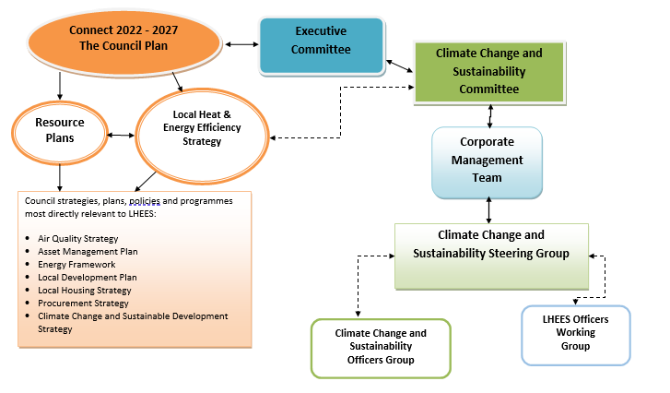

**3.1 Actions:**

|  |  |  |  |
| --- | --- | --- | --- |
| Action | Priority | Description | Responsibility |
| Develop a monitoring and evaluation framework for the LHEES delivery actions | Immediate | For delivery actions, identify the owner and the indicators to be measured. | Executive Director of Housing and Technical Resources |
| Annual review of both Strategy and Delivery Plan | Immediate | Update and amend both documents considering regulatory changes. Identify local targets. | Executive Director of Housing and Technical Resources |

**Engagement**

The LHEES Strategy and Delivery Plan have been developed in consultation with stakeholders across South Lanarkshire, and through the public engagement strategy. Implementation will also be a collaborative effort.

A key priority for the delivery of the LHEES is for the council to develop a stakeholder engagement plan. This will draw on the stakeholder identification and mapping work which took place as part of the LHEES development. Key stakeholder groups that the council will work with include:

* Local community groups
* Public sector partners
* Housing providers
* Delivery partners
* Electricity and gas network operators
* Local businesses
* Advice organisations

|  |  |  |  |
| --- | --- | --- | --- |
| Action | Priority | Description | Responsibility |
| Further develop and implement stakeholder engagement programme to support implementation of the first LHEES Delivery Plan | Immediate | Based on the stakeholder identification work undertaken as part of the LHEES Strategy development, The council will work with key stakeholders to progress the actions detailed in chapters 3 - 6. | Executive Director of Housing and Technical Resources |

1. Heat Network Delivery Areas

**Heat Networks (Scotland) Act 2021**

Section 47 of the Heat Networks (Scotland) Act 2021 places a duty on the local authority to review heat network zoning in their area. The areas in South Lanarkshire have been reviewed and those areas identified in sections 3.2 and 3.3 are considered as potentially suitable for the construction and operation of a heat network.

**Priority Heat Network Zones**

There are three priority indicative heat network zones in South Lanarkshire, two are in the Almada Street area of Hamilton, and the third is in Towers, East Kilbride. For a detailed insight into the methodology for heat network identification, refer to Appendix D of the Strategy Document.

**Heat Network Zone 1: Almada Street, Hamilton**

The Almada indicative heat network zone has an area of 865,998 m2. Within the outlined zone there are seven buildings registering a total estimated annual heat demand of 18,515 MWh/yr. There is a high heat density within this cluster with pockets of high heat demand (above 150 kWh/m²/yr.) which neighbour areas of lower heat demand (50-150 kWh/m²/yr.).

Key anchor loads include the First Endeavour new build housing development site, Hamilton Water Palace, Almada Street Council Headquarters and Holy Cross High School. There are six existing natural gas fuelled heat networks (one still in development at the time of writing) either overlapping a large extent of the indicative heat network zone or neighbouring it. This offers considerable potential for network expansion.

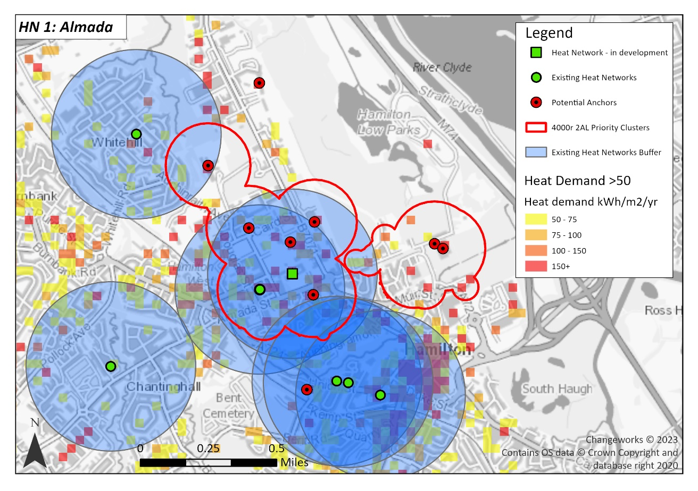Figure 1: Indicative Heat Network Zones 1 and 2: Almada Street, Hamilton.

Priority clusters have been identified based on a 4,000 kWh/yr/m linear heat density (a means of relating annual heat demand to a distance), while a 500m buffer around existing heat network approximates the area within which heat serves.

With support from the Scottish Government Heat Network Support Unit, a feasibility study has already been conducted for this site. A key driver for the investigation of this heat network is the age and condition of the existing heating system in the council headquarters buildings. This heating system is outdated and in need of replacement to decarbonise. Previous studies have investigated different heating technology options for the building, including gas-fired combined heat and power (CHP) and air source heat pumps (ASHP). However, the proximity of the headquarters to other public / semi-public buildings, with significant heat demands mean that there is an opportunity for a heat network. In addition, these buildings all currently use gas fed boiler systems which require transition to an alternative ZDEH. Development of a heat network in this area would ensure this target is met.

The next step is to develop an Outline Business Case (OBC) to understand the strategic, management, technical, economic, and financial cases for developing a heat network in Hamilton.

Further work is also required to develop an appropriate financial delivery model for the scheme, which will include an outline contractual agreement for the non-council-owned buildings.

Table 1: Breakdown of existing heat networks by proximity and fuel type in Almada

|  |  |  |  |  |
| --- | --- | --- | --- | --- |
| **Name** | **Proximity** | **Description** | **Connections to Buildings** | **Number of Customers** |
| Almada Street | Within the cluster | In development | - | - |
| Almada Street HQ | Within the cluster | Natural gas boiler | 1 | 10 |
| Victoria Court | Intersects cluster top left | Natural gas boiler | 22 | 22 |
| Dewar House | Intersects cluster bottom right | Natural gas boiler | 16 | 16 |
| Brandon House Business Centre | Intersects cluster bottom right | Natural gas boiler | 1 | 19 |
| Woodburn Court | Intersects cluster bottom right | Natural gas boiler | 32 | 32 |

**Heat Network Zone 2: Almada Street Extension**

To the east of the Almada heat network zone is another, albeit smaller, indicative heat network cluster covering an area of 345,273 m2 (see Figure 2). While there are two buildings registering a total heat demand of 4,957 MWh/yr, there is a low density of additional heat loads nearby indicated by the sparse distribution of orange/yellow heat demand rasters (A raster is a matrix of squares, or grid, used as a method of data analysis in GIS. Each cell in the grid contains a value representing information on the cell’s contents.) near the red ones. The key anchor loads include the Hamilton Palace Sports Ground and David Lloyd Gym - Hamilton. There is also an existing gas fuelled heat network that intersects the top left of the cluster. The potential for expanding the heat network zone to include this system will need to be investigated further.

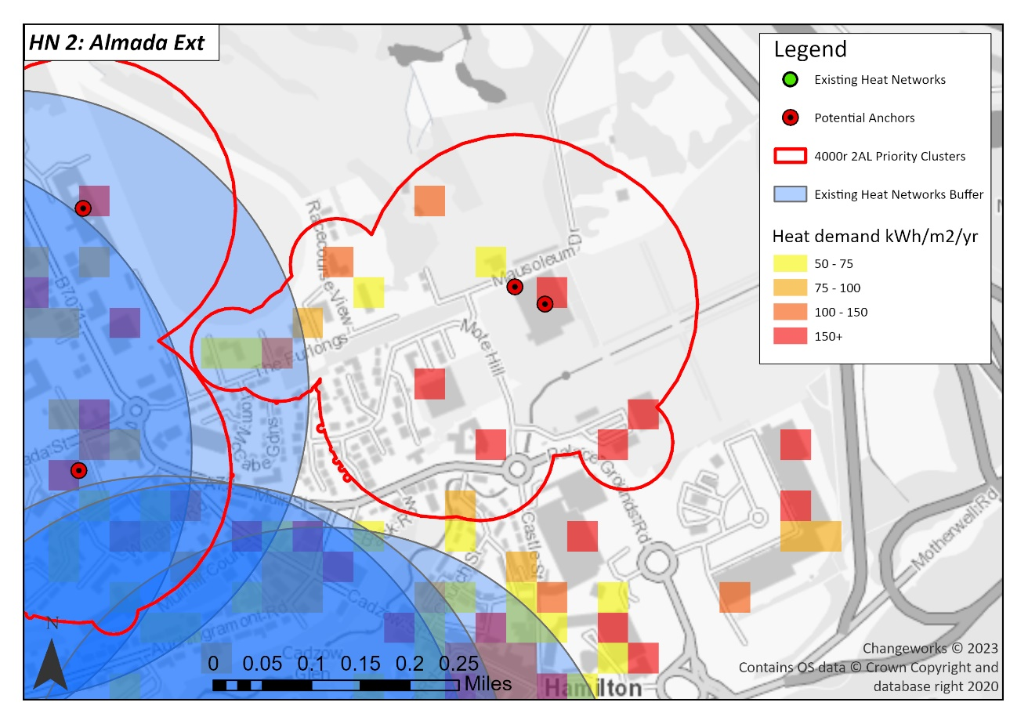

Figure 2: Detail of Indicative Heat Network Zone 2: Almada Street Extension

Table 2: Breakdown of existing heat network by proximity and fuel type in Almada Street

|  |  |  |  |  |
| --- | --- | --- | --- | --- |
| **Name** | **Proximity** | **Description** | **Connections to Buildings** | **Number of customers** |
| Almada Street HQ | Intersects top left cluster | Natural gas boiler | 1 | 10 |

**Heat Network Zone 3: Towers**

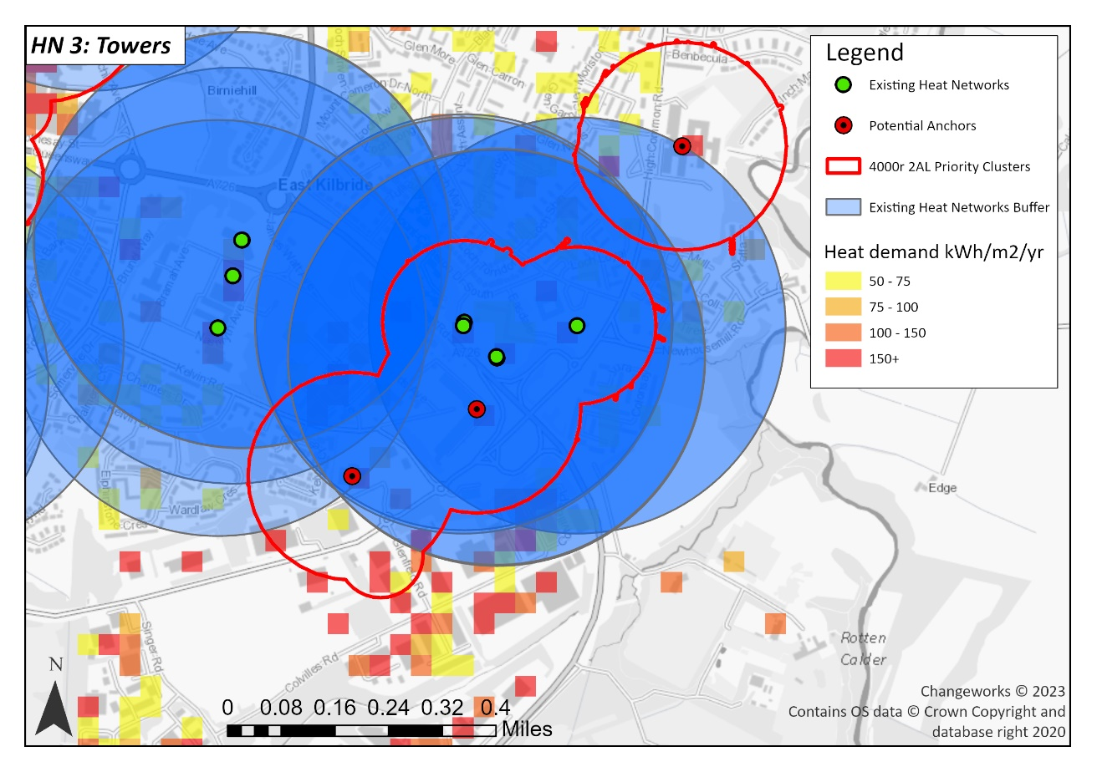The final indicative priority heat network zone identified in Towers has an area of 493,847 m2. There are two key anchor loads including South Lanarkshire College and a Nuffield Health Fitness and Wellbeing Gym registering 2,270 MWh/yr of heat. There are also parts of the cluster which have high heat demands of over 150 kWh/m²/yr. According to the data, there are three gas-fuelled communal heating systems within the cluster. There are a further two existing communal heating systems just outside of the indicative heat network zone, one of which is gas-fuelled, and the other is CHP.

Figure 3: Indicative Heat Network Zone 3: Towers, East Kilbride

Table 3: Breakdown of existing heat networks by proximity and fuel type in Towers, East Kilbride

|  |  |  |  |  |
| --- | --- | --- | --- | --- |
| **Name** | **Proximity** | **Description** | **Connections to Buildings** | **Number of customers** |
| White Cart Tower | Within cluster | Natural gas boiler | 1 | 108 |
| Clyde Tower | Within cluster | Natural gas boiler | 1 | 114 |
| Calder Tower | Within cluster | Natural gas boiler | 1 | 91 |
| James Watt Avenue/Scottish Enterprise Tech Park | Outside cluster | Natural gas boiler | 1 | 30 |
| Nasmyth Building | Outside cluster | CHP plant | 1 | 70 |

**Further Heat Network Opportunities**

The following eight indicative heat network zones have smaller area sizes than the priority three clusters shown above and should be considered as additional opportunities. Further exploration will be required to assess viability of these opportunities. This is likely to include:

* Determining existing system capacity and suitability for expansion
* Site inspections
* Design considerations such as heat source appraisal (e.g. ASHP, GSHP), energy centre location and layout, grid capacity constraints, pipework distribution routes, operating temperatures, individual building upgrades required (e.g. heat interface unit installation)
* Economic analysis to assess commercial viability.
* Funding options
* Stakeholder engagement plan

**Opportunity 1: Hamilton International Technology Park**

This indicative zone in Hamilton Technology Park has a high density of heat demand, as indicated by the large presence of red rasters in Figure 4. One of the anchor loads is the new University of the West of Scotland campus. The council has also recently taken ownership of one of the industrial units in Livingstone Boulevard, which could improve the feasibility of a heat network here. An existing heat network at Kilpatrick House intersects much of the heat network cluster, although its use for heat extraction will need to be further explored.

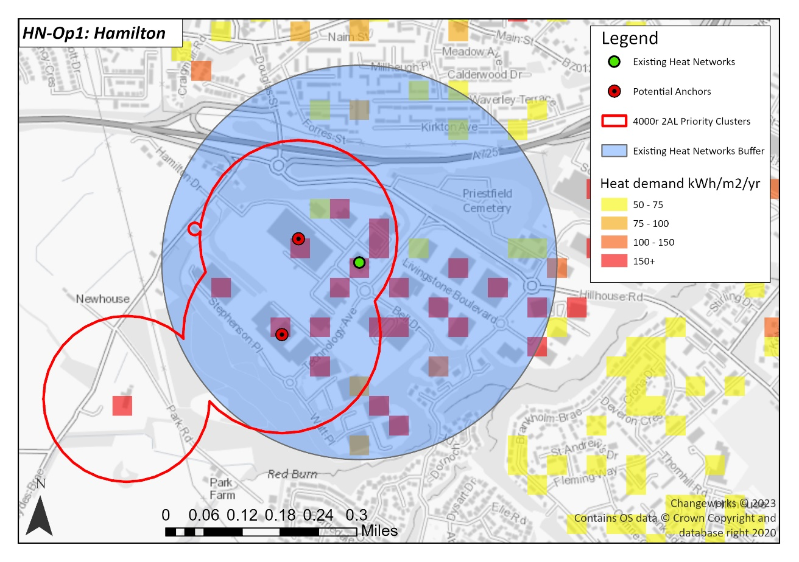

Figure 4: Further heat network opportunity 1 in Hamilton.

Table 4: Breakdown of existing heat networks by proximity and fuel type in Hamilton

|  |  |  |  |  |
| --- | --- | --- | --- | --- |
| **Name** | **Proximity** | **Description** | **Connections to Buildings** | **Number of customers** |
| Kilpatrick House, Hamilton International Park | Within the cluster | Technology "unknown" | 1 | 3 |

**Opportunity 2: East Kilbride Town Centre**

This indicative heat network zone has a high density of heat demand as indicated by the large presence of connecting red rasters in Figure 5. Three existing operational gas-fuelled heat networks (see Table Table 5) intersect the heat network cluster. Further exploration of the viability of development in this indicative zone is required. The next step for assessing the feasibility of this indicative zone is to review the East Kilbride Town Centre masterplan to align a potential heat network with planned future development and assess its commercial viability.

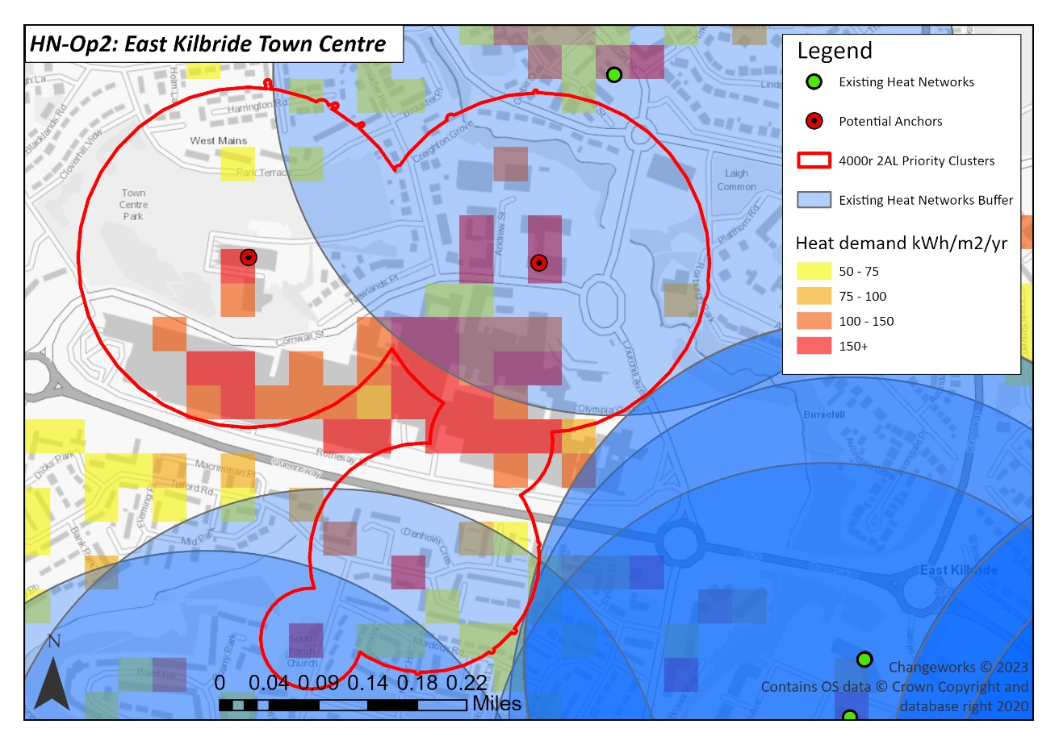

Figure 5: Further heat network opportunity 2 in East Kilbride Town Centre.

Table 5: Breakdown of existing heat networks by proximity and fuel type in East Kilbride Town Centre

| **Name** | **Proximity** | **Description** | **Connections to properties** | **Number of customers** |
| --- | --- | --- | --- | --- |
| Wellbeck House Sheltered Housing | Above cluster | Operational natural gas boiler | - | 14 |
| Deer Park | Intersects bottom of cluster | Natural gas boiler | 1 | 34 |
| Archibald Kelly Court | Intersects bottom of cluster | Natural gas boiler | 24 | 24 |

**Opportunity 3: Carluke**

This heat network cluster has heat demands of over 150 kWh/m²/yr where Carluke High School and Carluke Leisure Centre are situated. There is also a gas-fuelled heat network intersecting much of the outlined heat network zone (see Table 6). Further exploration is required to assess viability of extending the existing heat network, as described at the start of this section.

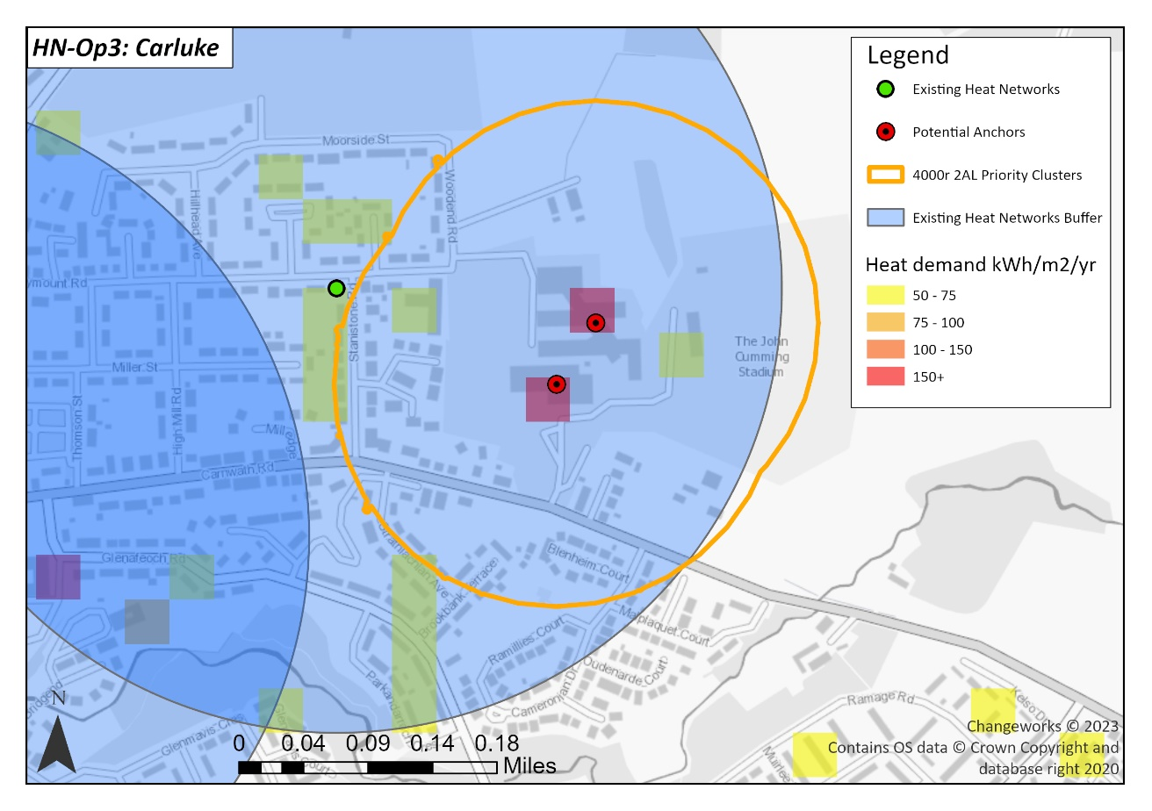

Figure 6: Further heat network opportunity 3 in Carluke.

Table 6: Breakdown of existing heat networks by proximity and fuel type in Carluke

|  |  |  |  |  |
| --- | --- | --- | --- | --- |
| **Name** | **Proximity** | **Description** | **Connections to properties** | **Number of customers** |
| Rosemount Court | Left of cluster | Natural gas boiler | 22 | 22 |

**Opportunity 4: East Kilbride (1)**

This cluster includes a single anchor load, Sanderson High School, in excess of 150kWh/m²yr. There is a gas-fuelled heat network intersecting part of the cluster. To the south there is a priority heat network in Towers. The proximity of this cluster means that it could be considered as part of a wider heat network scheme covering the town centre and neighbouring residential areas within East Kilbride.

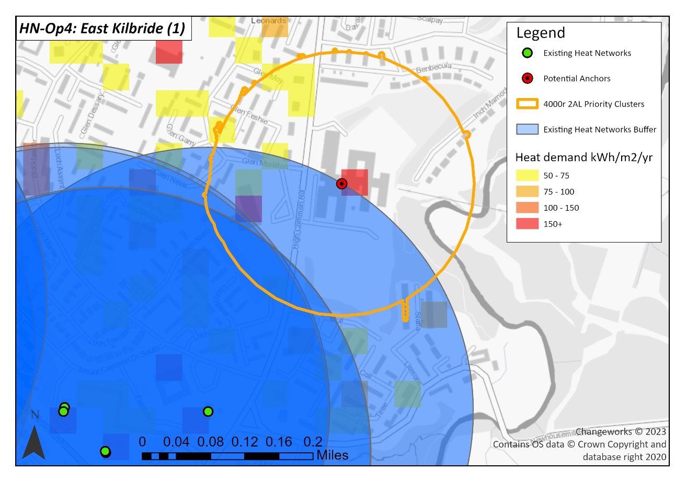

Figure 7: Further heat network opportunity 4 in East Kilbride (1)

Table 7: Breakdown of existing heat networks by proximity and fuel type in East Kilbride (1)

|  |  |  |  |  |
| --- | --- | --- | --- | --- |
| **Name** | **Proximity** | **Description** | **Connections to properties** | **Number of customers** |
| White Cart Tower | Radius intersects bottom of cluster | Natural gas boiler | 108 | 108 |
| Calder Tower | Within cluster | Natural gas boiler | 1 | 91 |
| Clyde Tower | Within cluster | Natural gas boiler | 1 | 114 |

**Opportunity 5: East Kilbride 2**

This indicative zone is a small heat network cluster with low heat density centred around Duncanrig Secondary School currently serving a primarily residential area. Two existing gas-powered heat networks (see Table 8) intersect much of the cluster opportunity providing potential opportunity for expansion of this heat network.

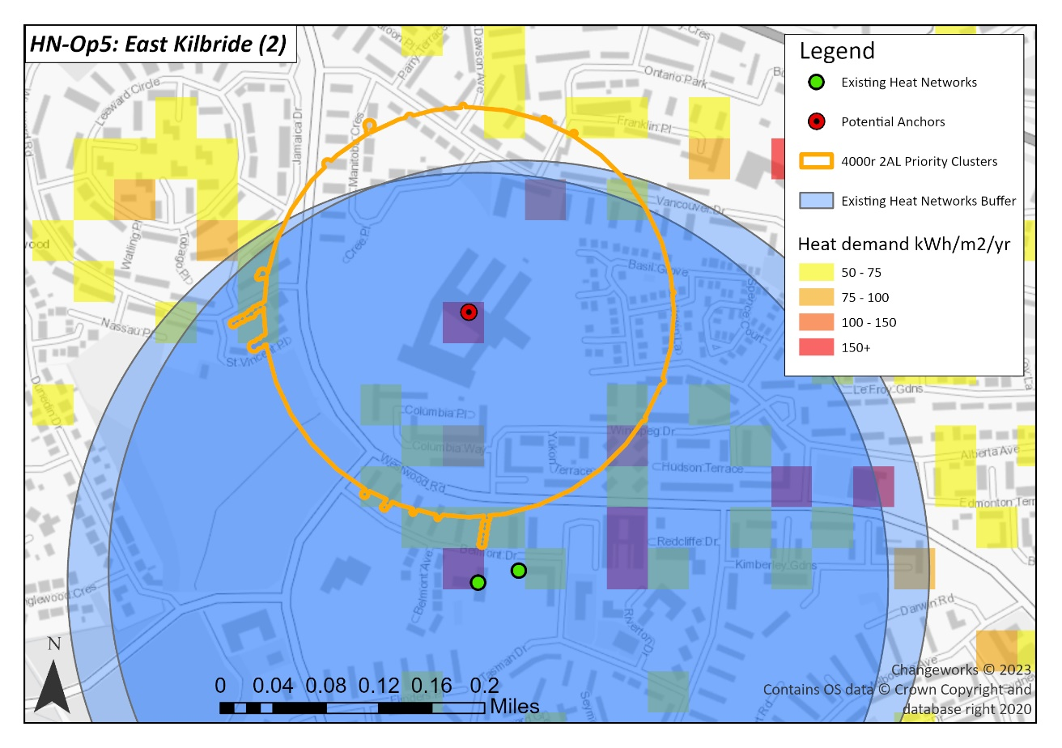

Figure 8: Further heat network opportunity 5 in East Kilbride (2)

Table 8: Breakdown of existing heat networks by proximity and fuel type in East Kilbride (2)

|  |  |  |  |  |
| --- | --- | --- | --- | --- |
| **Name** | **Proximity** | **Description** | **Connections to properties** | **Number of customers** |
| Canberra House | Outwith cluster | Natural gas boiler | 1 | 33 |
| Canberra House Sheltered Housing | Outwith cluster | Natural gas boiler | - | 33 |

**Opportunity 6: Blantyre (Leisure Centre)**

This heat network opportunity cluster has been identified due to its high heat load coming from Blantyre Sports Centre and the Blantyre miners’ welfare indoor bowling club. The cluster has a moderate heat density with high, but non-continuous, heat demands of above 150 kWh/m²/yr. Currently, the cluster serves domestic properties. For this indicative zone South Lanarkshire Council will review the local development plans to assess potential benefit and financial viability of a heat network here in the near future.

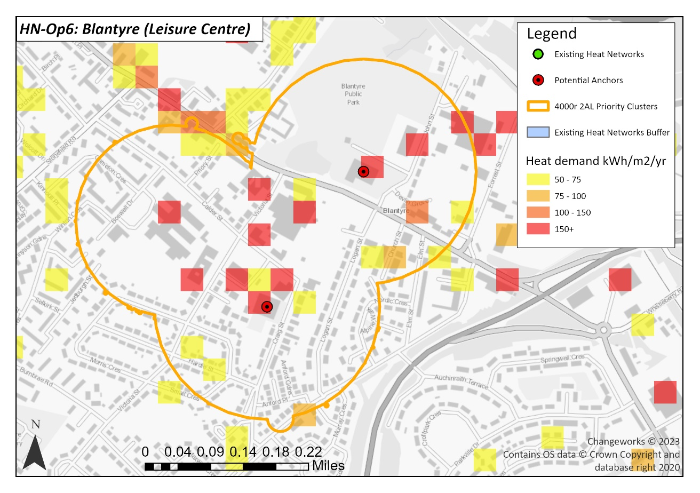

Figure 9: Further heat network opportunity 6 in Blantyre.

**Opportunity 7: East Kilbride (Hairmyres Hospital)**

This small cluster is served by two anchor points within Hairmyres Hospital with very high heat loads of above 500 MWh. However, heat density is low as indicated by the sparse distribution of red rasters. The cluster has potential to serve domestic properties nearby and lower load non-domestic properties. A robust assessment of the business case for heat network development in this area will determine financial viability of the project. Future planned developments in this area will be assessed by the council for heat network connection viability.

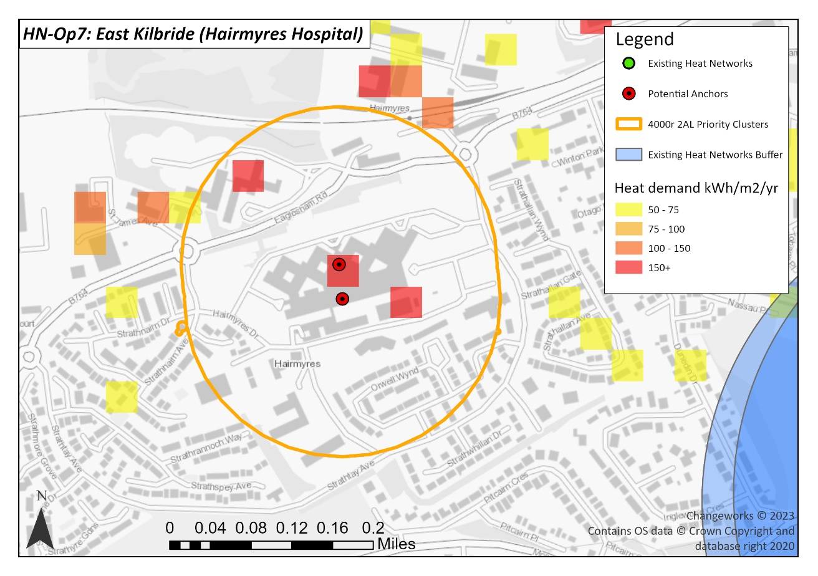

Figure 10: Further heat network opportunity 7 around Hairmyres Hospital

**Opportunity 8: Eastfield (South Lanarkshire Lifestyles Eastfield)**

This cluster is served by South Lanarkshire Lifestyle Eastfield with pockets of high heat demand of above 150 kWh/m²/yr in Trinity High School and Eastfield. The cluster would only serve a small number of domestic properties (247) nearby making financial viability challenging for this cluster. However, future planned development will be assessed by the council to understand the viability of a heat network here.

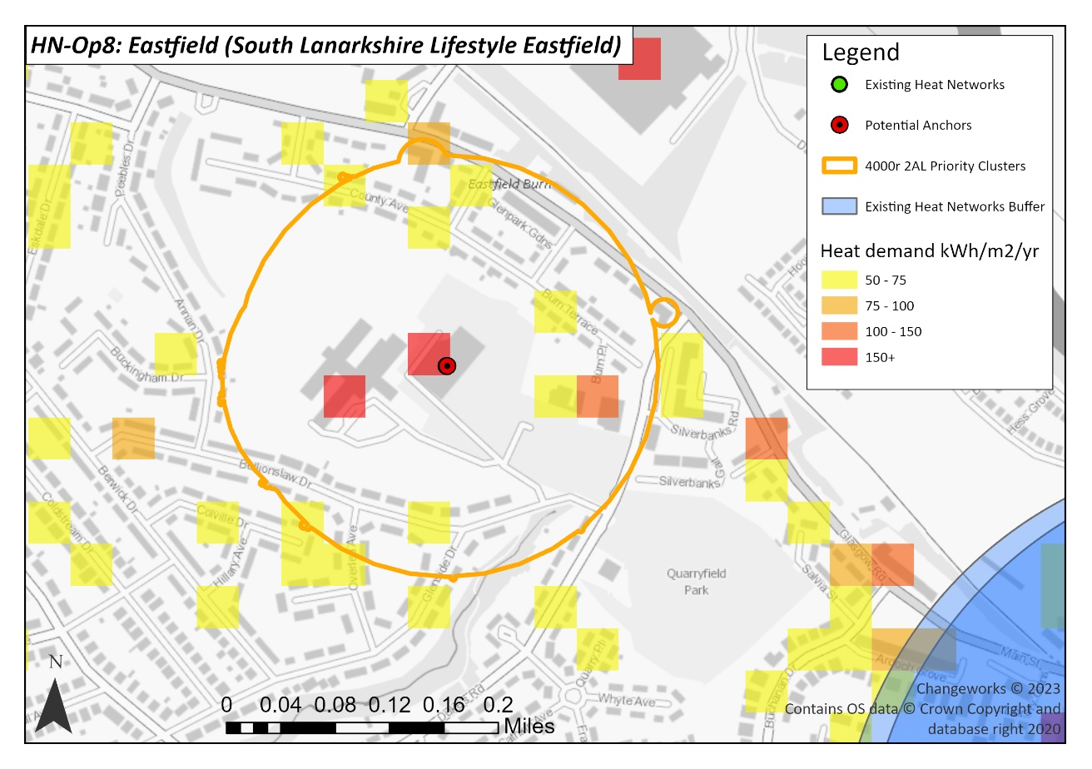

Figure 11: Further heat network opportunity 8 in Eastfield.

**Clyde Gateway D2 Grids Project**

This EU-funded project is a fifth-generation district heat and cold (5GDHC) grid which uses lower temperature. This provides opportunities for using low grade or ambient heat to supply buildings, with low levels of heat loss. This system integrates well with office buildings and there is a pilot project focussed on the proposed developments at Shawfield as part of the Clyde Gateway regeneration. South Lanarkshire Council will review possible extension to the grid to connect properties in South Lanarkshire.

**Summary of Actions for Heat Networks**

|  |  |  |  |
| --- | --- | --- | --- |
| Action | Priority | Description | Responsibility |
| Undertake Building Assessment Reports (BAR) for all council-owned public buildings | Immediate | South Lanarkshire Council will lead by example and undertake BARs for all its public buildings. These will be prioritised in the delivery areas outlined above. | Section Leader (Legislative), Housing and Technical Resources |
| Business Case for Almada Street heat network | Immediate | Progress with Outline Business Case. | Executive Director of Housing and Technical Resources; Heat Network Support Unit |
| Delivery Model for Almada Street heat network developed and approved | Immediate | Develop suitable delivery model for Almada Street heat network. This model may be suitable for future heat network opportunities in South Lanarkshire. | Housing and Technical Resources / Community and Enterprise Resources |
| Conduct feasibility studies for the identified priority heat network zones | Medium-term | Undertake detailed feasibility studies to fully assess the financial and technical viability of 10 indicative heat network zones. (A feasibility study for the Almada Street network is already complete.) | Housing and Technical Resources / Community and Enterprise Resources |
| Review Local Development Plans to assess viability of opportunities | Immediate | Review LDP for future planned development in the identified heat network zones (see 3.3). | Head of Planning and Regulatory Services, Community and Enterprise Resources |
| Designate heat network zones | Medium-term | Once BARs and feasibility studies have been completed these could be designated as zones to give clear opportunities for investment. | Head of Planning and Regulatory Services, Community and Enterprise Resources |

**Funding Heat Networks**

Currently there is an under-developed pipeline of heat network projects across Scotland. The Scottish Government is providing funding to stimulate and accelerate the development and growth of heat networks, as detailed below. Significant investment from the private sector and heat network developers is also required to achieve heat network deployment at the scale required to reach the national targets of 2.6 TWh of heat output by 2027 and 6 TWh of output by 2030.

**Scotland’s** **Heat Network Fund** is designed to support the development and roll out of heat networks across Scotland. It is open to any organisation seeking to develop and deploy heat networks in Scotland. In total £300 million is being made available to stimulate investment and grow the low carbon heat sector. The project must be large scale, deliver emissions reductions, and demonstrate a positive social and economic benefit. Applications can be made for enabling costs, commercialisation costs, and capital costs. The SHNF will only support projects that would not progress without capital grant funding or would not progress to the same scale. Therefore, applicants to the scheme need to clearly demonstrate the how the grant money will be used to expand the project outcomes and provide evidence the value of the grant is appropriate. Up to a maximum of 50% of the total eligible capital costs can be covered through this fund.

**The District Heating Loan Fund** offers low interest unsecured loans of more than £1 million designed to help address the financial and technical barriers to district heating projects. This fund offers an alternative to commercial borrowing which can be expensive and difficult to obtain. Repayment terms are either 10 or 15 years and larger projects above £500,000 will be considered on a case-by-case basis. This scheme is open to local authorities, registered social landlords, small and medium sized enterprises, and energy service companies with fewer than 250 employees.

**The** **Heat Network Support Unit** identifies, supports, and develops heat network projects for the public sector. The support available includes expert advice and grant funding to develop projects until they have a clear financial strategy and well-defined business model. The unit is active in project identification, aggregation, and stakeholder engagement and can support with working group management, stakeholder workshops, and policy linkage and review.

1. Social Housing and Mixed-Tenure Delivery Areas

The actions and delivery areas outlined in this section give an indication of the range of steps required to deliver progress on the LHEES. This includes initial activities such as developing plans to ensure effective prioritisation of retrofit across social rented properties. This section also outlines some area-specific projects at different stages of implementation. As this is a live document, further delivery actions will be identified over the course of the first five-year LHEES delivery phase.

**Priority Delivery Areas**

The delivery areas detailed below have been identified in line with two of South Lanarkshire’s priorities set out in the LHEES Strategy:

**Priority 1: Reduce heat demand using a fabric first approach** to improve the condition and energy efficiency of housing across all tenures to ensure that poor energy performance is removed as a driver of fuel poverty.

**Priority 2: Transition to zero direct emissions heating systems** in buildings across South Lanarkshire to tackle climate change.

**2a:** South Lanarkshire Council will lead by example by transitioning all council-owned properties to ZDEH, and no longer installing gas boilers.

**Targeting fuel poverty**

Analysis has been conducted to identify the areas of South Lanarkshire most at risk of fuel poverty. The results from this analysis will be used by the council to ensure it is effectively prioritising resources to have the greatest impact in tackling fuel poverty. A summary of the analysis findings is provided below:

The Scottish Index for Multiple Deprivation (SIMD) dataset has been used as a proxy to identify fuel poverty within South Lanarkshire. Almost half of the total properties owned by the council fall within the most deprived SIMD deciles (deciles one and two). This illustrates a strong link between the social housing tenure type and areas with high SIMD scores.

With a priority of alleviating fuel poverty, the council has used the LHEES process to investigate areas of high probability of multiple deprivation. Within the social housing sector, the five data zones with highest rates of deprivation (top 20%), have been analysed below in Table :

Table 9: The five data zones with the highest number of social housing properties which are within SIMD deciles 1-2.

|  |  |
| --- | --- |
| **Data zone reference (top 5)** | **Number of properties within SIMD deciles 1-2** |
| Hareleeshill - 01 | 347 |
| Whitlawburn and Greenlees – 02 | 296 |
| Fernhill and Cathkin – 04 | 288 |
| Cambuslang Central – 04 | 281 |
| Strutherhill – 02 | 275 |

To identify priority delivery areas, social housing SIMD deciles 1-2 have been combined properties in ‘heat pump readiness’ category 1 (those most suited to a transition from fossil fuel heat sources, as they are generally already well-insulated. See Strategy for full explanation of Categories 0-3 for on and off gas properties). These properties generally have higher levels of energy efficiency than properties in category 2 or 3. Therefore, there is a lower risk of increasing fuel poverty rates through electrification of heat (The current price differential between gas and electricity means that replacing gas heating systems with electric heating systems could lead to an increase in energy bills. Until this price differential is addressed by the UK Government, South Lanarkshire Council will focus on ‘category 1’ properties for the electrification of heat, as they are likely to have lower heat demand. This is to reduce the risk of increasing householders’ energy bills.).

A total of 1,680 properties which are connected to the gas grid meet the criteria, this equates to 6% of the total social housing stock. Strutherhill data zone at the top of the list in Table 9 also appears in the top five when looking at SIMD in isolation (as per Table ) with the majority of the 275 properties highlighted being category 1.

Table 9: The five data zones with the highest number of social housing Category 1 properties on the gas grid, which are within SIMD deciles 1-2.

|  |  |
| --- | --- |
| **Data zone reference (top 5)** | **Number of properties within SIMD deciles 1-2** |
| Strutherhill – 02 | 194 |
| Westburn and Newton - 05 | 91 |
| Hillhouse – 03 | 76 |
| Vicarland and Cairns | 73 |
| Westburn and Newton – 06 | 68 |

A similar exercise was carried out for off-gas properties, highlighting around 4,700 properties in total. Three data zones listed in Table 10 are close geographically, potentially providing economies of scale price reduction benefits for any retrofit programmes.

Cambuslang features within both Table and Table 10, indicating that it is an area that should be targeted within The council’s social housing investment programme, and that it has a high concentration of heat pump ready properties.

Table 10: The 5 data zones with the highest number of Category 1 properties off the gas grid, which are within SIMD deciles 1-2.

|  |  |
| --- | --- |
| **Data zone reference (top 5)** | **Number of properties within SIMD deciles 1-2** |
| Cambuslang Central – 04 | 223 |
| Burnhill and Bankhead North - 05 | 135 |
| Burnbank Central and Udston - 05 | 133 |
| Hareleeshill -01 | 132 |
| Shawfield and Clincarthill - 04 | 127 |

**Existing communal heating systems**

The council currently has 15 communal heating systems, 12 of which are in sheltered accommodation and three in multi-storey blocks. All these networks are currently using fossil fuels as the heat source. A decarbonisation programme will be developed to transition these existing 15 systems to zero emissions heat sources. The first area of delivery for this is the tower blocks in Calderwood, East Kilbride.

**Mixed-Tenure Multi-Storey Blocks in Calderwood**

The council commissioned a consultant to carry out a feasibility study into the potential for installing a communal ground source heating system for the Calderwood multi-storey blocks. All six blocks have mixed tenure with several privately owned flats in each block.

The study confirmed that a communal closed loop ground source heat pump system provides the best solution for reducing carbon emissions, energy usage and the cost of heating homes. The feasibility study confirms that a fabric first approach is the best approach to ensure correct sizing of the heat pumps. A technology appraisal has been completed to identify a suitable unit combing an internal heat pump and hot water cylinder to be installed in each flat. A suitability assessment has also been conducted to identify the location of boreholes. To progress this project The council will decide on an insulation approach (external or internal wall insulation).

There is a further opportunity to expand the network to the wider Calderwood area, incorporating a further 20 blocks. Technical site visits are required to assess the individual sites and confirm the positioning of boreholes. In addition to the residential properties the larger area plan creates the opportunity to include larger anchor loads including a church and community hall and Long Calderwood Primary School which currently has a gas boiler and ground space for boreholes. In addition to the public buildings there is a privately owned care home and assisted living complex that could be included.

**Town Centre Masterplans**

In response to the challenges facing our town centres, masterplans have been developed for Hamilton and East Kilbride. Both the Hamilton and East Kilbride plans share an ambition to achieve local and national net zero goals. This will be achieved by working towards carbon zero objectives and a more circular economy, generating localised renewable energy and recycling materials. For example, both masterplans will consider district heating networks as part of new housing provision and, following the principles of NPF4, both plans look to repurpose and reuse of buildings alongside reuse of materials.

**Summary of actions for social housing and mixed-tenure properties**

| Action | Priority | Description | Responsibility |
| --- | --- | --- | --- |
| Engage with Registered Social Landlords in South Lanarkshire to establish progress and future plans against LHESS outcomes | Immediate | Engage with RSLs to ensure their plans and progress are included within the LHEES and Delivery Plan. | Executive Director of Housing and Technical Resources and RSLs |
| Improve the energy efficiency of Council housing stock | Immediate | Implement a programme to improve the thermal performance of council housing stock, as part of the Housing Capital Programme.  Fabric first approach is embedded in the council’s Housing Investment Plan to 2032. | Executive Director of Housing and Technical Resources |
| Target capital investment in housing in areas at risk of fuel poverty | Immediate | Energy efficiency measures as part of the Housing Capital Programme are prioritised in areas where tenants are at a higher risk of fuel poverty or extreme fuel poverty, based on the findings from the fuel poverty analysis. | Executive Director of Housing and Technical Resources |
| Cease all gas-boiler installations in council housing stock | Immediate | The council will no longer programme gas boiler replacements except in exceptional cases (e.g., system failure where there is no time to install a zero-emissions heating system). | Executive Director of Housing and Technical Resources |
| Calderwood multi-storey heating upgrades | Immediate | Progress with recommendations from feasibility study. | Executive Director of Housing and Technical Resources |
| Use ABS programmes to retrofit mixed-tenure buildings | Immediate | Previous Area Based Schemes have been highly effective in delivering measures in mixed tenure buildings. The council will work with Housing Associations and other local stakeholders to identify and deliver mixed tenure projects, as this is an LHEES priority for South Lanarkshire. | Executive Director of Housing and Technical Resources in partnership with Housing Associations and other local stakeholders |
| Programme of decarbonisation for existing communal heating systems | Medium-term | Identify appropriate heat sources and upgrade the 15 existing systems. | Executive Director of Housing and Technical Resources |
| Meet Social Housing Net Zero Standard (See [Social housing net zero standard: Consultation](https://www.gov.scot/publications/consultation-new-social-housing-net-zero-standard-scotland/). An explanation of the relevance of SHNZS to LHEES is given in South Lanarkshire’s LHEES Strategy.) (SHNZS) requirements when confirmed | Medium-term | Develop South Lanarkshire Council’s strategic approach to meeting the new standard. | Executive Director of Housing and Technical Resources |

**Funding available for social housing and mixed tenure**

**Social housing**

**The Social Housing Net Zero Heat Fund** supports social housing landlords across Scotland to install zero direct emission heating systems and energy efficiency measures. Funding for “fabric first” energy efficiency projects is also available; however, applicants are required to demonstrate a commitment to installing eligible ZDEH systems into these properties. There is currently £200 million available over five years up to 2026 and the fund supports capital costs and resource support to help build a pipeline of future projects. The fund can cover up to a maximum of 60% of total capital expenditure costs for ZDEH elements and 50% of the fabric and energy efficiency measures.

**Mixed tenure**

**Energy Efficient Scotland: Area Based Schemes (ABS)** are designed and delivered by local authorities, in combination with utility companies and local delivery partners. This funding is provided by Scottish Government. Schemes are targeted in areas in or at risk of fuel poverty and is intended for owner-occupiers and private landlords. ABS has historically focussed on installing single insulation measures but is now expanding to a ‘whole house’ approach and includes other measures such as zero emissions heating systems. By working on an area-based delivery model, the programme enables mixed-tenure projects, bringing together homeowners, housing associations, and private landlords.

1. Private Tenure Housing Delivery Areas

**Priority Delivery Areas**

The delivery areas detailed below have been identified in line with two of South Lanarkshire’s priorities set out in the LHEES Strategy:

**Priority 1: Reduce heat demand using a fabric first approach** to improve the condition and energy efficiency of housing across all tenures to ensure that poor energy performance is removed as a driver of fuel poverty.

**Priority 2: Transition to zero direct emissions heating systems** in buildings across South Lanarkshire to tackle climate change.

**2b:** South Lanarkshire Council will actively support, encourage, and enable owner-occupiers and private sector landlords to retrofit homes.

**Owner-occupied homes**

The Heat in Buildings Bill Consultation proposes a minimum energy efficiency standard which owner-occupied homes must meet by 2033. The outcome of this consultation is yet to be published. However, this will determine the drivers, goals, and timescales to which owner-occupiers will need to respond. The council will revise plans at this stage to understand the best way to support households.

**Private Rented Sector**

Private rented accommodation generally has poorer energy efficiency than domestic tenures. It is likely that homes in the private rented sector will be required to meet a minimum energy efficiency standard sooner than owner-occupied homes. The Scottish Government is currently consulting on the proposal to create a new ‘Heat in Buildings Standard’. Private landlords are likely to be required to meet the standard by the end of 2028.

**Identifying delivery areas**

South Lanarkshire Council is using data outputs from LHEES to identify suitable clusters of private tenure housing for retrofit. Key characteristics such as construction type, heating systems, EPC and SIMD ratings will be used to develop a short list of clusters for further engagement.

The council will facilitate stakeholder engagement sessions with relevant parties to discuss next steps in developing a targeted retrofit strategy with property owners (landlords and owner-occupiers). At this stage a process of data confirmation will also be carried out.

**Summary of actions for private tenure housing**

| Action | Priority | Description | Responsibility |
| --- | --- | --- | --- |
| Confirm delivery areas for private tenure housing | Immediate | Using the Power BI tool developed as part of this LHEES, the council will identify and confirm delivery areas. | Executive Director of Housing and Technical Resources |
| Community group engagement | Immediate | Support community groups and other stakeholders to promote retrofit and assist householders with navigating the challenges. | Lanarkshire Climate Hub/Community and Enterprise Resources/Finance and Corporate Resources |
| Direct engagement with property owners (both owner-occupiers and private landlords) | Immediate | Develop a targeted retrofit strategy with property owners, in response to Heat in Buildings Bill. | South Lanarkshire Council Website/Home Energy Scotland |
| Target ABS funding to facilitate retrofit of private housing at risk of fuel poverty | Immediate | The identified delivery areas will be used to help inform the targeting of area-based schemes.  ABS programmes will reflect the needs of local communities set out in Local Housing Strategies (LHS) and LHEES. | Executive Director of Housing and Technical Resources with Housing Associations and other local stakeholders |
| Target ECO4 funding to facilitate retrofit in areas with a high risk of fuel poverty. | Immediate | Use identified delivery areas to inform targeting of ECO4 Flex. This may require a review of the current Statement of Intent. | Executive Director of Housing and Technical Resources in partnership with energy suppliers and installers. |
| Support private sector landlords to meet the minimum energy efficiency standards | Immediate | Support landlords of privately rented properties to understand and meet their obligations. Signpost to advice and funding available. | Executive Director of Housing and Technical Resources with partners such as Home Energy Scotland |

**Funding available for private tenure housing**

**Energy Efficient Scotland: Area Based Schemes (ABS)** are designed and delivered by local authorities, in combination with utility companies and local delivery partners. As described in 4.3, by working on an area-based delivery model, the programme enables mixed-tenure projects, bringing together homeowners, housing associations, and private landlords.

**Owner-occupiers**

**The HES grant and loan** is available to homeowners and offers grant funding for heat pumps of £7,500, or £9,000 to those living in rural areas. There is also £7,500 available as an optional interest free loan to further help towards the installation of a heat pump. £6,000 of interest free loan funding is available for households for solar PV panels when taken as a package of measures including a heat pump. In addition to this funding, up to 75% of the cost of energy efficiency measures can be covered by grant funding, up to a maximum of £7,500 or £9,000 in rural areas. The final 25% can be covered by an interest free loan or paid by the customer as the loan is optional. These energy efficiency measures include but are not limited to cavity wall insulation, solid wall insulation, loft insulation, and floor insulation.

**Warmer Homes Scotland (WHS)** offers funding and support to households struggling to stay warm and keep on top of energy bills. This programme is available for homeowners and private sector tenants. WHS takes a ‘whole house’ approach, offering eligible households a bespoke package of measures that take account of both the needs of the property and the needs of the household. Heating measure installations are not available in private rented properties. This programme is most often fully grant funded and potential improvements include wall insulation, loft insulation, draught-proofing, central heating, and renewables. Households must meet the eligibility criteria (Eligibility criteria detailed on the Home Energy Scotland website) and live in a property with a low efficiency rating. Interest free loans of up to £10,000 are available for homeowners or landlords who require further assistance to help pay a contribution towards the work.

**The Energy Company Obligation (ECO 4)** is in its fourth round as grant/subsidy scheme which provides insulation and heating measures for low income, vulnerable owner occupiers. The measures and funding available are based on specific eligibility criteria and can include insulation, district heating connection, renewable measures, heating installation and repair. This funding is managed through Ofgem, with energy companies determining which retrofit projects they choose to fund and what level of funding they provide. It is available to households in an Affordable Warmth Group in receipt of benefits or tax credits. This fund is also available to households in properties with and EPC D, E, F, or G.

**ECO Flex** is a household referral mechanism made available through the wider ECO 4 scheme. This program allows local authorities to widen the eligibility criteria to include households that would otherwise not be eligible through the ECO 4 standard criteria. Under this scheme, participating local authorities can refer owner occupied and private tenured households considered to be at risk of living in fuel poverty or on low income and vulnerable to the impacts of living in a cold home.

**The Great British Insulation Scheme (GBIS)** complements ECO 4 and is designed to deliver improvements to the least energy efficient homes in Great Britain. The aim of the scheme is to tackle fuel poverty and help reduce energy bills by supporting low-income and vulnerable households. Unlike the ECO 4 ‘whole house’ approach, GBIS will mostly deliver single insulation measures. In Scotland this scheme is available to homes with an EPC rating of D-G and within council tax bands of A-E.

**Private rented sector**

**The Private Rented Sector Landlord loan** offers loan funding for registered landlords. This funding can be used to cover the costs of energy efficiency improvements including but not limited to glazing, insulation, renewables, and even connections to district heating schemes. The funding available varies based on the number of properties owned by the landlord and the measures that are being installed. Generally, up to £15,000 can be borrowed per property for energy efficiency measures and conditions vary dependant on the amount borrowed. Up to £17,500 is available for up to two renewable systems per property and a maximum £6,000 is available for energy storage.

1. Non-Domestic Delivery Areas

**Priority Delivery Areas**

Data is limited on non-domestic buildings, as many existing datasets are incomplete. Energy efficiency upgrade information is not currently well-reported in the non-domestic sector ([An evidence review of data associated with non-domestic buildings](https://www.climatexchange.org.uk/media/5408/cxc-an-evidence-review-of-data-associated-with-non-domestic-buildings-august-2022.pdf) (2022)). This is an issue across Scotland. Therefore, a priority action to enable to identification of delivery areas is to collect data on non-domestic buildings in South Lanarkshire, for example through undertaking Building Assessment Reports (BARs ([Heat networks: Building Assessment Report (BAR) guidance - gov.scot (www.gov.scot)](https://www.gov.scot/publications/building-assessment-report-bar-guidance/))). The role of a BAR is to help assess the suitability of a non-domestic property for connecting to a heat network, as defined in Part 5 of the Heat Networks (Scotland) Act 2021 ([Heat Networks (Scotland) Act 2021 (legislation.gov.uk)](https://www.legislation.gov.uk/asp/2021/9/2021-03-31)). The primary use of BAR information is to inform decisions on the particular suitability of areas for the construction and operation of a heat network, and subsequently to inform designation decisions, should these areas be progressed for consideration for designation.

**Primary School Estate**

South Lanarkshire Council has undertaken feasibility studies carried out into the works required to meet the zero emissions targets by 2038. The council will identify measures and suitable technologies to be implemented across the whole primary school estate, where possible, upgrading the whole building envelope. The council will also investigate the feasibility of installing solar PV on all primary schools.

**Our Lady of Lourdes Primary**

The council were recently successful with a bid to Scotland’s Public Sector Heat Decarbonisation Fund to support the retrofit and refurbishment works to Our Lady of Lourdes Primary in East Kilbride by delivering a Net Zero schools demonstrator project. The project will replace the current gas heating system with a clean heat Air Source Heat Pump array. This project will be delivered alongside East Kilbride Community Growth Area and will ensure that we are satisfying anticipated increase in demand from new housing development and increased nursery provision locally.

The refurbishment works will include:

• replace existing gas boilers with new ASHP system

• replacement roofing including insulation

• over cladding including insulation

• new electrical light fittings and rewire

• mechanical ventilation

The energy efficiency/ new heating phase of the project commenced in April 2024 and is due to complete by August 2024.

**Larkhall Leisure Centre**

The council are constructing a new leisure centre in Larkhall. The outline design is based on facilities prioritised by residents in an online survey carried out in 2022. This building will be built to a high energy efficiency standard (for example Passivhaus or Breeam excellent) including a low or zero carbon heating solution, with any residual carbon being offset through carbon sequestration.

To meet future climate change and sustainable energy targets, it is essential that this building is planned and designed to be carbon neutral (embodied and operational) through orientation of building, use of natural resources such as ventilation, light, heat and water, green infrastructure, sourcing materials and equipment, energy efficiency achieved by latest technology.

**Summary of actions for non-domestic buildings**

| Action | Priority | Description | Responsibility |
| --- | --- | --- | --- |
| Continue to improve the energy efficiency of Council-owned non-domestic properties | Immediate | Utilise the Central Energy Efficiency Fund (CEEF) Programme to undertake energy efficiency projects. | Executive Director of Housing and Technical Resources |
| All new or replacement heating systems in Council buildings to be zero direct emissions | Immediate | The council will take a zero emissions-first approach to heating system replacement, with new or replacement heating systems designed to be compliant with public bodies duties set under Section 44 of the Climate Change Act and the net zero declarations made by the council. | Executive Director of Housing and Technical Resources |
| Primary school solar PV feasibility | Immediate | Carry out a desktop study of the entire primary school portfolio of all 128 schools using existing data to assess the schools and consider if the roofs can have PV panels installed, or in the case of the existing PV arrays on the school roofs, could these be expanded or increased. | Executive Director of Housing and Technical Resources |
| Net zero primary schools | Medium-term | Based on the findings from net zero feasibility studies of primary schools, The council will identify measures and suitable technologies to be implemented across the whole primary school estate, where possible, upgrading the whole building envelope. | Executive Director of Housing and Technical Resources |
| Complete BAR updates for all non-domestic stock | Medium-term | Improve accuracy of non-domestic data by carrying out building assessment reports. Using this new dataset, further assessments of heat network viability will be carried out using the LHEES standard methodology. | Section Leader (Legislative), Housing and Technical Resources |

**Funding available for non-domestic buildings**

**The Community and Renewable Energy Scheme (CARES)** aims to accelerate progress towards the Scottish Government’s target of 2GW of community and locally owned energy by 2030. CARES encourages local or community ownership of renewable energy across Scotland and provides funding and support for community groups to install renewable energy generation. This is achieved by working with a network of regional development officers that provide free impartial advice and support to communities. CARES supports a wide variety of projects ranging from renewable technologies in community buildings, community benefits, and shared ownership. CARES funding is expected to form part of a project’s funding package along with other loans, community shares, bonds, etc. It offers a range of support which can be found below.

* **The Community Heat Development Programme** is a service designed to provide community organisations and groups of householders help to develop their ideas for locally generated, low, and zero carbon heat projects. This programme does not offer direct funding but will discuss the feasibility of the community heat project idea and provide advice on next steps, including advise on where to look for potential funding.
* **The Community Buildings Fund** offers an 80% grant of up to £80,000 to decarbonise your community building. This fund can cover the costs of installing energy efficiency measures and renewable technologies such as heat pumps, batteries, and solar PV. This fund is set to run until the end of March 2025, subject to availability.
* **The Let’s Do Net Zero: Off Electricity Grid Communities Fund** provides capital funding through to March 2024. There is no upper limit of application amount and up to 90% grant funding is available. This fund can be used for a range of projects including but not limited to developing zero carbon heat, upgrading energy infrastructure, energy storage and/or renewable energy generation, project management, and professional advice. The overall funding available for capital works for 2023-2024 is £3,000,000 and therefore CARES may not be able to fully meet the requested funding.

The **Scottish National Investment Bank** is supporting the public and private sector to provide long-term capital to businesses and projects across Scotland to help develop a fairer, more sustainable economy. The Bank’s ambition is to not only use public capital but to leverage additional private capital to support the delivery of its mission. The Bank will receive its capital returned along with additional income generated at the end of the investment term. The bank will help identify, develop, and assess investment opportunities and make investments to deliver its mission.

The **Scottish Public Sector Heat Decarbonisation Fund** is delivered by Salix on behalf of the Scottish Government. The Scottish Government has made £20 million grant funding available in the financial year 2023/24 for projects to decarbonise heating systems by installing zero direct emissions systems, and for retrofit energy efficiency measures to support the overall decarbonisation of heat in buildings. Applications should take a ‘whole building’ approach to improve the energy efficiency of buildings as well as to ensure the optimal performance of zero-direct emissions heating systems. Eligible organisations are local authorities, arm's length external organisations (ALEOs), and universities The fund is currently closed for applications.

The **Scottish Public Sector Energy Efficiency Loan Scheme** is also provided through Salix and offers zero-interest loans to public sector bodies to facilitate energy efficiency improvement projects that result in financial and carbon savings. This scheme is funded by the Scottish Government and the loan can cover up to 75% of the total project cost. Salix offers ongoing client and technical support on project delivery alongside networking and knowledge sharing opportunities with other public sector peers. This scheme has a minimum loan value for a single project of £500 with a total minimum application value of £5,000. There is no maximum loan value.

1. Summary

This Delivery Plan is designed to sit alongside the LHEES Strategy. It provides a more detailed view of the actions required over the next five years to decarbonise South Lanarkshire’s domestic and non-domestic building stock. This Delivery Plan details the immediate and medium-term actions that can be delivered now, given the existing policy landscape.

It is a statutory duty for the council to update the LHEES every five years. Due to the urgency of the climate emergency, and the rapidly evolving policy landscape, the Strategy and Delivery Plan will both be reviewed and updated on an annual basis. This means they should be treated as live documents which will respond to the introduction of new standards, regulation, and delivery programmes, to any changes in the LHEES process, and to future opportunities within South Lanarkshire.

If you need this information in another language or format, please contact us to discuss how we can best meet your needs. Phone 0303 123 1015 or email [equalities@southlanarkshire.gov.uk](mailto:equalities@southlanarkshire.gov.uk)