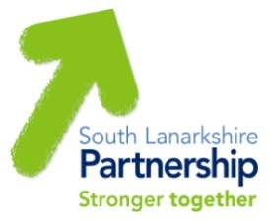

South Lanarkshire
Community Planning Partnership

Working together to improve the quality of life for all in South Lanarkshire

Community Plan
for South Lanarkshire
2022-2032

Annual Outcomes Improvement Report
2023-24

Contents

Chapter | Page Number
Introduction to Community Planning in South Lanarkshire  - Preface  - What we are?  - Who we are?  - What are we trying to achieve?  - How do I get involved? | 3
Our Ambitions  - Delivery of the Community Plan | 4-5
Community Plan  - Performance Highlights | 6
Community Plan  - Overall Performance at a glance | 7-8
Places for Wellbeing:  how we are making a difference  - Thriving Businesses and Fair Jobs  - Caring, connected communities  - People live the healthiest lives possible  - Putting learning at the centre  - Our children and young people thrive  - Good quality, sustainable housing for everyone | 9-21
Working with Communities:  how you can get involved  - Community Participation and Engagement  - Neighbourhood Planning  - Community Partnerships  - Sustainable Development and Climate Change  - Community Led Planning  - Participatory Budgeting  - Volunteering  - Community Asset Transfer  - Participation Requests | 22-36
Appendices  - Links with the National Performance Framework  - Community Planning Partnership Structure | 37-38
Section 1 - Introduction to Community Planning in South Lanarkshire

Preface
This document is for you, and everyone else who lives or works in South Lanarkshire. It shows the progress of the South Lanarkshire Community Planning Partnership during 2023-24 and gives example of the work that we are doing to make a difference; and how this has impacted on local people and communities.

What are we?
All our Community Planning Partners are working together to make South Lanarkshire a better place to live and work. We work with each other and with communities to provide the best possible services that local people want and need. Further information can be found on the Community Planning Partnership website www.southlanarkshirecommunityplanning.org.

Who are we?
Our partnership includes a wide range of national and local organisations. Some of these organisations you will know well. Our community partners lead on local planning and area-based Community Partnerships. A full list can be found on our website.

What are we trying to do?
Our Community Planning Partners are working together to make South Lanarkshire a better place to live, learn, play and work. Our aim is to work with communities to deliver better services targeted at reducing poverty and tackling inequalities and deprivation across South Lanarkshire.
Further information can be found on the Community Planning Partnership website www.southlanarkshirecommunityplanning.org.

How do I get involved?
There are many ways to get involved in your local community and influence the work of the partnership, for example, through volunteering, joining a local action group, helping to find out what matters in your area or getting involved in how decisions are made. More information can be found on the Community Planning website www.southlanarkshirecommunityplanning.org/info/74/getting_involved.

Section 2 – Our Ambitions

Our Ambitions
Our Community Plan sets out how we will continue to support the people living in our communities to participate in Community Planning and puts the places where our communities live at the centre of change. We will continue to focus on improving how we work better together to deliver local needs and priorities.
This work will happen across three key ambitions: People; Progress; and Planet.
People – Together, we will take a people first approach to improving everyone’s wellbeing. People told us that empowerment comes from the community and it’s not something that is given to them. We understand that long-lasting change will only be achieved if we all work together, putting our communities at the heart of community planning. We will continue to have community conversations that matter. We will work with communities to ensure that their voices are heard and support them to act on the things that are important to them through a “Can Do” approach.
Progress – Together, we will build on what we have learned to improve how we do things and the wellbeing of everyone. Delivering the right things that matter to people, in the right place and at the right time. We have been inspired by the phenomenal community response to the global pandemic and have seen how our communities “Can Do” do more with the right information and support from us. Our focus will be to continue to grow and develop the relationships and the excellent partnership working that has supported our communities to maintain and improve their wellbeing throughout the pandemic.
Planet - Together, we will act in ways that protect our natural world for a healthier future. We will work together to develop local solutions to protect nature and to take action on climate change and support our young people to lead the way.
The ambitions set out where we want to see change happening across the themes of Progress, People and Planet. From your feedback, we know that there are six other priorities that are important to you. We are already working to improve services in these areas and have plans that show how this is being done. Our Places for Wellbeing model shows how the plan connects though place, ambitions and priorities.

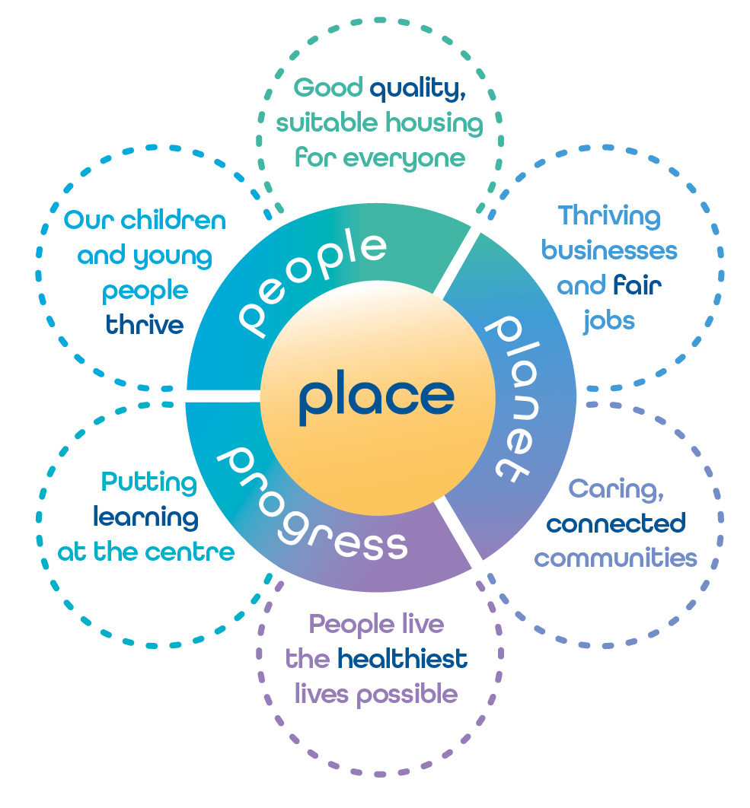
You can read the full Community Plan on the Community Planning website: www.southlanarkshirecommunityplanning.org/info/1/what_is_community_planning/135/our_priorities.
Section 3 – Community Plan Performance Highlights

There is a significant amount of work being undertaken in our communities, and by our partners across South Lanarkshire to make places fairer, better and greener. This report highlights some of the work that has been done.

The following are examples of key areas of work.

- Thriving Businesses and Fair Jobs: 490 Full Time Equivalent (FTE) jobs have been safeguarded over 2023-24 as a direct result of South Lanarkshire Council’s Business Support.
- Caring, connected communities:12 employees from across the partnership participated in the Health in the Community (HIIC) Training hosted by The Scottish Community Development Centre (SCDC) and will work with communities to deliver what they have learned.
- People live the healthiest lives possible: 1,398 new carers identified in South Lanarkshire.
- Putting learning at the centre: 1,928 adults were supported into work (530 adults) or further/higher education (601 adults). The remaining adults continue to be supported to find work or further/higher education opportunities.
- Our children and young people thrive: 57 care experienced young people participated in the South Lanarkshire Local Employability Partnership (SLLEP) funded employability programmes with 87.5% progressing to a positive destination of employment, learning (college etc) or further training.
- Good quality, sustainable housing for everyone: 326 additional council homes have been delivered through the Affordable Housing Supply Programme.

Section 4 – Community Plan Overall Performance at a glance

The following provides a summary of our performance against our priority measures. These are:-

- Putting learning at the centre
- Our children and young people thrive
- Thriving businesses and fair jobs
- Caring, connected communities
- People live the healthiest lives possible
- Good quality, sustainable housing for everyone

The full CPP performance report can be accessed using the following link: www.bit.ly/CPP2324Q4ProgressReport

Status of priority measures
67
7
2
0
0
xxx 67 Improved or Maintained 9 Slippage or Deteriorated

Status | Definition
Blue | The action to achieve change has been completed
Green | On course to achieve the target or complete the action as planned/the timescale or target has been met as per expectations
Amber | There has been minor slippage against timescale or minor shortfall against target
Red | There has been major slippage against timescale or major shortfall against target
To be reported later | For some measures, the statistics are not yet available to allow us to say whether the target has been reached or not. These will be reported when available

Most improved measures | Least improved measures
Number of young people and adults with Additional Support Needs supported into training, employment and education | Increase the percentage of employability participants progressing to positive destinations
By March 2024, 100% of young people will have a Person-Centred Pathway Plan | By March 2024, 80% of participants in the Mellow Bumps Pregnancy Sessions will report increased knowledge and understanding about stress, anxiety and self-care
Number of new employer engagement contacts developed and vacancies filled | By March 2024, 75% of young people have been offered a low or medium need mental health support, report it has improved their mental wellbeing
Increase number of energy efficiency and decarbonisation measures installed in council homes in South Lanarkshire | Increase the percentage of Housing Option interventions where homelessness is prevented
Number of people participating in a co-produced Self Directed Support Assessment to exercise choice and control over their care | Continue to implement the Rapid Re-housing Transition Plan (RRTP)

Section 5 – Places for Wellbeing: How we are making a difference

Thriving Businesses and Fair Jobs – Social Enterprise Strategy 2023-2027

Why is this important?
44 South Lanarkshire Social Enterprises engaged and participated in a range of programmes including the South Lanarkshire Business Accelerator and Climate Confident South Lanarkshire pilot.

Targeted support to start up and grow Social Enterprise is a key priority for South Lanarkshire Council (SLC), who approved the South Lanarkshire Social Enterprise Strategy 2023-2027 in August 2023. This support outlined in the strategy, supplements, and adds value to the council’s existing Business Support Programme.

Many of our Social Enterprises are micro businesses (a very small company with less than 10 employees), often reliant on grant funding and the range of issues they face are broad and complex. Social Enterprises are businesses (albeit ones where the profit is to be reinvested into the business) where the aim of support is to ensure that they become and remain a sustainable business that can compete to win business in the open market.

According to the most recent Scottish Government Social Enterprise Census (2021) there are 177 Social Enterprises operating in South Lanarkshire. The estimated Gross Value Added (GVA) by South Lanarkshire active Social Enterprises in 2021 was £35.2mn. This represents 13.3% Scottish Social Enterprises GVA in 2021. Social Enterprises are local employers and in 2021 employed 1,280 Full Time Equivalent employees – 1.4% of the Scottish total.

Key sectors where Social Enterprises are active here in South Lanarkshire are Childcare and Early Years, Health and Care and Arts and Creative industries.

How are we doing?
A Steering Group made up of third sector partners, SLC and NHS Lanarkshire oversees the successful delivery, monitoring, and reporting against the strategy objectives. The strategy priorities align with the national strategy priorities for Social Enterprise, SLC Economic Strategy and the council’s Community Wealth Building approach. Taking this partnership approach, the council has delivered a range of capacity building and additional business support programmes including:

Following a successful pilot in 2022/23, council officers working with partners have commissioned two Business Accelerator Programmes aimed at building business growth and sustainability of organisations.

Procurement Workshop – this half day workshop in partnership with the Supplier Development Programme introduced organisations to public sector tendering and how they can do business with the council.

South Lanarkshire Social Enterprise Network – SLC resourced the development of a refreshed South Lanarkshire Social Enterprise Network to encourage networking, peer support and provide an opportunity for meaningful engagement and collaboration across the sector.

Climate Confident South Lanarkshire Pilot – a series of bespoke interventions including the opportunity for organisations to receive expert help, peer learning and access to a digital tool, aimed at supporting organisations to take significant steps towards net zero and positive climate action.

Social Enterprise small grants – match funding to start and/or increase income through trading and work towards sustainability through income generation. Grants available up to 50% of eligible project costs (excluding VAT) and up to a maximum total grant award of up to £2.5k for single organisation applicants and up to £7.5K for consortia applications.

Priority Next Steps
There are several key areas of work underway to directly support the sustainability and growth of local Social Enterprise. Delivering on the objectives set out in the South Lanarkshire Social Enterprise Strategy going forward, we will:

- Explore delivery of a Young Entrepreneur’s Programme in all secondary schools in South Lanarkshire;
- Test new forms of democratic finance and pilot a Community Bond Initiative;
- Build on the work that has taken place with colleagues in the Improvement Service on Shaping Places for Wellbeing and pilot a Community Wealth Building Exchange in the Cambuslang/Rutherglen areas to build supply chain opportunities with Social Enterprises; and
- Deliver a range of additional capacity building and business support e.g. workshops, events, and programmes.

What people have said about the Business Accelerator Programmes:
“I just want to thank you for the delivery of the Leadership Programme. I have found it immensely useful at exactly the right time for me. The mix of group discussion and theoretical sessions to underpin the 1:1 coaching has been of great value”.
“I have found the experience to be quite revelatory! Both in the communicating with peers about shared issues, to the real deep thinking the sessions…”.
“The Programme has exceeded my expectations. I wasn't sure what to expect coming into this but I'm really enjoying it. Not only the Expert’s knowledge but also how the group has been facilitated in a way that creates safety for everyone to share. The 1-1 was brilliant”.

Further information
- Support for Business - Social Enterprise Support

Caring, connected communities – Climate and Nature

Why is this important?
The Community Planning Partnership through working with and supporting communities, aims to ensure in its work that steps are taken to mitigate and adapt to the impacts of climate change and nature change whilst ensuring that no one is left behind. As well as rapidly reducing greenhouse gas emissions (known as ‘mitigation’), it is also important to improve resilience to the unavoidable impacts of climate change (known as ‘adaptation’). The United Nations Sustainable Development Goals (SDGs) is the framework which the partnership uses to track and monitor progress. These are a comprehensive set of global goals to end poverty, protect our planet, and improve living conditions for all. Achieving each goal depends on the success of another, for example ending poverty and reducing inequalities must go hand in hand with a healthy economy, whilst protecting the planet. Making sure no one is left behind is critical to the success of delivering on the SDGs. To create stronger, more resilient communities, and support transformational change, residents, community groups, organisations and businesses across South Lanarkshire need to be at the heart of climate and nature change.

How are we doing?
Community based climate and nature activity during 2023/24, included, increasing the awareness of all of the SDGs including through Community Planning events.

In the lead up to national Climate Change week in September/October 2023, staff visited local community groups and volunteers, businesses, schools/college, an eco farm and a cycle park to learn about the amazing work that they are doing in and around communities across South Lanarkshire and to share their stories with the wider community. You can learn more here: Climate and Nature Community Action stories.

Members of the South Lanarkshire Youth Council and the South Lanarkshire School Youth Forum on Climate Change and Sustainability invited Community Planning leaders to learn more about the climate and nature issues facing young people locally and nationally. These issues included topics such as reducing, reusing and recycling; fast fashion; transport; education; and social media. The young people also shared some of the excellent work that they are doing at school and where they live to tackle some of these issues such as Conference of Schools (COS) events; waste recycling pilots in High Schools; a mobile phone app project; and further exploration of travel and travel habits.

As part of the national Climate Change week and Tackling Poverty week, a community-led event which focussed on ‘Having Climate and Nature Conversations that Matter’ was held. Community groups and schools from across South Lanarkshire shared their stories with the wider community through various conversation cafes which focused on the themes of green travel, communities in action, nature-based solutions, food growing and engagement. Key speakers were Laura Young (Less Waste Laura) who is an award-winning climate advocate and environmental scientist and Alex Cameron-Smith of Sniffer, which is an environmental charity, working across Scotland on the three key themes of leadership, placemaking and innovation. Those attending were asked to submit a personal pledge. These highlighted the need for a stronger focus on doing more locally, through community led action and personal actions to reduce our impact on the environment. Commitments included the following themes: air quality and emissions; education; energy; food; greenspace; nature and biodiversity; recycling; resilience; transport and waste.

Students from South Lanarkshire College were also in attendance for the purposes of furthering their studies and using their skills to develop a pictorial representation of the discussions and learning from the day as shown below.

Priority Next Steps
- The council’s Youth Family and Community Learning Team will support young people to continue the dialogue on what matters to them about Climate and Nature with Community Planning leaders.
- The partnership will continue to work with communities to deliver on the “Planet” ambition set out in the Community Plan, and the Partnership’s commitment to ‘invest in our planet by putting local areas at the centre of our work’ and ‘to work together to develop local solutions to protect nature and to take action on climate change and support young people to lead the way’. This includes a key area of work to co-produce and co-deliver actions with our communities.

Further Information
- Community Planning Partnership - Community Planning Events
- South Lanarkshire Community Learning and Development Partnership
- South Lanarkshire Council - Sustainable Development and Climate Change Strategy

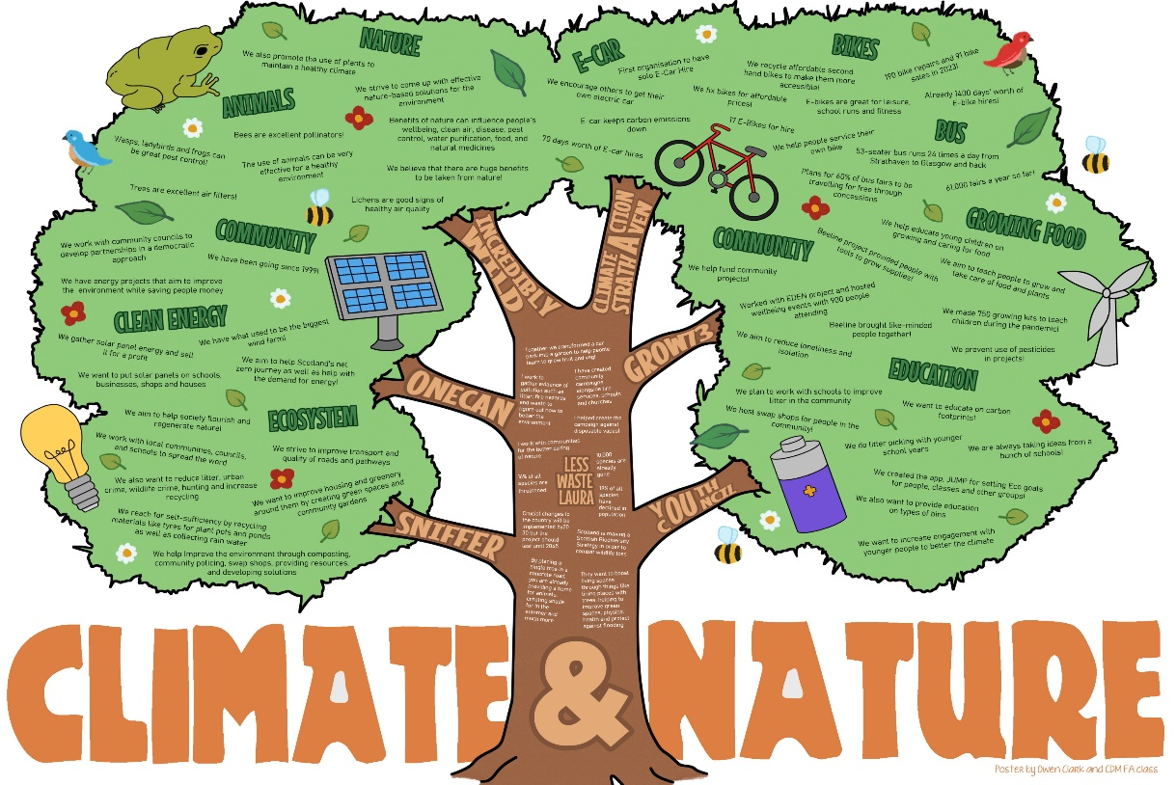

Graphic by South Lanarkshire College Students

People live the healthiest lives possible – Promoting early intervention, prevention, and health improvement - Telehealth and Telecare

Why is this important?
South Lanarkshire University Health and Social Care Partnership is committed to promoting early intervention, prevention, and health improvement so that people can remain independent and live their healthiest life possible. Innovation and change play a key role and we have seen an increase in the use of technology to assist people and promote their independence and help them to remain in their own homes.

Technology Enabled Care (TEC) supports people to maintain essential links with the wider community and live safely and independently at home. Key services include the use of assistive technology and demand for this continues to increase. The redesign of the community alarm service from analogue to digital for 7,000 service users has been successful. Training in TEC for Health and Social Care staff, third party organisations and service users is a key area of focus.

How are we doing?
There is a range of telehealth and telecare options which people can access, and the following case study provides an insight into the real benefits to people who use them in terms of service and convenience while offering transformational and sustainable options in service delivery. 6,580 digital alert alarms have been installed as of 31 March 2024. The main reason telecare is requested is to improve a person’s safety and reduce risk of harm.

There is a dedicated TEC team to support this work. The team is situated in the award-winning Blantyre LIFE Care Campus, where visitors can try out assistive technology such as kettles, virtual assistant technology, personal GPS tracking systems, etc. and speak to the team about how these solutions can support them and their loved ones at home. The TEC zone at Blantyre LIFE is a first of its kind health and social care collaboration with the Glasgow Science Centre. The innovative and interactive TEC zone plays an important role in supporting residents and service users to live independently and well.

Near Me is a video consulting service that enables people to attend appointments from home or wherever is convenient. The service is already widely used across NHS Scotland for health and care appointments. The service is now being rolled out across a wide range of public services. All you need is a device for making video calls like a smartphone and an internet connection. Instead of travelling to their appointment, NHS Lanarkshire Near Me allows patients or service users to enter an online waiting area from their computer, smartphone or tablet. The service is notified when they arrive, and a health or care provider joins the virtual consultation. There are also Near Me, Near You community spaces in South Lanarkshire at Biggar Library, Blantyre LIFE, Larkhall Lighthouse, The Old Schoolhouse, Abington, Whitlawburn Community Centre, Forth Valley Community Centre and Coalburn One-Stop Shop.

Case study – Technology Enabled Care
Karen has progressive Multiple Sclerosis (MS) and lives with her husband Kevin who works full time. Until recently Karen was managing well with support from the Care at Home Service, however, Karen recently experienced several falls. Kevin is very concerned about Karen’s safety and wellbeing when at home on her own. A community alert alarm was recommended following assessment and was installed in Karen and Kevin’s home. The community alarm alert responders respond to alert alarm activations when Kevin is at work. The Care at Home Coordinator also showed Kevin how to use Amazon Alexa Show’s video call “drop-in” function to keep in contact with Karen while he is at work. Kevin purchased smart bulbs to allow Karen to control the lighting in their home from voice commands to the Amazon Alexa device. Karen advised the introduction of technology improved her health, wellbeing and independence. Kevin noted the drop-in feature is invaluable to him in his caring role and provides him with peace of mind when at work.

Priority Next Steps
Lanarkshire’s Technology Enabled Care (TEC) Team will continue to provide an integrated approach to sustaining people to live independently at home and within their community. The focus of the team is to promote early intervention, prevention and self-management empowering Lanarkshire citizens to use technology to live their best lives, have choice, control and reduce the risk of harm. The team are actively involved with colleagues to identify ways to transform services and provide solutions to make services more sustainable for the future.

Further information
- Assistive Technology
- Sensory Support
Putting learning at the centre – Pathfinders Programme for Young People

Why is this important?
Pathfinders is an alternative intervention initiative with an overarching aim of embedding a Community Learning and Development (CLD) approach within the core of mainstream education to improve outcomes for young people identified as being ‘on the edge of care’. The initiative was developed through multi-agency planning to offer appropriate and meaningful support to identified young people and their families. Pathfinders has adopted the attachment theory principles to develop positive and consistent relationships.

The aim of the programme is to deliver support in a non-statutory way, which is provided holistically across a range of settings, school, community and the home. Pathfinder support is bespoke, tailored to each young person and family, and takes the form of both individual and group support. Home visits and parental engagement are key elements of the work. Pathfinder staff are well connected to key partners in the wider community to ensure appropriate referrals into and out of the provision.

How are we doing?
The Pathfinders Programme is currently embedded within seven schools in South Lanarkshire, with 14 Youth, Family and Community Learning Pathfinder workers. These are: Cathkin High School; Trinity High School; Stonelaw High School; Lanark Grammar School; Calderside Academy, Blantyre; St Andrew’s and St Bride’s, East Kilbride, and Carluke High School. This is funded through a mix of Whole Family Wellbeing Funding (WFWF) and Pupil Equity Funding. In 2023-24 the programme set a target to engage with 350 young people and families, providing support and sustained engagement that meets identified needs. At the end of March 2024, Pathfinders had worked with a total of 534 young people and families, exceeding our target by 52.5%.

Impact and participation levels are recorded through agreed measures that are reported through the South Lanarkshire Community Learning and Development Plan. The following data demonstrates progress against targets set for the year 2023-24:

- 5% increase in meaningful participation in school or learning in their social skills. Actual increase 88%.
- 5% increase in young people who recognise a positive adaptation in their behaviour. Actual increase 18%.
- 5% increase in young people who identify positive development in their Health and wellbeing. Actual increase 24%.
- 5% increase in meaningful participation in school or learning. Actual Increase 12%.

Priority Next Steps
The Pathfinders Team have successfully secured funding from the Scottish Government’s UNCRC Innovation fund to develop a youth led consultation process that will allow young people to be the catalyst for change in relation to areas that affect their lives. This funding will support the further development of youth voice in relation to developing appropriate interventions and support and has enabled us to create rich opportunities for a committee of 21 young people participating in the Pathfinders programme to directly influence the service that they receive and be involved and influence decisions affecting them/the programme and other young people in South Lanarkshire.

This element of the programme has three distinct phases:-
1. Skills development – to allow the participants the opportunity to develop the key skills and knowledge to actively influence the programme and services they receive.
2. Consultation - the participants will develop and deliver a series of consultation events with their peer groups.
3. Conference/Youth Summit – young people involved will host a conference for key partners, sharing life experiences, barriers to participation and evidence of need to shape future policies.

What people have said about the programme

“Work placement has given me the opportunity to go do something I like and want to do as a job when I leave school”.

“Football is a hobby and has given me something to do during the holidays. Pathfinders have included me in the Football events during summer. I have met people and friends there”.

“The different opportunities Pathfinders have given me I have been more open to go and trying new things than saying I don’t want to do the stuff. I have done that before”.

“Pathfinders have helped me talk to people more about how you feel helping with my feelings. I can go round there when I am having a bad day or need someone to talk to”. Young Person

“Karis and Pathfinders have had an enormously positive impact on my daughter’s life. To have someone who will always be there to support and reinforce that she has talents has been very important to my daughter, to have someone who can provide opportunities which fit her needs, talents and interests has been life affirming for her. Karis has been pivotal in bringing my daughter back to a place of happiness after the struggles she has had, and my husband and I are eternally grateful to Karis”. Parent of Young Person

Further information
- Youth, Family and Community Learning - South Lanarkshire Council

Our children and young people thrive – Family Support Hubs

Why is this important?
Central to South Lanarkshire’s vision for whole family support, is for families to flourish and get the right help at the right time, supporting a child's right to be raised safely within their own families for as long as they need it. Within South Lanarkshire, four Family Support Hubs are now open and provide easier access to help families. The hubs provide an early social work response to pregnant women, babies, children and young people up to 18 years of age to prevent an escalation to statutory teams by providing intensive whole family support. In the first year of operation, the Family Support Hubs have responded to 61% of the total referrals to Children and Family Social Work. The hubs are community facing and offer better access to support for families in Cambuslang, East Kilbride, Hamilton and Lanark. The hubs have had such a positive impact on families, that families themselves are now the second largest referrer to this support in the past year.

How are we doing?
To reduce the number of babies, children and young people who have to live away from their families, we have been supporting all families identified by our Early Years Multi Agency networks as needing extra help during pregnancy with Family Group Decision Making sessions. This approach is expected to empower families to make their own plan to safeguard their child.

In an effort to reduce the use of child protection procedures, the Hamilton Family Support Hub have introduced a Parent Plan approach for vulnerable pregnancies. This approach still ensures there is early identification and response to risk and safeguarding concerns through a robust assessment and review process using a Getting It Right For Every Child (GIRFEC) approach. This has been successful, resulting in positive outcomes for families. This approach will be scaled up across all four of the Family Support Hubs in 2024.

A Parenting Support Groupwork Pathway has been expanded to include support for parents with children aged 0-18 years. This includes evidence based and accredited programmes. For those parents not requiring additional or intensive groupwork programmes, the pathway has been expanded to include Family Support Hub specific groupwork programmes. These provide general parenting and wellbeing support, a positive social experience and an opportunity for parents to engage with their local Family Support Hubs.

Priority Next Steps
A reflective Practice Coordinator is aligned to the hubs to support trauma informed practice amongst staff. In year two, a Trauma Recovery Councillor will support families. The counsellor will work directly with families, as an early intervention approach before a situation has escalated and in line with local and national priorities.

During consultation, families said that staff with relevant lived experience should work in the Family Support Hubs. In 2023, 3.5 individuals with lived experience were recruited. They work across all four Family Support Hubs. Their remit within the team is to try to reduce the impact of parental substance use by providing support to parents to address any barriers to their recovery. Evaluating and building upon the initial successes of peer support remains a priority. The support has been received positively by parents, Social Work colleagues and partners.

Peer Support Worker Case study – Sharon’s Story (name has been changed)

Sharon was referred to me following a period of emotional crisis. She uses cannabis to deal with her mental health and is significantly affected by her partner’s alcohol use. Establishing the relationship from the start was slightly difficult as Sharon didn’t feel she could trust services due to being let down with her previous service from Social Work. I had initially formed a relationship over the phone with Sharon for about two weeks, as her having someone to speak to when she was feeling most on edge and anxious was reassuring for her to feel comfortable and understood before I managed to visit her in her home.

I had shared my lived experience with Sharon, we had so much in common with certain life events growing up which we could relate together, we could then navigate the emotions and triggers to a point of acceptance to allow Sharon to move forward with life again, being able to relate to Sharon has helped strengthen the working relationship between ourselves.

I helped Sharon link in with the Clydesdale Resource Network – Mental Health Team in Lanark, also supporting Sharon to contact the doctor for referrals to her Community Psychiatric Nurse (CPN) and councillor for ongoing support. There was quite a lot of barriers at the start as Sharon has felt misunderstood in the past from her CPN and counsellor, the experience had caused her to disengage from the services and her mental health had spiralled into an emotional dark place.

Working together to build up Sharon’s confidence and self-assurance has improved her mental health and day to day living. Sharon is more driven and motivated to embrace day to day tasks and follow through with her routines for the children and herself. Her confidence has now increased, and she is learning to play the ukulele and piano and going to join a local music group.

Levels of stress within the family home have reduced significantly, Sharon is more confident in lifting the phone and seeking appropriate supports from Mental Health Services, family and friends and social work. Relationships with family members have also improved.

I have learned in this experience that crisis can come at any time but so can solutions, and being able to problem solve with Sharon has been effective. I feel pointing out Sharons’ strengths and talents crossed out her negative self-concept and gave me great fulfilment knowing what work I was putting in was being reciprocated as both Sharon and I were reaching goals together.

Feedback from Sharon:
“Carol has been amazing. When we started, she said her goal was to help me get to a point where I don't feel like I need to move away to solve my problems. Didn't think that was likely but was wrong. It's helped to have someone safe to talk to and to feel like I have someone on my side. It’s been easier to maintain the house and focus on moving forward again instead of feeling overwhelmed and frozen. I'm almost grateful for what happened before now because I doubt anyone else would have been able to help as much as she has”.

What people have said about the Family Support Hubs

“The support helped me to improve mine and my children’s situation, not only their environment but wellbeing too. My perception of Social Work has changed as a result”.

The support from the hub has helped me overcome all obstacles in my way and helped get my confidence back as their kind words has reminded me of the person who I truly am throughout my healing process”.

“I have found the approach to be more supportive than my previous experience of Social Work and I’m planning to also take up the option of attending the parenting groups offered”.

“My hub worker helped me and my daughter get through a traumatic experience of domestic abuse by spending time with us, being available when we needed her and having a caring and supportive approach”.

“I would not have managed over the past few months without having the emotional support. It has got me through a very difficult period, and even if I didn't call one week, just knowing someone was there for me if I needed it was great”.

Further information
- Family support hubs - South Lanarkshire Council

Good quality, sustainable housing for everyone – South Lanarkshire ECO4 Scheme

Why is this important?
The South Lanarkshire Local Housing Strategy 2022-2027 aims to ensure everyone has access to a home that they can afford and meets their needs. This includes the ability to heat and maintain their home, with the higher cost of energy alongside other cost of living pressures having impacted on the affordability of heating and maintenance, putting them in or at risk of fuel poverty. Private home owners on lower incomes or with residents who are vulnerable to the effects of a cold home may be particularly affected, including homes with very young children, older people, and people with health problems.

The Scheme also aligns with the Scottish Government’s Climate Change Plan that sets out a pathway for achieving Net Zero. Also, with the Scottish Government’s Heat in Buildings Strategy, that includes proposals to create a new Heat in Buildings Standard, requiring people who own their home to meet a minimum energy efficiency standard by 2033 and private rented home owners, by 2028.

How are we doing?
Recognising these challenges, in 2023 South Lanarkshire Council was amongst the first local authorities in Scotland to fully launch a new ‘Energy Company Obligation Scheme’. This allows national energy company funding to be used by locally based contractors to make energy efficiency improvements to eligible private tenure homes at no cost to the homeowner or landlord.

Administered through Ofgem, the current version of the Scheme is known as ECO4 and runs until March 2026. Local authorities participate play a significant role working with contractors to ensure that the funding reaches households who will benefit the most.

The South Lanarkshire ECO4 Scheme launched in July 2023 and so far, 128 private tenure households have benefited from the installation of retrofit energy efficiency measures. Within these, 326 measures have been installed over that period, surpassing the 300 annual target set out in the council’s Local Housing Strategy and Community Plan. A range of 18 different measures have been installed, with the most common installations being new Solar Power systems (23% of installations) and boilers being upgraded to a renewable energy heating system (21% of installations). Twenty properties have benefited from first time central heating and 77 properties have benefited from a variety of home insulation measures (23%). Each of these will contribute to making homes being easier to heat and reduced bills for residents.

Priority Next Steps
The scheme can be targeted to areas assessed as having poor property conditions, or where particular customer groups and household compositions reside. By working in partnership with the Fuel Poverty Group and contractors, we aim to ensure that the scheme reaches those most in need and at risk of fuel poverty.

Case study - ECO4 Scheme by South Lanarkshire Council
A resident who had issues with her boiler contacted Retrofit Group who are one of several approved ECO installers in South Lanarkshire. After gathering some more information, she was advised that the household could be eligible for ECO funding as the household income was less than the £31,000 threshold.

The old heating system was temperamental, so the company prioritised a surveyor’s visit to carry out an assessment of the heating system. From this, the recommended energy efficiency measures were to replace the boiler with a new condensing boiler and to upgrade the heating controls.
Once the company submitted all the paperwork, an assessment of eligibility was completed by the council within one week, and the installation was completed by the engineer within a single day, minimising the disruption to the resident.

The resident told Retrofit, “I have just had the hottest shower since I moved into the property in August last year. This has taken away a lot of anxiety for me! I now know that when I turn on the tap or shower that I have hot water and I don’t have to continually boil my kettle. Thank you so much”.

Through ECO4, this resident who lives on a low-income, now has an improved heating system providing better energy efficiency, a warm home and safe access to warm water.

Further information
More information on eligible households and approved contractors for South Lanarkshire ECO4 can be found in the links below:
- ECO Flex for suppliers - South Lanarkshire Council
- ECO Flex approved contractors - South Lanarkshire Council
- Contact: ECO4Flexscheme@southlanarkshire.gov.uk

Section 6 – Working with Communities: How you can get involved

Community Participation and Engagement

Why is this important?
Our work as a partnership is intended to improve outcomes for people who live, play and work in South Lanarkshire, particularly in those areas that experience the poorest outcomes. There is a lot of evidence that shows that when people are involved in decisions about services which affect them, outcomes are improved. As a partnership, we want to find ways to speak to communities and encourage them to act themselves and to have an influence on how services are delivered where they live.

The Community Empowerment Act 2015 (www.gov.scot/publications/community-empowerment-scotland-act-summary/) means that legally the partnership has to place communities at the centre of its work, and work together with them to produce locality plans which we call Neighbourhood Plans, in areas which have the poorest outcomes. In South Lanarkshire we are ambitious and work to extend this beyond the legal requirements and listen to and involve communities in a real and meaningful way. The Act also sets out other requirements for public organisations, for example, in relation to Community Asset Transfers and Participation Requests.

During the year, many consultation and engagement activities were carried out by partners with communities in the South Lanarkshire area. The following sections in the report highlight some areas of this work.

Working with Communities: Neighbourhood Planning

Why is this important?
Neighbourhood Planning is where both residents, local agencies and organisations are committed to working together to develop local plans for their communities. This work aims to reduce the inequalities that exist in our most deprived communities and improve outcomes for residents. Key to this is supporting communities to drive the process and work alongside partners and service providers. Together they build a shared understanding of local needs and priorities and respond to these making the most of our shared resources.

Neighbourhood Planning involves communities in real and meaningful ways and has created positive change in these communities. For more information on the progress that has been made in these areas please see the communities’ Annual Reports: www.southlanarkshire.gov.uk/cp/info/26/community_matters

How are we doing?
We are working with nine communities to progress Neighbourhood Planning and a further one area is in progress. The following is a snapshot of current activity in some of the areas that are currently developing new plans.

Hamilton South
The Hamilton South Plan includes the areas of Eddlewood, Fairhill, Low Waters and Laighstonehall. Local people and the Stakeholder Group have created a plan that can includes actions that recognise both the individual and collective communities of their area. The Stakeholder Group meets every six weeks and is growing all the time, with both officers and community representatives attending regularly from across the whole area.

East Kilbride South
In East Kilbride South, the first Stakeholder Group meeting was held in August 2023. This was well attended by local groups and organisations. At that meeting, it was agreed to proceed with a whole ward plan and start the consultation to find out more about the hopes and aspirations of local people to inform the plan. An online consultation was held in October 2023 followed by door-to-door consultation within the priority area in November. The door-to-door work and visits to five local schools were completed in March 2024. The information will be analysed at the end of April 2024 with the plan on track to be in draft in Summer 2024 and to be completed and ready to present to the CPP Board in September 2024.

In East Kilbride South, the first Stakeholder Group meeting was held in August 2023. This was well attended by local groups and organisations. At that meeting, it was agreed to proceed with a whole ward plan and start the consultation to find out more about the hopes and aspirations of local people to inform the plan. An online consultation was held in October 2023 followed by door-to-door consultation within the priority area thereafter. Engagement work was also carried out at the 5 primary schools. The consultation closed on 2 May 2024 with 782 survey responses. Next steps are to develop the Stakeholder Group, to build its capacity and carry out further consultation to conclude the engagement activity and identify local priorities.

Case study – Burnhill Neighbourhood Plan
A local group in Burnhill have developed a derelict piece of land they call the “High Backs” to use as a community space as there is a lack of facilities in the area to host community activity. This includes space for community growing in raised beds, a potting shed and a poly tunnel and three outhouses/sheds within the garden to be used as a coffee hut, community pantry, a space for activities and a stage for the young people in the area.

The main issues being addressed are the top 10 priorities highlighted by local people in the Neighbourhood Plan which are: more social and recreational opportunities, housing and environmental improvements, play park and sports park improvements, stronger and better communities, better education training and employment opportunities, greater community safety, health improvements, better financial wellbeing, easier to get about and move around, and more variety of shops and businesses.

Some of the activities and projects designed to address these issues are Wellbeing Hubs, Family Hubs, Citizen’s Advice Drop in, Parent Café, Youth Action Group, Cooking Courses, coffee mornings. Throughout the year they also organise free themed community events such as summer fun days, Easter egg hunts, Halloween events and a Christmas Elf Trail for the whole community. The group are currently working on creating a community pantry to allow local people access to free food and other household essentials, becoming a free sanitary product outlet and working to create a project plan with a developer to explore the potential for further development of the community space.

Some of the highlights from this year’s Neighbourhood Planning Progress Report are:
• 254 local people took part in the Participating Budgeting process, allocating funding to local projects.
• Over 50 people accessed free sanitary products.
• £50 vouchers for 100 residents to help with the rise in the cost of living.
• 8 adults took part in a healthy 'on a budget' cooking class.
• 15 cold weather packs given out to elderly residents.
• Coffee mornings with over 25 people present at each one.
• 950 residents attended the free big community events Easter, Summer, Halloween and Christmas.
• 1,000 people following the What's On in Burnhill social media page – the average post reach is 4.4k.
• 50 pumpkins, 100 advent calendars and 100 Easter eggs were given out for free to families.
• Burnhill Young Volunteers recognised with a volunteering award.
• 50 residents attended bingo in the High Backs.
• 100 residents were involved in outings/trips.
• 35 residents attending weekly Family and Wellbeing Hubs.
• 60 young people took part in the football summer club arranged by Glencairn Football Club 2006s.

Link to High Backs Youtube video: https://www.youtube.com/watch?v=-eBGdIXgZwY

How can you get involved?
If you have an interest in any of the communities that already have a Neighbourhood Plan, you can get involved by supporting delivery of the plan. If you would like more information or would like to get involved in Neighbourhood Planning in your community, please contact the Community Engagement Team. You can call us on 0303 123 1017 or email us at communities@southlanarkshire.gov.uk

Further information
- South Lanarkshire Community Plan 2022-2032
- Neighbourhood Plans - Annual Progress Reports
- South Lanarkshire Community Planning Partnership
- Community Empowerment (Scotland) Act 2015
- National Standards for Community Engagement

Working with Communities: Community Partnerships

Why is this important?
South Lanarkshire Community Planning Partnership is wholly committed to ensuring that communities are fully engaged in the process of Community Planning.

To achieve this, and to strengthen local democracy and community led decision making, locality-based Community Partnerships are being developed. Two have already been formed in the Cambuslang/Rutherglen and Clydesdale locality, and a further two are currently in development in the East Kilbride and Hamilton localities. The Community Partnership will act as an intermediary between the Neighbourhood Planning Stakeholder Groups, Community Councils and the Community Planning Partnership (CPP) Board.

There are 3 key commitments highlighted within South Lanarkshire’s Community Plan. These are supported and delivered in the work of the Community Engagement Team in partnership with Community Planning Partners, and other key stakeholders. These include the following:-

- We will continue to support and encourage every community to identify and act on their local priorities.
- We will bring communities together to share priorities and work jointly on them.
- We will involve local representatives in community planning at all levels, including on the Community Planning Partnership Board.

How are we doing?
The Community Planning Partnership Community Development Officer supports the meetings of the established Partnership groups in the Cambuslang and Rutherglen and Clydesdale localities. Both groups identify priorities and needs from within the localities, work with partners and communities to deliver on these and present updates on their progress to the strategic Community Planning Partnership Board. Since June 2022, a representative from each Partnership has attended the Board on behalf of their groups.

Both established Community Partnerships are currently focussing on how they will share information about their work within their local communities. One way to do this is using the Community Planning website to highlight action points from meetings, as well as future planning and priorities. This will further emphasise their essential roles in the Community Planning process and will publicise them more within the local areas. They are also focusing on the allocation of Lived Experience Funding, which will assist in their aim to reduce deprivation and tackle poverty.

Partnerships in the East Kilbride and Strathaven and Hamilton localities (Hamilton includes Blantyre, Bothwell, Hamilton, Larkhall, Stonehouse, Uddingston) are currently being developed. Work will continue to strengthen the new Community Partnerships in theses areas and there will be further meetings with Community Councils and Stakeholder Groups.

How can you get involved?
Community Partnerships maximise opportunities for local people to be more involved, and influential in decision making that affects them in line with the South Lanarkshire Community Planning Partnership strategic priorities. Community Councils, Neighbourhood Planning, and other area stakeholders such as Community Led Planning Groups are currently involved in Community Partnerships. If you or your group would like to get involved, or require further information, please contact communities@southlanarkshire.gov.uk or 0303 123 1017.

You can also visit the following website for more details and information regarding community planning, and Community Partnerships in South Lanarkshire:- https://www.southlanarkshirecommunityplanning.org/info/1/what_is_community_planning/136/community_partnerships.

“I am really enjoying working alongside representatives from the four Community councils across Cambuslang and Rutherglen and the four Our Place Our Plan Stakeholder Groups. Although we are still relatively new, our role is to act as an intermediary to ensure that communities are properly and meaningfully engaged, involved and influential in Community Planning and the work of the South Lanarkshire Community Planning Partnership Board”.

Cheryl Burnett, Springhall and Whitlawburn OPOP Stakeholder and Chair of the Cambuslang and Rutherglen Community Partnership.

Further information
What is Community Planning?: The Community Planning Partnership in South Lanarkshire and what it could mean to you (youtube.com)

Working with Communities: Sustainable Development and Climate Change

Why is this important?
Climate change and sustainable development are important considerations for community planning because they have significant implications for the well-being of communities, the environment, and future generations. This has been identified as a priority in the new Community Plan and can only be delivered through working together, with our communities. Community Planning Partners can help to ensure that development is resilient, sustainable, fair, and that legal requirements are met.

Empowering communities to take climate action and be more environmentally sustainable is one of the council’s priority actions and work in this area reflects wider understanding of community participation in tackling climate change. Recognising that public engagement is central to tackling the impacts of climate change, the Scottish Government set out a framework for engaging the people of Scotland in a transition to a net zero nation by 2045. The three objectives underpinning the framework which set out the importance of community planning are noted below:

- Understand – Communicating climate change and how it relates to people’s lives;
- Participate – Enabling participation in shaping just, fair, and inclusive policies that promote mitigation and promotion of climate change; and
- Act – Encourage taking climate action in households, communities and places.

How are we doing?
As communities are central to creating a just and fair transition to net zero, over the past year we have undertaken community place-based climate action across South Lanarkshire to support and empower communities to become sustainable, inclusive and thriving places. Led by the council’s Sustainable Communities Engagement Officer (SCEO), work has focused on building relationships between communities, council services and external partners to help support and encourage climate action at a community level. The officer has been involved in several community-based initiatives during 2023/24 aimed at supporting engagement on climate and sustainability focused issues across South Lanarkshire. Direct engagement with community groups has helped them to achieve their aspirations with regards the sustainable development and climate change agenda. Examples include:

- Supporting delivery of the ONECAN Carluke Community Climate Conference;
- Supporting community networking and learning exchanges directly within communities; and
- Supporting grant applications to help realise community aspirations.

How can you get involved?
South Lanarkshire Council will continue to administer the Climate Emergency Fund over the coming year which will be made available to community groups who are looking to pursue environmental, sustainability, or climate change projects. These grants will allow communities to implement activity that is important to them and will better enable them to respond to the unique challenges areas face in tackling climate change and its local impacts. You can get involved by applying for a grant to help deliver activities in your communities. Grants of up to £2,500 are available to community groups and partner organisations and information on how to apply can be found by following the link below.

Further Information
- Sustainable development and climate change strategy: www.southlanarkshire.gov.uk/info/200303/climate_change_and_sustainability/2100/sustainable_development_and_climate_change_strategy
- Climate Emergency Grants: www.southlanarkshire.gov.uk/info/200168/getting_involved_in_your_community/2023/climate_emergency_and_social_enterprise_grants
Working with Communities: Community Led Planning

Why is this important?
The Community Led Planning process enables communities to identify local priorities and produce an action plan that helps people to take realistic steps towards the change they want to see. By bringing everyone together to think about what is needed, this process highlights the skills and resources already available in the community, as well as identifying the gaps and the support required from others to make it happen.

How are we doing?
Communities across South Lanarkshire in the Clydesdale, East Kilbride and Larkhall areas have created their own Community Action Plans. These plans have been developed through extensive community engagement activity delivered by local people, for the benefit of the whole community to take ownership of and work together to achieve the priorities set out in the plan. You can find more information about the communities that have their own plans and view their latest plans on the Community Planning website: - https://www.southlanarkshire.gov.uk/cp/downloads/file/458/local_community_plans.

Case Study – Crawford Community Led Plan Engagement Work
In 2023, community representatives in the village of Crawford came together to consider how they understand their community and collectively decided to undertake a community led planning exercise to get to know their community better, enhancing their understanding of the priorities of the people within the village and moving forward towards having stronger collective action for the future.

A Steering Group of 10 local members was created, with representation from six local community groups and some local residents who were not part of a community group. To truly get the value out of this experience, the group decided to lead every element of the community planning exercise themselves instead of appointing any contractors to ensure full attention to detail from the onset. They designed a survey to find out the views of the community. This was delivered to every property in the area (including 51 rural remote properties). The response rate from this survey exceeded the 40% target the group had set.

The Steering Group hosted a community event to share the survey feedback and identify key projects for action, using this engagement session to fully understand how these priorities would be achieved. They used interactive stalls, for example in the village shop, community café, village hall to show physical examples of how to achieve the priorities in the community’s plan. This is a unique engagement method, created to encourage active participation from community members in supporting the next stages of the Community Plan once launched.

Whilst this process has been ongoing, the Village Hall was listed for closure. As a result of their engagement work, the Steering Group were able to identify that the village hall is an important asset within the community and is valued by local residents. The Steering Group has taken steps to become a registered charity Crawford, Elvanfoot, Dar Action Resource (CEDAR) so that they can apply for a Community Asset Transfer to retain the village hall as a community asset.

How can you get involved?
If you have an interest in any of the communities that already have a local action plan, you can get involved by supporting delivery of the plan. If you live or work in a community that would like to create their own action plan, please see our local Community Planning Toolkit for further information. If you would like more information, please contact the Community Engagement Team. You can call 0303 123 1017 or email us at communities@southlanarkshire.gov.uk.

Further information
Community Planning Toolkit: www.southlanarkshire.gov.uk/cp/downloads/file/365/community_led_planning_toolkit
If you would like a copy of the toolkit, including template documents, please email: contact@southlanarkshirecommunityplanning.org

Working with Communities: Participatory Budgeting

Why is this important?
Participatory Budgeting (PB) actively engages residents in local priority setting, decision making and the allocation of elements of public funds.

How are we doing?
The PB process has been adopted across nine Neighbourhood Planning areas who are sharing a bigger budget than usual thanks to match funding from the national lottery. £286,000 (allocation based on population size) was shared between these neighbourhoods and a variety of approaches are being used to allocate this funding, based on local circumstances. Three neighbourhoods had undertaken their PB processes in 2022/23 while our other communities have completed their own this year.

2,996 local people have had their say on how money should be spent within their community. Example of projects funded across all areas include: youth activities including, youth clubs, football, skateboarding, and a playscheme; family activities and community events; mental wellbeing support; food growing; emergency food aid; keep fit classes; and a child and family programme. The Hamilton South area participated in its first Participatory Budgeting (PB) exercise, and after doorstep, online and community voting, £21,000 was allocated to groups and organisations who operate locally and benefit local residents. The beneficiaries of the funding have participated in training, promoted sustainability through environmental based projects and contributed to supporting local groups to assist with the current economic challenges being faced in communities.

“Hamilton South Church would just like to say a huge thank you for the recent grant award of £2,000 which will allow us to purchase new integrated ovens and hobs for our kitchen. This new kitchen equipment will help us extend our work and widen our partnerships across Hamilton South. We intend to link with local community groups and organisations in terms of offering our facilities for cookery classes, improving skills, and promoting healthier eating. Our weekly lunch club will also benefit as we can now offer a wider variety of hot food”. Hamilton South Church Volunteer

How can you get involved?
If you would like more information or would like to get involved in Neighbourhood Planning in your community, please get in touch with the Community Engagement Team. You can call us on 0303 123 1017 or email us at communities@southlanarkshire.gov.uk.

Further information
- PB Scotland - Participatory Budgeting in Scotland
- The PB Charter for Scotland - PB Scotland
- South Lanarkshire Community Planning Partnership - Community Matters

Working with Communities: Volunteering

Why is this important?
During the economic crisis, volunteers within South Lanarkshire continue to give their time, energy, and commitment every day to support their communities. Relieving pressure on statutory services, volunteering is an essential for the delivery of life saving interventions the Third Sector offer. The benefits of volunteering are evident, volunteers have a direct impact on improving mental health, reducing social isolation and an increase in wellbeing for themselves and those they support.

How are we doing?
The benefits of a collaborative approach to volunteering are as apparent now as they were when the “post COVID learning and evaluation exercise” was carried out. To build on the positive effect partnership working has on communities, Voluntary Action South Lanarkshire (VASLan) and South Lanarkshire Council’s Employability Services have been working together to create a smoother journey into volunteering. The new employability pathway is a streamlined referral path, working closely with key workers across four employability programmes. Key workers aim to remove barriers to volunteering by offering support in areas such as confidence building, life, and social skills. At the point where these barriers are reduced, a VASLan Volunteer Support Officer offers a tailored approach to volunteering placement, working with the key worker and volunteer. The Development Officer will link potential volunteers with opportunities throughout South Lanarkshire ensuring a stable, secure, and successful placement.

2022 saw the creation of the South Lanarkshire Volunteering Strategy, endorsed by all partners through signing a Volunteering Pledge. VASLan took the lead on the creation of the strategy and the partnership continues to utilise the strategy to promote good practice and strengthen the volunteering offer to South Lanarkshire. Continuing to support and guide partners and voluntary organisations in good volunteering practice remains one of VASLan’s main priorities. Working in partnership with Volunteer Scotland they will continue to promote the Quality Standards Pipeline and to support organisations to sign the Volunteer Charter, achieve Volunteer Friendly or Investing in Volunteers accreditation. VASLan are proactive in promoting good volunteer management, supporting organisations to apply and gain the quality standard their organisation is eligible for.

Coming out of the COVID pandemic, and facing daily cost of living challenges, it is vital that VASLan work with partners and the Third Sector to support the delivery of services by creating a strong volunteer network. Supporting the creation of flexible, inclusive, and diverse volunteering opportunities will remain to be an essential part of their work, by doing so VASLan will support volunteers into meaningful opportunities while supporting the Third Sector to thrive.

The following are some of the highlights of 2023/24:

- 728 new volunteers registered;
- 80 volunteers given tailored pre-volunteering support;
- 1,591 volunteering placements facilitated;
- 82 new volunteering opportunities created;
- 11 organisations have achieved a quality standard. 21 are currently working towards a Quality Standard and an additional 14 have indicated an interest;
- 377 new Saltire volunteer registrations;
- 20,088 Saltire hours logged;
- 5 Saltire Group Administrators approved; and
- 274 Saltire Certificates issued.

Further Information:
- Voluntary Action South Lanarkshire (VASLan)
Working with Communities: Community Asset Transfer

Why is this important?
Local councils, the Scottish Government and other public authorities, own or rent lots of land and buildings, like schools, hospitals, parks and forests. The Community Empowerment (Scotland) Act 2015 gives community organisations a right to ask to take over control of land or a building. If the community organisation’s plan is better for people, they will be allowed to buy, rent or have the use of it. This is called Community Asset Transfer (CAT). The Act sets out specific criteria that needs to be met by community organisations. The ownership or control of community assets is a powerful tool for communities to drive change and achieve their goals.

The CAT process allows statutory partners including the council to work closely with their communities to develop local services and provision that are responsive to the needs of residents. By capitalising on the local knowledge and expertise of those who live in these communities we can assist in the flexible usage of public sector assets and work together to make the greatest impact possible in the communities in which we serve.

How are we doing?
In 2023-24, South Lanarkshire Council was the only Community Planning Partner that dealt with Community Asset Transfer requests. South Lanarkshire Council’s CAT Officer continues to work with a high degree of interest from local residents and community groups to take advantage of the legislation by using land and property owned by the council. During 2023/24, SLC received and validated seven CAT requests. Three of these were for the purchase of land, the remaining four for lease. Four were approved, one declined, one temporarily withdrawn, and one continues to be negotiated. The number of ongoing enquiries, which have been supported, has also grown, with over 50 organisations working on proposals from community growing spaces to community football pitches. In addition, due to potential closures of buildings because of funding pressures in South Lanarkshire Leisure and Culture, the CAT Officer has been supporting 27 potential transfers to interested parties.

How can you get involved?
CAT is open to any community-controlled body which has the relevant constitution or governance documentation and is open to all members of the community they serve. Any group applying for a CAT must show they have organisational strength to take on and manage an asset, and that they are supported by the community which they serve. The CAT process is an exciting opportunity which can benefit any community but involves a lot of time and effort. In recognition of this, the CAT Officer can provide tailored support to each organisation. This support can be augmented by assistance from other organisations, such as Voluntary Action South Lanarkshire (VASLan), Community Enterprise, Just Enterprise, Community Ownership Support Services and the Scottish Council for Voluntary Organisations (SCVO).

Blantyre Soccer Academy – Larkfield Hall and Stonefield Pitches
“The CAT Officer supported Blantyre Soccer Academy with their approach to purchase both land and a former community centre from the council to develop these into an asset worthy of the Blantyre community which they serve.

The group developed and submitted a comprehensive business plan and have already worked with the Scottish Football Association to receive funding which will support the pitch development aspect of this property.

Everybody involved is excited about the potential of this project”. Jimmy Whelan, Chairperson Blantyre Soccer Academy

Further information
- Community Asset Transfer
Working with Communities: Participation Requests

How are we doing?
Participation requests are a formal way for community bodies to request to be involved in decisions and put forward their ideas on how services could be changed to improve outcomes for the community. Requests can be made to a range of public bodies including South Lanarkshire Council, NHS Lanarkshire, Police Scotland, Scottish Fire and Rescue, etc.

In 2023-24, no participation requests were received by Community Planning Partners.

To make a participation request, your group must meet some requirements including having a membership open to your community and working for community benefit. Your first step should be getting in touch with the public body you would like to work with for assistance in getting started.

This can identify if they are the right public body to contact and they can also help you to get advice and information about any existing consultations or decision-making processes that you could be involved in without needing to make a formal participation request.

Further information
- Participation Requests
- Annual report 2023-2024 - South Lanarkshire Council

Appendix 1
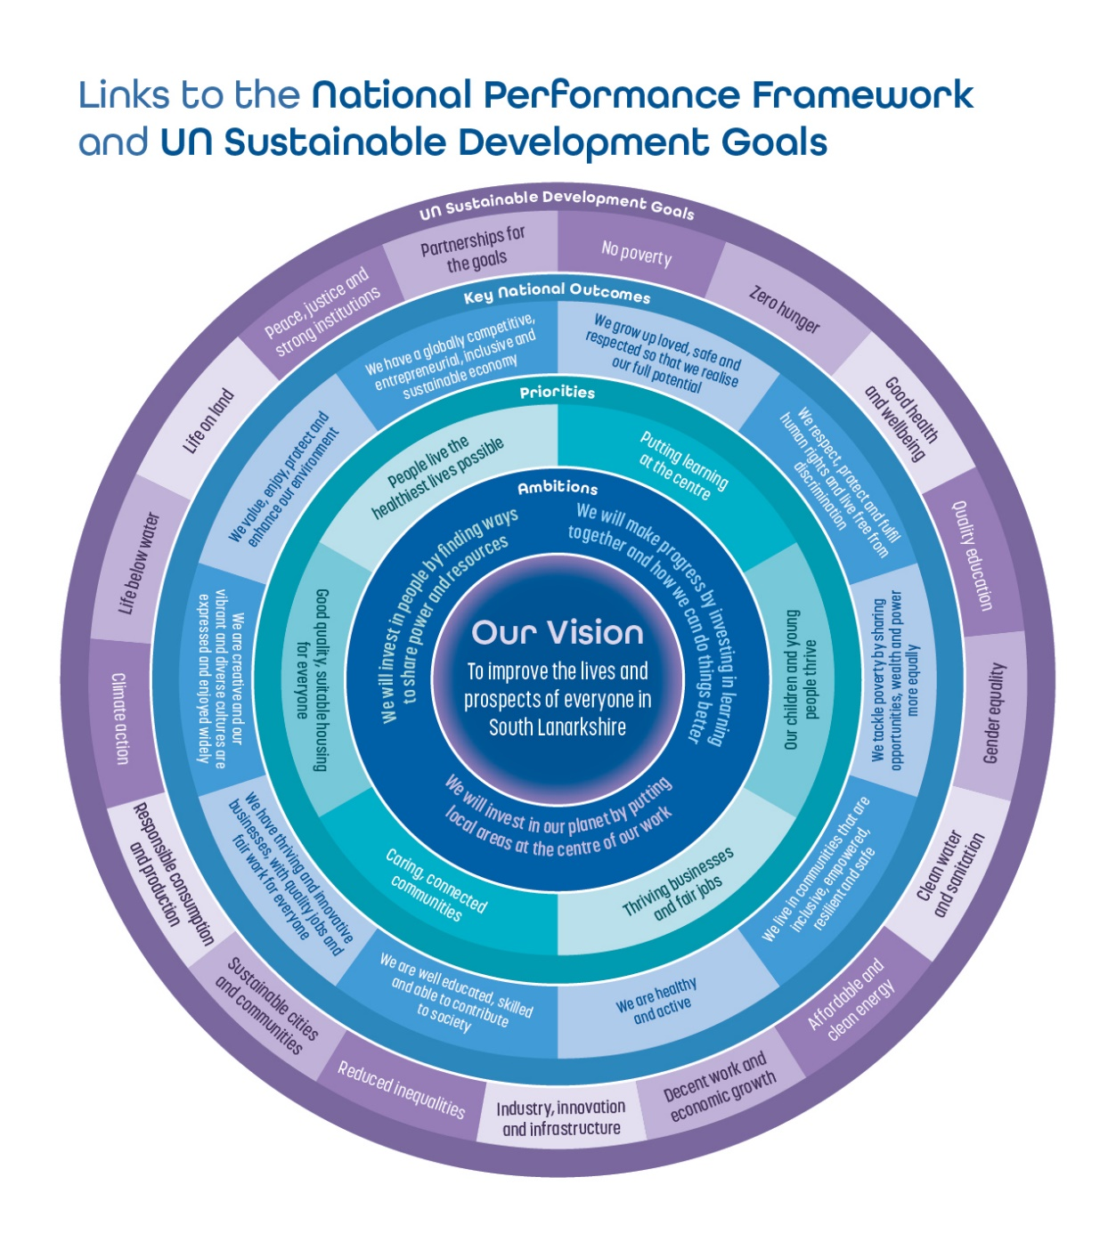

Appendix 2

CPP Structure Diagram



